|  |  |
| --- | --- |
|  | **MINISTRY OF EDUCATION AND TRAINING** |

**FPT UNIVERSITY**

**Capstone Project Document**

**REALTIME HELP DESK SYSTEM VIA VIDEO CALL**

|  |  |
| --- | --- |
| **Group 2** | |
| Group members | Nguyễn Viết Công Hậu – Team Leader – SE61546 Lưu Nguyễn Ngọc Thư – Team Member – SE61997 Nguyễn Ngô Đức Khải – Team Member – SE60889 |
| Supervisor | Mr. Nguyễn Huy Hùng |
| Ext. Supervisor | N/A |
| Capstone Project code | RHDSV2C |

* Ho Chi Minh City, December 2017 -

This page is intentionally left blank.

**Special thanks to our supervisor, Mr. Nguyen Huy Hung.**

**Special thanks to our friend, Nam Kolo (Tran Hoang Nam), who creates a great editor (Kolo-draftjs).**

**Special thanks to our families & friends.**

**Special thanks to FPT University, where our dreams begin.**

**Acknowledgements**

We would like to say thanks to the open-source software community around the world who help us in this project.

**Play Framework 2.6**

Copyright © 2009-2017 Lightbend Inc. (<https://www.lightbend.com>).

Licensed under the Apache License, Version 2.0.

**Morphia**

Copyright © MongoDB Inc.

Licensed under Apache, Version 2.0.

**MySQL Connector/J**

Copyright © Oracle Corporation.

Licensed under GPL License.

**Apache Commons Codec**

Copyright © 2002-2017 The Apache Software Foundation. All Rights Reserved.

Licensed under Apache, Version 2.0.

**Apache Commons Validator**

Copyright © 2002-2017 The Apache Software Foundation. All Rights Reserved.

Licensed under Apache, Version 2.0.

**Jedis**

Copyright © 2011 Jonathan Leibiusky.

Licensed under the MIT License.

**Hibernate Core**

Copyright © Hibernate.org

Licensed under the GNU Lesser General Public License, version 2.1

**React.js**

Copyright © 2017 Facebook Inc.

Licensed under the MIT License.

**Flux Application Architecture**

Copyright © 2014 - 2015 Facebook Inc.

**Redux.js**

Copyright © Dan Abramov

Licensed under the MIT License.

**Kolo-draftjs**

Copyright © 2017 Nam Kolo (Tran Hoang Nam)

Github: <https://github.com/namKolo/kolo-draftjs>

Licensed under the MIT License.

**Draft.js**

Copyright © 2017 Facebook Inc.

Licensed under the BSD License.

**Draft.js Plugins**

Copyright © Draf.js Plugins Team (<https://www.draft-js-plugins.com/>).

Licensed under the MIT License.

**Firebase Libraries**

Copyright © Google Inc.

Licensed under the MIT License and the Apache License, Version 2.0.

**WebRTC-Experiment**

Copyright © Muaz Khan

Licensed under the MIT License

**Table of Contents**

Acknowledgements 4

Table of Contents 5

List of Tables 8

List of Figures 10

Definitions, Acronyms, and Abbreviations 12

A. INTRODUCTION 13

1. Project Information 13

2. Introduction 13

3. Current Situation 13

4. Problem Definitions 13

5. Proposed Solution 13

5.1 Features functions 14

5.2 Advantages and Disadvantage 14

6. Functional Requirements 15

7. Roles and Responsibility 15

B. SOFTWARE PROJECT MANAGEMENT PLAN 16

1. Problem Definition 16

1.1 Name of this Capstone Project 16

1.2 Problem Abstract 16

1.3 Project Overview 16

2. Project organization 19

2.1 Software Process Model 19

2.2 Roles and responsibilities 19

2.3 Tools and Techniques 20

3. Project Management Plan 21

3.1 Software development life cycle 21

3.2 Phase Detail 23

3.3 All Meeting Minutes 23

4. Coding Convention 23

C. SOFTWARE REQUIREMENT SPECIFICATION 24

1. User Requirement Specification 24

1.1 Guest Requirement 24

1.2 User Requirement 24

1.3 Expert Requirement 24

1.4 Staff Requirement 24

1.5 Admin Requirement 25

2. System Requirement Specification 25

2.1 External Interface Requirement 25

2.2 System Overview Use Case 26

2.3 List of Use Case 26

3. Software System Attribute 100

3.1 Usability 100

3.2 Reliability 100

3.3 Availability 100

3.4 Security 100

3.5 Maintainability 101

3.6 Portability 101

3.7 Performance 101

4. Conceptual Diagram 101

D. SOFTWARE DESIGN DESCRIPTION 104

1. Design Overview 104

2. System Architectural Design 104

2.1 System Architecture Overview 104

2.2 Web Service Architecture Description 105

2.3 Front-end Application Architecture Description 106

3. Component Diagram 107

4. Detailed Description 109

4.1 Class Diagram 110

4.2 Class Diagram Explanation 112

4.3 Interaction Diagram 116

5. Interface 127

5.1 Guest Interface Design 127

5.2 User Interface Design 129

5.3 Expert Interface Design 134

6. Database Design 136

6.1 Entity Relationship Diagram (ERD) 136

6.2 Data Dictionary 138

7. Algorithms 140

7.1 Definition 140

7.2 Define Problem 140

7.4 Solution 141

7.5 Complexity 141

7.6 Flowchart 141

7.7 Example 142

E. SYSTEM IMPLEMENTATION & TEST 146

1. Introduction 146

1.1 Overview 146

1.2 Test Approach 146

2. Database Relationship Diagram 146

2.1 Physical Diagram 147

2.2 Data Dictionary 148

3. Test Plan 154

4.1 Features to be tested 154

4.2 Features not to be tested 155

4. System Testing Test Case 155

4.1 Guest Test Case 156

4.2 User Test Case 160

4.3 Expert Test Case 165

F. SOFTWARE USER’S MANUAL 168

1. Installation Guide 168

1.1 Setting up environment at server side 168

1.2 Web Applications Deployment Process 168

2. User Guide 171

2.1 User 171

2.2 Expert 175

2.3 Staff 177

G. APPENDIX & COPYRIGHT INFORMATION 180

1. Appendix 180

2. Copyright Information 181

**List of Tables**

Table 1: Hardware requirement for server 18

Table 2: Hardware requirement for client 18

Table 3: Software requirement 18

Table 4 Tools and Techniques 20

Table 5: <Guest> Login (UC_HELPY12) 29

Table 6: <Guest> Sign Up (UC_HELPY13) 31

Table 7: <User> Call (UC_HELPY25) 34

Table 8: <User> Chat (UC_HELPY26) 36

Table 9: <User> Share Screen (UC_HELPY28) 38

Table 10: <User> Video Call (UC_HELPY29) 40

Table 11: <User> Start Conversation with Chat Bot (UC_HELPY30) 42

Table 12: <User> Close Conversation (UC_HELPY31) 44

Table 13: <User> Get Conversation List (UC_HELPY32) 46

Table 14: <User> Give Feedback (UC_HELPY33) 48

Table 15: <User> Logout (UC_HELPY34) 50

Table 16: <User> Get Conversation (UC_HELPY35) 52

Table 17: <User> Update Profile (UC_HELPY36) 55

Table 18: <Expert> Accept Request (UC_HELPY06) 57

Table 19: <Expert> Decline Request (UC_HELPY07) 60

Table 20: <Expert> Get Request (UC_HELPY08) 62

Table 21: <Expert> Get Request List (UC_HELPY09) 64

Table 22: <Expert> Update Expertise Fields (UC_HELPY11) 67

Table 23: <Staff> Ban User (UC_HELPY14) 69

Table 24: <Staff> Review Expert Registration (UC_HELPY15) 71

Table 25: <Staff> Set Role (UC_HELPY16) 73

Table 26: <Staff> Accept Expert Registration (UC_HELPY17) 76

Table 27: <Staff> Assign Request (UC_HELPY18) 78

Table 28: <Staff> Decline Expert Registration (UC_HELPY19) 80

Table 29: <Staff> Get Pending Request List (UC_HELPY20) 82

Table 30: <Staff> Get Request (UC_HELPY21) 84

Table 31: <Staff> Start Conversation with Requester (UC_HELPY22) 86

Table 32: <Admin> Add Staff (UC_HELPY01) 89

Table 33: <Admin> Remove Staff (UC_HELPY03) 91

Table 34: <System> Assign Request (UC_HELPY23) 93

Table 35: <System> Match Request (UC_HELPY24) 96

Table 36: <Chat Bot> Create Request (UC_HELPY04) 98

Table 37: <Chat Bot> Start Conversation with User (UC_HELPY05) 100

Table 38: Conceptual Diagram Data Dictionary 103

Table 39 Class dictionary 111

Table 40: User Attributes 112

Table 41: User Methods 112

Table 42: Expert Attributes 112

Table 43: Expert Methods 112

Table 44: User Role Attributes 112

Table 45: User Role Methods 113

Table 46: Expertise Field Attributes 113

Table 47: Expertise Field Methods 113

Table 48: Interested Expertise Fields Attributes 113

Table 49: Interested Expertise Fields Methods 113

Table 50: Expertise Fields Attributes 113

Table 51: Expertise Fields Methods 114

Table 52: Request Attributes 114

Table 53: Request Methods 114

Table 54: Conversation Attributes 114

Table 55: Conversation Methods 114

Table 56: Conversation Participant Attributes 115

Table 57: Conversation participant Methods 115

Table 58: Message Attributes 115

Table 59: Message Methods 115

Table 60: Feedback Attributes 115

Table 61: Feedback Methods 116

Table 62: Describe Content of All Entities 138

Table 63: Detail Data Dictionary 140

Table 64 Dataset sample of users’ feedback scores 143

Table 65 Dataset samples for experts average scores for each user 144

Table 66 Dataset samples for Similar Users 144

Table 67 Use-Base Recommendation Result Example 144

Table 68: Attribute Data Dictionary 154

Table 69: Hardware requirement for server 168

Table 70: Hardware requirement for client 168

Table 71: Software requirement for server 168

Table 72: Software requirement for client 168

**List of Figures**

Figure 1: <Guest> Overview Use Case 27

Figure 2: <Guest> Login (UC_HELPY12) 27

Figure 3: <Guest> Sign Up (UC_HELPY13) 29

Figure 4: <User> Overview Use Case 32

Figure 5: <User> Call (UC_HELPY25) 32

Figure 6: <User> Chat (UC_HELPY26) 34

Figure 7: <User> Share Screen (UC_HELPY28) 36

Figure 8: <User> Video Call (UC_HELPY29) 39

Figure 9: <User> Start Conversation with Chat Bot (UC_HELPY30) 41

Figure 10: <User> Close Conversation (UC_HELPY31) 43

Figure 11: <User> Get Conversation List (UC_HELPY32) 45

Figure 12: <User> Give Feedback (UC_HELPY33) 47

Figure 13: <User> Logout (UC_HELPY34) 49

Figure 14: <User> Get Conversation (UC_HELPY35) 50

Figure 15: <User> Update Profile (UC_HELPY36) 53

Figure 16: <Expert> Overview Use Case 55

Figure 17: <Expert> Accept Request (UC_HELPY06) 55

Figure 18: <Expert> Decline Request (UC_HELPY07) 58

Figure 19: <Expert> Get Request (UC_HELPY08) 60

Figure 20: <Expert> Get Request List (UC_HELPY09) 62

Figure 21: <Expert> Update Expertise Fields (UC_HELPY11) 65

Figure 22: <Staff> Overview Use Case 67

Figure 23: <Staff> Ban User (UC_HELPY14) 67

Figure 24: <Staff> Review Expert Registration (UC_HELPY15) 70

Figure 25: <Staff> Set Role (UC_HELPY16) 72

Figure 26: <Staff> Accept Expert Registration (UC_HELPY17) 74

Figure 27: <Staff> Assign Request (UC_HELPY18) 76

Figure 28: <Staff> Decline Expert Registration (UC_HELPY19) 78

Figure 29: <Staff> Get Pending Request List (UC_HELPY20) 80

Figure 30: <Staff> Get Request (UC_HELPY21) 82

Figure 31: <Staff> Start Conversation with Requester (UC_HELPY22) 84

Figure 32: <Admin> Overview Use Case 87

Figure 33: <Admin> Add Staff (UC_HELPY01) 87

Figure 34: <Admin> Remove Staff (UC_HELPY03) 89

Figure 35: <System> Overview Use Case 91

Figure 36: <System> Assign Request (UC_HELPY23) 92

Figure 37: <System> Match Request (UC_HELPY24) 94

Figure 38: <Chat Bot> Overview Use Case 96

Figure 39: <Chat Bot> Create Request (UC_HELPY04) 96

Figure 40: <Chat Bot> Start Conversation with User (UC_HELPY05) 98

Figure 41: Conceptual Diagram 102

Figure 42 System Architecture Overview 105

Figure 43 Web Service Architecture 106

Figure 44 Front-end Application Architecture 107

Figure 45 Component Diagram 108

Figure 46 Class Diagram 110

Figure 47: Sequence diagram - <User> Chat 117

Figure 48: Sequence diagram - <User> Close Conversation 118

Figure 49: Sequence diagram - <User> Get Conversation List 119

Figure 50: Sequence diagram – <User> Get Conversation 120

Figure 51: Sequence diagram - <User> Give Feedback 121

Figure 52: Sequence diagram - <Expert> Accept Request 122

Figure 53: Sequence diagram - <Expert> Decline Request 123

Figure 54: Sequence diagram - <Expert> Get Request List 124

Figure 55: Sequence diagram - <Expert> Get Request 125

Figure 56: Sequence diagram - <User> Start Conversation with User 126

Figure 57 Entity Relation Diagram 137

Figure 58 User-Based Recommendation Flow Chart 142

Figure 59 Physical Diagram 147

Figure 60 Check Java Runtime Environment Veresion 169

Figure 61 Check Node.js Version 169

Figure 62 Check NPM has been installed 169

Definitions, Acronyms, and Abbreviations

|  |  |
| --- | --- |
| Name | Definition |
| Helpy | The name of the project’s product. |
| Expert | A man who has expertise could resolve user problems. |
| Expertise Field | A field or topic that an expert has skills. |
| IT | Information Technology |

# A. INTRODUCTION

## 1. Project Information

* Project Name: REALTIME HELP DESK SYSTEM VIA VIDEO CALL
* Project Code: RHDSV2C
* Product Type: Web application
* Start Date: Tuesday, September 9, 2017
* End Date: Friday, December 8, 2017

## 2. Introduction

In this document, we will introduce a solution for REALTIME help desk system via video call. Nowadays, people have demands for finding a support expert to help them resolve their technical problem at any time and everywhere. Based on our researches and analysis, we proposed a solution for this problem.

We build a system, which allows users to get help from expert. Users can help for helps in different areas such as application issues, coding issues, writing problems, etc. and receive support in real time via video calls.

Besides, this document also shows our working process and our perspective in the system, designs, architecture and workflow.

## 3. Current Situation

Nowadays, working & studying by the help of computers is more and more common. Computers with many programs can help human resolve problems faster. However, sometimes the computer creates its own problem for the users.

When user get issues with computer programs and software, users usually ask help from their friends who have expertise in technology. But, "their friends" are not always has free time to help them. Some "IT guys" get uncomfortable when many people ask them to help resolving the computer software issues.

Users also seem hard to find someone could help his software issue in realtime. If they ask help on a forum, it takes time to get the solution for their issues. And sometimes, the solution could not resolve the problem.

## 4. Problem Definitions

From above current situation, we have these disadvantages:

* Cannot get help at anytime from anywhere.
* Difficulties in finding expert of a field.

## 5. Proposed Solution

We would like to build a system that were computers users who get troubles with software may look for experts can help them.

Helpy Application is a web application with following functions:

### **5.1 Features functions**

* Register account
* Request for helps
* Matching users’ request with experts
* Chat, voice chat
* Users and experts share user’ screen for fixing issues
* Feedback

### **5.2 Advantages and Disadvantage**

* Advantages:
  + - * + Innovative idea in Vietnam
        + Easy to use application
        + Friendly interface
* Disadvantages:
  + - * + Difficulties in matching the right person to resolve the users issues.
        + The cost in web application maintenance is high
        + Users’ demand change

## 6. Functional Requirements

Function requirements of the system are listed as below:

* User component:
  + Register account
  + Request for help
  + Chat, voice call with experts
  + Share screen with expert for fixing issues
  + Feedback on experts’ work
  + Update profile
* Expert component:
  + Register expert account
  + Receive request for help
  + Chat, voice call with users
  + Watch users’ shared screen for fixing issues
  + Get paid
* Staff component:
  + Manage user and expert
  + Create request
* Admin component:
  + Manage staff

## 7. Roles and Responsibility

|  |  |  |  |  |
| --- | --- | --- | --- | --- |
| No | Full Name | Role | Position | Contact |
| 1 | Nguyễn Huy Hùng | Project Manager | Supervisor | hungnh@fpt.edu.vn |
| 2 | Nguyễn Viết Công Hậu | Developer | Leader | haunvcse61546@fpt.edu.vn |
| 3 | Lưu Nguyễn Ngọc Thư | Developer | Member | thulnnse61997@fpt.edu.vn |
| 4 | Nguyễn Ngô Đức Hải | Developer | Member | khainndse60889@fpt.edu.vn |

# B. SOFTWARE PROJECT MANAGEMENT PLAN

## 1. Problem Definition

### **1.1 Name of this Capstone Project**

* Official name: REALTIME HELP DESK SYSTEM VIA VIDEO CALL
* Vietnamese name: Hệ Thống Hỗ Trợ Khắc Phục Sự Cố Thông Qua Video
* Abbreviation: RHDSV2C

### **1.2 Problem Abstract**

As current in Vietnam, as well as other developed countries, the technology grows and appears every day, it requires us to study and solve the technology problem. But when having difficult problems yourselves, you would hardly resolve them yourselves. In those cases, you will need an expert. The problem is, that expert is not always available, or you do not know who is trustful enough to help you.

We provide an application to match users’ request to experts of the request’s expertise field to help them, and the users can chat, call or share screen with the experts to help these experts determine the problem and guide them resolve the technology complex.

### **1.3 Project Overview**

#### **1.3.1 Current Situation**

Below are the problems encountered in this project:

* **Machine learning:** matching the suitable expert to user request for help
* **Schedule of team member:** team members can have a conflict in meeting schedule because of sick, or class and work schedule, etc.
* **Framework study:** team member can have a problem when applying the play framework into project.

#### **1.3.2 The Proposed System**

We build a chatbot to support creating the request based on user requirements, it will minimize staff’s quantity of work, as well as users’ waiting time.

Our system includes a web application. In detail, the web application provides following features:

* For users:
  + Users can join conversation with expert. In this function, they can chat, voice call, video call or shared file with the experts.
  + Users can request for help by starting a conversation with a chatbot. Chatbot will create the request based on user’s provided information.
  + After a conversation, user can rate the expert.
  + User can update their info and request for expert upgrading.
* For experts:
  + Expert can join conversation with users requested help.
  + After a conversation, expert can rate the quality of conversation.
  + Expert can update their info, as well as their expertise.
* For staffs:
  + Staff can ban users, update users’ role or review expert.
  + Staff can create, review and assign users’ requests.
* For admins:
  + Admin can add, remove staffs.

#### **1.3.3 Boundaries of the System**

* Allow user request for help by chatting with a simple chat bot, chat bot that answering following a script
* Auto assign request for suitable expert
* Allow user to chat, call, video call and share screen with another user
* Not allow user to take control the other’s system while share screen
* Not support payment method

#### **1.3.4 Future plan**

With further research and development, the system can apply the following features:

* Support expert ranking
* Support payment method
* Upgrade the assign request algorithm to improve the automatic assign request process
* Upgrade the chat bot to improve the user support process

#### **1.3.5 Development Environment**

##### **1.3.5.1 Hardware requirements**

**- For server:**

|  |  |  |
| --- | --- | --- |
| *Criteria* | *Minimum Requirements* | *Recommended* |
| *Internet Connection* | *Cable (4 Mbps)* | *Cable (8 Mbps)* |
| *Operating System* | *Window Server 2008 R2* | *Window Server 2008 R2* |
| *Computer Processor* | *64-bit CPU 1.4GHz with 2 cores* | *64-bit CPU 2.50GHz with 4 cores* |
| *Computer Memory* | *2 GB RAM* | *4 GB RAM or more* |

Table 1: Hardware requirement for server

**- For client:**

|  |  |  |
| --- | --- | --- |
| *Criteria* | *Minimum Requirements* | *Recommended* |
| *Internet Connection* | *Cable (4 Mbps)* | *Cable (8 Mbps)* |
| *Operating System* | *Windows 7* | *Windows 10* |
| *Computer Processor* | *Intel® Core i3 1.4GHz* | *Intel® Core i5 2.50GHz* |
| *Computer Memory* | *1GB RAM* | *2GB RAM or more* |
| *Web Browser* | Firefox (v52 or higher), Chromes (v28 or higher) | *Chrome latest stable version* |

Table 2: Hardware requirement for client

##### **1.3.5.2 Software requirements**

|  |  |  |
| --- | --- | --- |
| *Name* | *Name/Version* | *Description* |
| *Operating System* | *Windows 10* | *Operating system and platform for development* |
| *Environment* | *Java JDK 8* | *Specification for developing web application* |
| *Modeling tool* | *StarUML 2.8,*  *Draw.io* | *Software modeling tool* |
| *Integrated development environment* | *- IntelliJ IDEA 2017.2.3 (Web Service/Staff Web Application Development) - WebStorm 2017.2.3 (Front-end Application Development) - Netbeans IDEA 8.2 (Worker Service Development)* | *Programming tools* |
| *Database Management System* | *MySQL 5.7, MongoDB 3.4* | *Used to create & manage the database for system* |
| *Caching* | *Redis 2.8 (Redis Windows 3.0)* | *Use to save temporary data of web service or share data between web service & worker service.* |
| *NPM* | *Npm v 5.5.1 or higher.* | *Javascript Package Manager* |
| *Node.js* | *Node.js 8.9.0 or higher. (Recommended Node.js Long Time Support versions)* | *Javascript runtime* |
| *Source control* | *Git hosted by Github.com* | *Used to source control & version control.* |
| *Web browser* | *Chrome 28 or higher.* | *Testing browser* |

Table 3: Software requirement

## 2. Project organization

### **2.1 Software Process Model**

This project is developed using Scrum model – part of an agile framework for Software development project. Our team choose Scrum model because of the following reasons:

* Releases & prototypes are delivered every sprint (2 weeks). Two weeks is the time suitable for the team can manage risks when there is a change in requirement.
* Because of the delivery every sprint, all team must work to avoid misunderstanding the requirements or miscommunication.
* Able to learn new technology and skills at the developing time.

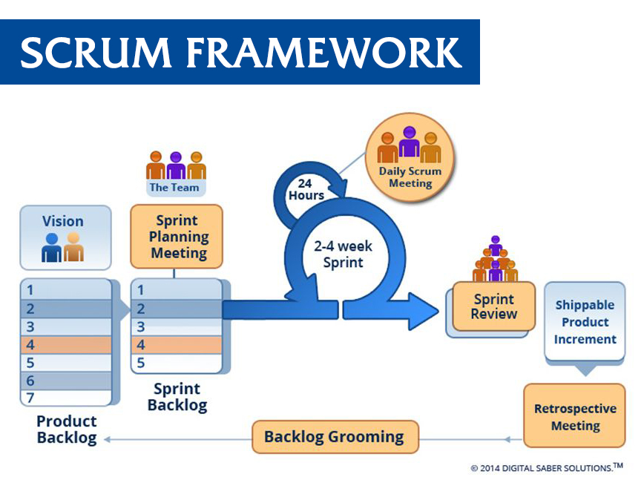

### **2.2 Roles and responsibilities**

|  |  |  |  |
| --- | --- | --- | --- |
| No | Full Name | Role in Group | Responsibilities |
| 1 | Nguyễn Huy Hùng | Product Owner | * Specifying user requirements * Controlling the development process * Giving out technique and business analysis support |
| 2 | Nguyễn Viết Công Hậu | Scrum master | * Managing the working process * Clarifying requirements * Designing database * Designing diagram * Creating test plan * Coding * Testing |
| 3 | Lưu Nguyễn Ngọc Thư | Developer, Tester | * Prepare documents * Designing database * Designing diagram * Coding * Testing |
| 4 | Nguyễn Ngô Đức Hải | Developer, Tester | * GUI Design * Designing database * Designing diagram * Coding * Testing |

### **2.3 Tools and Techniques**

|  |  |  |
| --- | --- | --- |
| No | Tool / Technique | Name / Version |
| 1 | Web Server | Apache 2.4 |
| 2 | Database Systems | MySQL 5.7, MongoDB 3.4 |
| 3 | Temporary Storage | Redis 2.8 (Redis Windows 3.0) |
| 4 | Back-end Framework | Play Framework 2.6 |
| 5 | Front-end Technology | React.js & Flux Architecture with Redux |
| 6 | Video/Audio Call, Screen Sharing Technology | WebRTC |

Table 4 Tools and Techniques

## 3. Project Management Plan

### **3.1 Software development life cycle**

|  |  |  |  |  |  |
| --- | --- | --- | --- | --- | --- |
| Phase | Description | Deliverables | Resource needed | Dependencies and Constrains | Risks |
| Requirement Analysis and Design | * Collecting customer requirement * Identifying and clarifying requirements for the system in general * Choosing architect style * Designing the architect for the system * Designing mockup * Creating the documents | * Software introduction report * Software project management plan report * Software requirement specifications report * Software design report | 2 weeks | N/A | * Missing requirement * Unclear the scope of project |
| Chat and Share File function | * Coding the chat function * Coding the share file function |  | 2 weeks | Depend on “Requirement Analysis and Design” | * Lack of experience * Time obstacle * Wrong architecture |
| Call and Staffs’ Function | * Coding the voice call function * Coding the staff component’s function |  | 2 weeks | Depend on “Requirement Analysis and Design” | * Lack of experience * Time obstacle * Wrong architecture |
| Share Screen and Request Matching Function | * Coding the share screen function * Coding the request matching function |  | 2 – 3 weeks | Depend on “Requirement Analysis and Design” | * Lack of experience * Time obstacle * Wrong architecture |
| Test and Review | * Acceptance testing * Review the documents |  | 2 weeks | Depend on coding stage | Time obstacle |

### **3.2 Phase Detail**

|  |  |  |
| --- | --- | --- |
| Task | Description | Author |
| Requirement analysis | Define which main functions of the system | Nguyễn Viết Công Hậu |
| Choose architecture | Give out the architecture of the system and some critical techniques was also researched | Nguyễn Viết Công Hậu |
| Create the documents | Create the documents of the project | Lưu Nguyễn Ngọc Thư |
| Design mockup | N/A | Nguyễn Ngô Đức Khải |
| Design the architecture | N/A | Nguyễn Viết Công Hậu  Lưu Nguyễn Ngọc Thư  Nguyễn Ngô Đức Khải |

### **3.3 All Meeting Minutes**

Meeting minutes are contained in folder “Meeting minutes” in the attached CD.

## 4. Coding Convention

|  |  |  |
| --- | --- | --- |
| *No* | *Convention* | *Description* |
| *1* | *Naming convention* | * *Use* ***camel-case*** *style for variables and functions name (Lowercase for first letter)* * *Use* ***camel-case*** *for classes (Uppercase for first letter)* |
| *2* | *Indentation* | * *Use four* ***spaces*** *per indentation level* * *Use eight* ***spaces*** *to continue indent* * *Use* ***“;”*** *for separate statements and expressions* |
| *3* | *Classes* | * *Classes should be declared using* ***class*** *keyword* * *Using* ***public, private, protected*** *to declare protective level of instance variable and function* * *Use* ***this*** *to refer current class instance* |

Reference: <http://www.oracle.com/technetwork/java/codeconvtoc-136057.html>

# C. SOFTWARE REQUIREMENT SPECIFICATION

## 1. User Requirement Specification

### **1.1 Guest Requirement**

Guest is a person who doesn’t access to the system. Guest can use some functions in the system, to use all functions, guest must login. These are some functions guest can use:

* Login
* Sign up

### **1.2 User Requirement**

User is a person who access to the system as user role. Guest can use following functions:

* Call
* Chat
* Share screen
* Video call
* Start conversation with Chat Bot
* Close conversation
* Get conversation list
* Give feedback
* Logout
* Get conversation
* Update profile

### **1.3 Expert Requirement**

Expert is a person who access to the system as expert role, he/she is the expert of some expertise fields who can help user resolve the problem through a conversation. Besides users’ functions, expert can also use following functions:

* Accept request
* Decline request
* Get request
* Get request list
* Update expertise fields

### **1.4 Staff Requirement**

Staff is a user who manage the users and the expertise fields. Staff can use following functions:

* Ban user
* Review expert registration
* Set role
* Accept expert registration
* Assign request
* Decline expert registration
* Get pending request list
* Get request
* Start conversation with requester

### **1.5 Admin Requirement**

Admin is a person who manages staffs and users. Besides staffs’ functions, admin can also use following functions:

* Add staff
* Remove staff

## 2. System Requirement Specification

### **2.1 External Interface Requirement**

#### **2.1.1 User Interface**

- The user interface uses Vietnamese.

- The user interface displays best on 1366x768 screen.

#### **2.1.2 Hardware Interface**

Desktop PC.

#### **2.1.3 Software Interface**

Web application: work with browsers Firefox (v52 or higher), Chromes (v28 or higher).

#### **2.1.4 Communication Protocol**

Use HTTP protocol 1.1 for communication between the web browser and the web.

Use WebRTC ("Web REALTIME Communication") protocols for making screen sharing, video/audio calls.

### **2.2 System Overview Use Case**

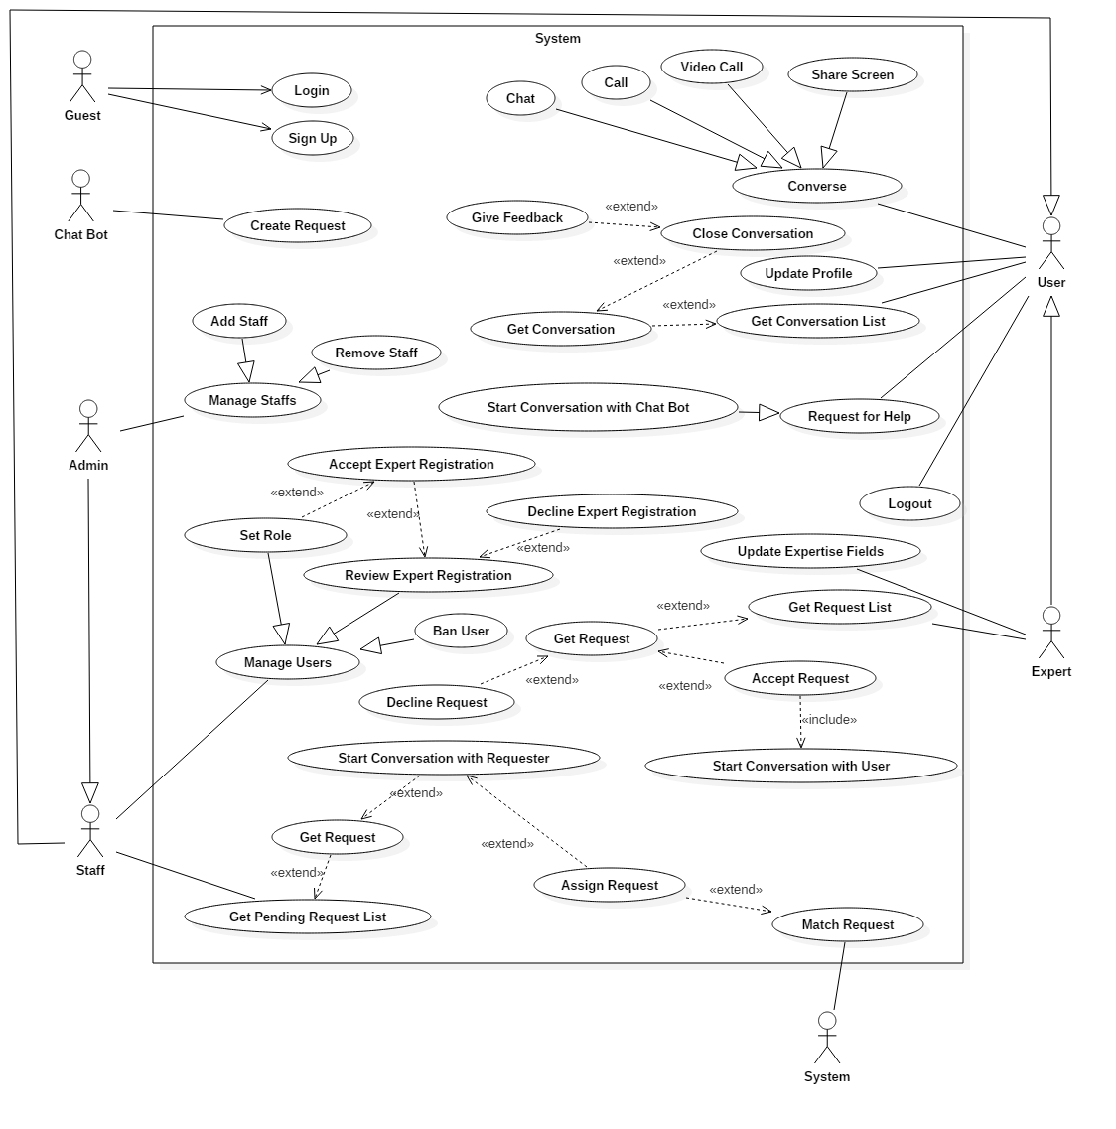

### **2.3 List of Use Case**

#### **2.3.1 <Guest> Overview Use Case**

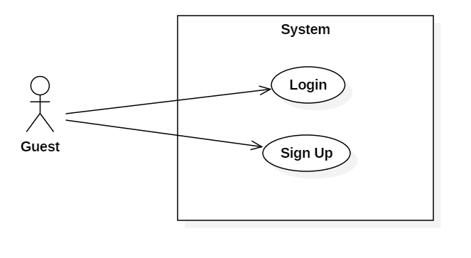

Figure 1: <Guest> Overview Use Case

##### **2.3.1.1 <Guest> Login**

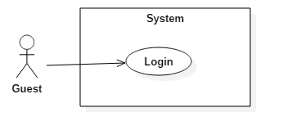

Figure 2: <Guest> Login (UC_HELPY12)

|  |  |  |  |
| --- | --- | --- | --- |
| **USE CASE – UC_HELPY12** | | | |
| **Use Case No.** | UC_HELPY12 | **Use Case Version** | 0.2 |
| **Use Case Name** | Login | | |
| **Author** | Lưu Nguyễn Ngọc Thư | | |
| **Date** | 09/11/2017 | **Priority** | High |
| **Actor:**   * Guest   **Summary:**   * This use case allows guest to login to system.   **Goal:**   * To login to the system.   **Triggers:**   * Actor sends login command.   **Preconditions:**   * Guest does not login yet.   **Post conditions:**   * Success: Actor accesses the system successfully. * Fail: System shows error messages.   **Main Success Scenario:**   |  |  |  | | --- | --- | --- | | ***Step*** | ***Actor Action*** | ***System Response*** | | 1 | [Alternative no.1]  Actor clicks “Đăng nhập” button in the login form. |  | |  |  | [Exception no.1]  System displays the home page. |   **Alternative Scenario:**   |  |  |  | | --- | --- | --- | | ***Step*** | ***Actor Action*** | ***System Response*** | | 1 | Guest input invalid username or password |  | |  |  | System displays error message: “Tên đăng nhập và mật khẩu không hợp lệ.” |   **Exceptions:**   |  |  |  | | --- | --- | --- | | ***No*** | ***Cause*** | ***System Response*** | | 1 | Internet connection lost. | System displays an error message: “Bạn đã ngắt kết nối. Vui lòng kiểm tra lại đường truyền mạng.” |   **Relationships:** **N/A**  **Business Rules:**   * Username must be at least 4 characters. * Password must be at least 6 characters. * Password must be encrypted. * Actor logged in may have role(s): user, expert, staff, admin, user and staff, or expert and staff. | | | |

Table 5: <Guest> Login (UC_HELPY12)

##### **2.3.1.2 <Guest> Sign Up**

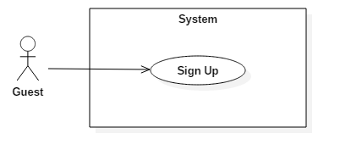

Figure 3: <Guest> Sign Up (UC_HELPY13)

|  |  |  |  |
| --- | --- | --- | --- |
| **USE CASE – UC_HELPY13** | | | |
| **Use Case No.** | UC_HELPY13 | **Use Case Version** | 0.2 |
| **Use Case Name** | Sign Up | | |
| **Author** | Lưu Nguyễn Ngọc Thư | | |
| **Date** | 09/11/2017 | **Priority** | High |
| **Actor:**   * Guest   **Summary:**   * This use case allows guest to create a new account.   **Goal:**   * To create a new account.   **Triggers:**   * Actor sends sign up command.   **Preconditions:**   * Actor has not logged in yet.   **Post conditions:**   * Success: New account is created successfully. * Fail: System displays error messages.   **Main Success Scenario:**   |  |  |  | | --- | --- | --- | | ***Step*** | ***Actor Action*** | ***System Response*** | | 1 | Actor clicks “Đăng ký” button in the register form.  [Alternative no.2] |  | |  |  | [Exception no.1]  System adds new account. |   **Alternative Scenario:**   |  |  |  | | --- | --- | --- | | ***No*** | ***Actor Action*** | ***System Response*** | | 1 | Actor does not fill required information. |  | |  |  | System displays messages: “Xin vui lòng điền các thông tin bắt buộc.” |   **Exceptions:**   |  |  |  | | --- | --- | --- | | ***No*** | ***Cause*** | ***System Response*** | | 1 | Internet connection lost. | System displays an error message: “Bạn đã ngắt kết nối. Vui lòng kiểm tra lại đường truyền mạng.” | | 2 | Guest input already exist username. | System show warning message “Tên đăng nhập đã tồn tại.” | | 3 | Guest input already exist email. | System shows warning message “Email đã tồn tại.” |   **Relationships:** **N/A**  **Business Rules:**   * Username must be at least 4 characters and maximum of 45 characters. * Password must be at least 6 characters and maximum of 128 characters. * Password must be encrypted. * First name is not null and maximum of 45 characters. * Last name is not null and maximum of 45 characters. * Email pattern should be: **[^[_A-Za-z0-9-\\+]+(\\.[_A-Za-z0-9-]+)*@"+"[A-Za-z0-9-]+(\\.[A-Za-z0-9]+)*(\\.[A-Za-z]{2,})$]** (following RFC 5322 standard). * After sign up, information of account will be stored in database of the system with role “User”. | | | |

Table 6: <Guest> Sign Up (UC_HELPY13)

#### **2.3.2 <User> Overview Use Case**

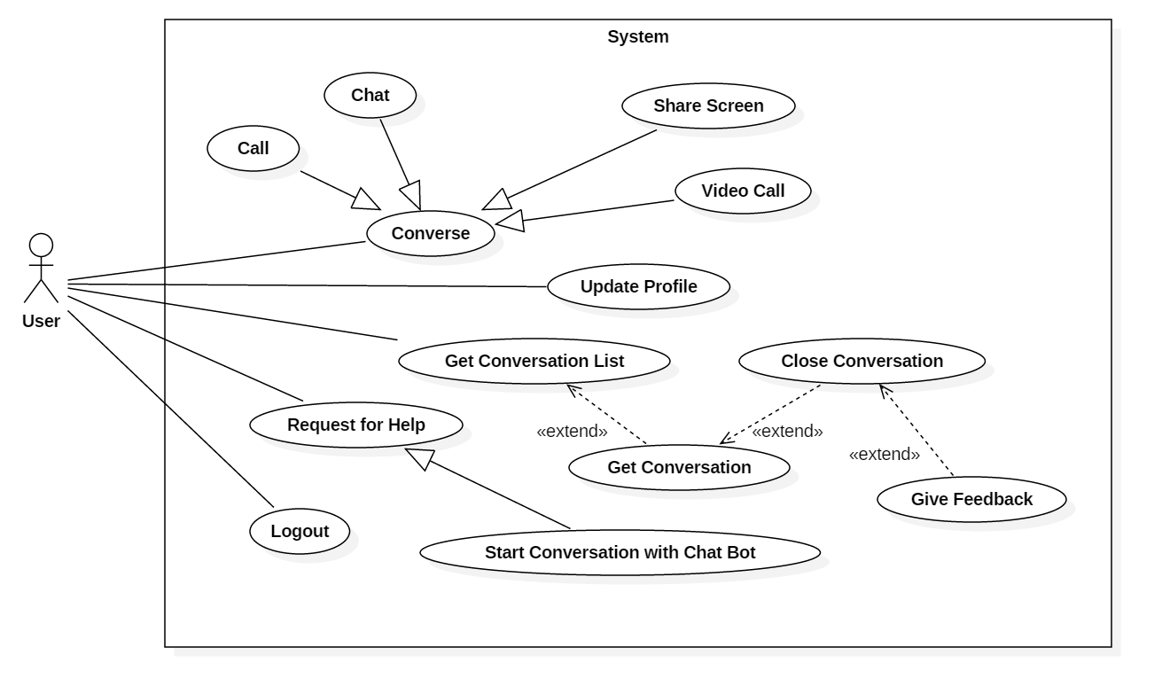

Figure 4: <User> Overview Use Case

##### **2.3.2.1 <User> Call**

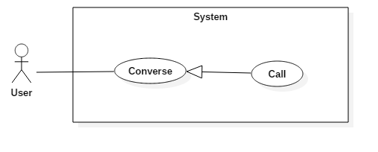

Figure 5: <User> Call (UC_HELPY25)

|  |  |  |  |
| --- | --- | --- | --- |
| **USE CASE – UC_HELPY25** | | | |
| **Use Case No.** | UC_HELPY25 | **Use Case Version** | 0.2 |
| **Use Case Name** | Call | | |
| **Author** | Lưu Nguyễn Ngọc Thư | | |
| **Date** | 09/11/2017 | **Priority** | High |
| **Actor:**   * User   **Summary:**   * This use case allows user to call the other users.   **Goal:**   * To call other users.   **Triggers:**   * Actor sends call command.   **Preconditions:**   * User logged in as user role.   **Post conditions:**   * Success: System displays a call frame and allows the conversation participants may communicate by their voices. * Fail: System displays error messages.   **Main Success Scenario:**   |  |  |  | | --- | --- | --- | | ***Step*** | ***Actor Action*** | ***System Response*** | | 1 | Actor clicks "Gọi điện" button from call methods list in the conversation view. |  | |  |  | [Exception no.1] System displays a call frame and allows the conversation participants may communicate together by their voices. |   **Alternative Scenario: *N/A***  **Exceptions:**   |  |  |  | | --- | --- | --- | | ***No*** | ***Cause*** | ***System Response*** | | 1 | Internet connection lost. | System displays an error message: “Bạn đã ngắt kết nối. Vui lòng kiểm tra lại đường truyền mạng.” |   **Relationships:**   * Abstract use case: Converse.   **Business Rules:**  The maximum time the actors can do a call is 30 minutes. | | | |

Table 7: <User> Call (UC_HELPY25)

##### **2.3.2.2 <User> Chat**

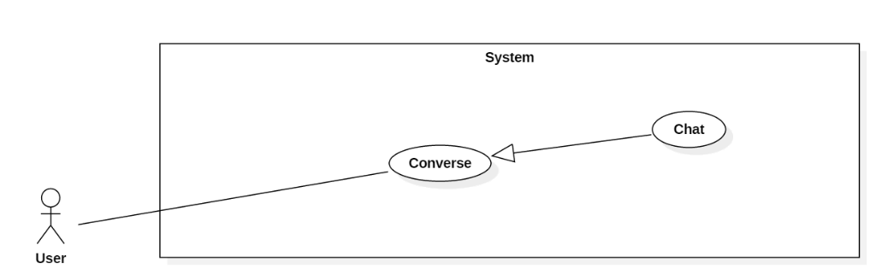

Figure 6: <User> Chat (UC_HELPY26)

|  |  |  |  |
| --- | --- | --- | --- |
| **USE CASE – UC_HELPY26** | | | |
| **Use Case No.** | UC_HELPY26 | **Use Case Version** | 0.2 |
| **Use Case Name** | Chat | | |
| **Author** | Nguyễn Viết Công Hậu | | |
| **Date** | 23/09/2017 | **Priority** | High |
| **Actor:**   * User   **Summary:**   * This use case allows users to chat (send text messages) with other users or chat bot in a conversation.   **Goal:**   * To chat (send text messages) with other users or chat bot in a conversation.   **Triggers:**   * Actor sends chat command.   **Preconditions:**   * Actor logged in as user role. * Actor has opened a conversation.   **Post conditions:**   * Success: The text message that actor would like to send to the conversation is loaded successfully and the system displays its information (include post time) on the conversation. * Fail: The system displays error messages.   **Main Success Scenario:**   |  |  |  | | --- | --- | --- | | ***Step*** | ***Actor Action*** | ***System Response*** | | 1 | User inputs text to the text box. |  | | 2 | User presses ENTER or clicks “Gửi” button. |  | |  |  | [Exception no.2]  The message sent by user is being sent to server.  [Exception no.1] When the message has been sent successfully, system displays the information of the message includes the post time of the message on the conversation view. |   **Alternative Scenario: N/A**  **Exceptions:**   |  |  |  | | --- | --- | --- | | ***No.*** | ***Cause*** | ***System Response*** | | 1 | The Internet connection is lost. | System displays error message: “Bạn đã ngắt kết nối. Vui lòng kiểm tra lại đường truyền mạng.” | | 2 | The message user would like to send is more than 200 characters. | System displays message: “Tin nhắn quá dài. Bạn chỉ có thể nhập 200 ký tự trên mỗi tin nhắn.” |   **Relationships:**   * Abstract use case: Converse.   **Business Rules:**   * The minimum total characters actor can send per message: 1 character. * The maximum total characters actor can send per message: 200 characters. | | | |

Table 8: <User> Chat (UC_HELPY26)

##### **2.3.2.3 <User> Share Screen**

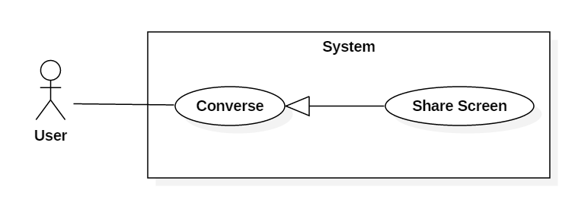

Figure 7: <User> Share Screen (UC_HELPY28)

|  |  |  |  |
| --- | --- | --- | --- |
| **USE CASE – UC_HELPY28** | | | |
| **Use Case No.** | UC_HELPY28 | **Use Case Version** | 0.1 |
| **Use Case Name** | Share Screen | | |
| **Author** | Nguyễn Viết Công Hậu | | |
| **Date** | 10/11/2017 | **Priority** | High |
| **Actor:**   * User   **Summary:**   * This use case allows users to share screen with other users in a conversation.   **Goal:**   * To share screen with other users in a conversation.   **Triggers:**   * Actor sends the share screen command.   **Preconditions:**   * Actor logged in as user role.   **Post conditions:**   * Success: System opens the share screen frame allows the conversation participants share screen to the other. * Fail: System displays error messages.   **Main Success Scenario:**   |  |  |  | | --- | --- | --- | | ***Step*** | ***Actor Action*** | ***System Response*** | | 1 | Actor clicks "Ch.sẻ màn hình" button from call methods list in the conversation view. |  | |  |  | [Exception no.1]  [Exception no.2]  [Exception no.3] System display the share screen frame allows the conversation participants can view the screen of the participant who share his/her screen. |   **Alternative Scenario: *N/A***  **Exceptions:**   |  |  |  | | --- | --- | --- | | ***No*** | ***Cause*** | ***System Response*** | | 1 | Internet connection lost. | System displays an error message: “Bạn đã ngắt kết nối. Vui lòng kiểm tra lại đường truyền mạng.” | | 2 | Conversation no longer exists. | System displays an error message: “Cuộc trò chuyện đã kết thúc.” | | 3 | User no longer exists. | System displays an error message: “Người dùng không tồn tại.” |   **Relationships:**   * Abstract use case: Converse.   **Business Rules:**   * The person who was shared screen cannot take control the other’s machine. * User can chat, call while sharing screen. | | | |

Table 9: <User> Share Screen (UC_HELPY28)

##### **2.3.2.4 <User> Video Call**

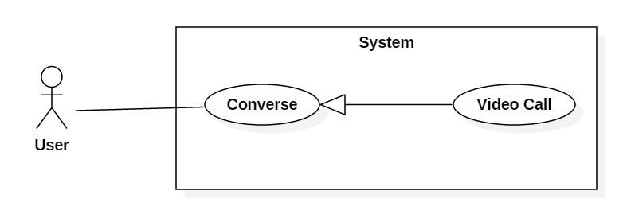

Figure 8: <User> Video Call (UC_HELPY29)

|  |  |  |  |
| --- | --- | --- | --- |
| **USE CASE – UC_HELPY29** | | | |
| **Use Case No.** | UC_HELPY29 | **Use Case Version** | 0.1 |
| **Use Case Name** | Video Call | | |
| **Author** | Nguyễn Viết Công Hậu | | |
| **Date** | 09/11/2017 | **Priority** | High |
| **Actor:**   * User   **Summary:**   * This use case allows actor to communicate with the others in a conversation by voice and video capturing from his/her camera.   **Goal:**   * To video call with other participants in a conversation.   **Triggers:**   * Actor sends the video call command.   **Preconditions:**   * Actor logged in as user role.   **Post conditions:**   * Success: System opens the video call frame allows the conversation participants video call to each other. * Fail: System displays error messages.   **Main Success Scenario:**   |  |  |  | | --- | --- | --- | | ***Step*** | ***Actor Action*** | ***System Response*** | | 1 | Actor clicks "Gọi video" button from call methods list in the conversation view. |  | |  |  | [Exception no.1] [Exception no.2] System displays the video frame allows the conversation participants to view the videos capturing each other and can communicate by their voices. |   **Alternative Scenario: *N/A***  **Exceptions:**   |  |  |  | | --- | --- | --- | | ***No*** | ***Cause*** | ***System Response*** | | 1 | Internet connection lost. | System displays an error message: “Bạn đã ngắt kết nối. Vui lòng kiểm tra lại đường truyền mạng.” | | 2 | Conversation no longer exists. | System displays an error message: “Cuộc trò chuyện đã kết thúc.” |   **Relationships:**   * Abstract use case: Converse.   **Business Rules:**   * The maximum time the actors can do a video call is 20 minutes. | | | |

Table 10: <User> Video Call (UC_HELPY29)

##### **2.3.2.5 <User> Start Conversation with Chat Bot**

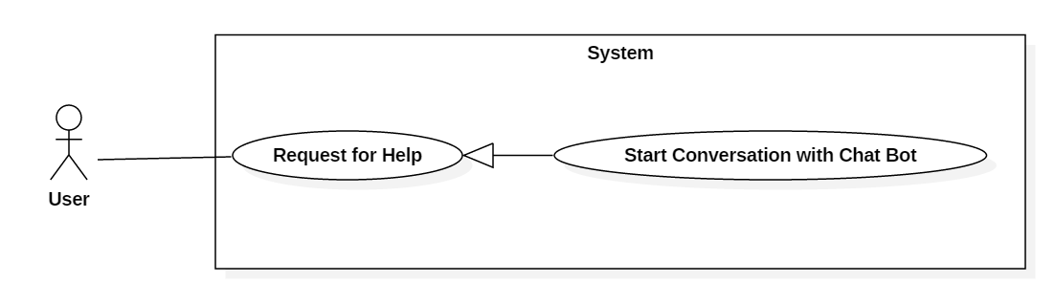

Figure 9: <User> Start Conversation with Chat Bot (UC_HELPY30)

|  |  |  |  |
| --- | --- | --- | --- |
| **USE CASE – UC_HELPY30** | | | |
| **Use Case No.** | UC_HELPY30 | **Use Case Version** | 0.1 |
| **Use Case Name** | Start Conversation with Chat Bot | | |
| **Author** | Nguyễn Viết Công Hậu | | |
| **Date** | 10/11/2017 | **Priority** | High |
| **Actor:**   * User   **Summary:**   * This use case allows users to start conversation with chat bot for create request for help of an expertise field.   **Goal:**   * To start conversation with chat bot for creating an request for help.   **Triggers:**   * Actor sends the start conversation with chat bot screen command.   **Preconditions:**   * Actor logged in as user role.   **Post conditions:**   * Success: The conversation between actor and chat bot is displayed. * Fail: System displays error messages.   **Main Success Scenario:**   |  |  |  | | --- | --- | --- | | ***Step*** | ***Actor Action*** | ***System Response*** | | 1 | Actor clicks topic link from list of topics. |  | |  |  | [Exception no.1] [Exception no.2]  [Exception no.3] System displays the conversation between actor and chat bot which contains all messages has been sent. |   **Alternative Scenario: *N/A***  **Exceptions:**   |  |  |  | | --- | --- | --- | | ***No*** | ***Cause*** | ***System Response*** | | 1 | Internet connection lost. | System displays an error message: “Bạn đã ngắt kết nối. Vui lòng kiểm tra lại đường truyền mạng.” | | 2 | Conversation no longer exists. | System displays an error message: “Cuộc trò chuyện đã kết thúc.” | | 3 | User no longer exists. | System displays an error message: “Người dùng không tồn tại.” |   **Relationships:**   * Abstract use case: Request for Help.   **Business Rules:**   * N/A | | | |

Table 11: <User> Start Conversation with Chat Bot (UC_HELPY30)

##### **2.3.2.6 <User> Close Conversation**

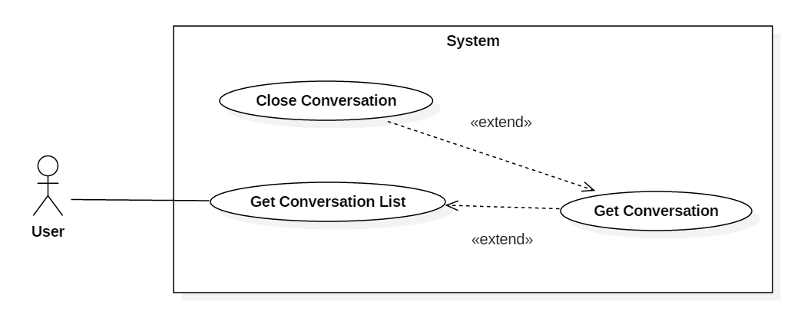

Figure 10: <User> Close Conversation (UC_HELPY31)

|  |  |  |  |
| --- | --- | --- | --- |
| **USE CASE – UC_HELPY31** | | | |
| **Use Case No.** | UC_HELPY31 | **Use Case Version** | 0.1 |
| **Use Case Name** | Close Conversation | | |
| **Author** | Lưu Nguyễn Ngọc Thư | | |
| **Date** | 09/11/2017 | **Priority** | High |
| **Actor:**   * User   **Summary:**   * This use case allows users to close the conversation.   **Goal:**   * To close the conversation.   **Triggers:**   * Actor sends the close conversation command.   **Preconditions:**   * Actor logged in as user role.   **Post conditions:**   * Success: System closes the conversation and displays the feedback of conversation. * Fail: System displays error messages.   **Main Success Scenario:**   |  |  |  | | --- | --- | --- | | ***Step*** | ***Actor Action*** | ***System Response*** | | 1 | Actor clicks "Kết thúc" button in the conversation view. |  | |  |  | [Exception no.1] [Exception no.2] System closes the conversation and displays the feedback form of conversation. |   **Alternative Scenario: *N/A***  **Exceptions:**   |  |  |  | | --- | --- | --- | | ***No*** | ***Cause*** | ***System Response*** | | 1 | Internet connection lost. | System displays an error message: “Bạn đã ngắt kết nối. Vui lòng kiểm tra lại đường truyền mạng.” | | 2 | Conversation no longer exists. | System displays an error message: “Cuộc trò chuyện bạn muốn kết thúc không tồn tại.” |   **Relationships:**   * Extend from: Get Conversation.   **Business Rules:**   * Assignee must have the expertise field match with the topic of request. | | | |

Table 12: <User> Close Conversation (UC_HELPY31)

##### **2.3.2.7 <User> Get Conversation List**

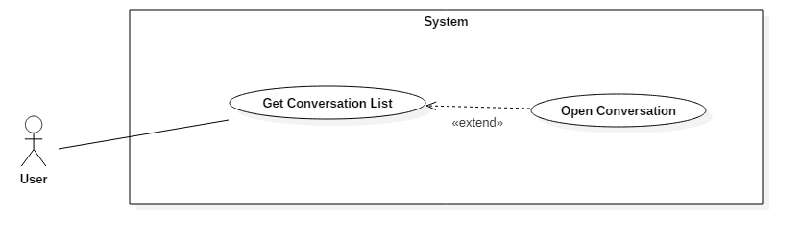

Figure 11: <User> Get Conversation List (UC_HELPY32)

|  |  |  |  |
| --- | --- | --- | --- |
| **USE CASE – UC_HELPY32** | | | |
| **Use Case No.** | **UC_HELPY32** | **Use Case Version** | 0.4 |
| **Use Case Name** | Get Conversation List | | |
| **Author** | Nguyễn Ngô Đức Khải | | |
| **Date** | 23/09/2017 | **Priority** | High |
| **Actor:**   * User   **Summary:**   * This use case allows users to get conversation list.   **Goal:**   * Views conversation list.   **Triggers:**   * Actor sends get conversation list command.   **Preconditions:**   * Actor logged in as user role.   **Post conditions:**   * Success: List of conversations that actor has been joined is displayed. * Fail: System displays error messages.   **Main Success Scenario:**   |  |  |  | | --- | --- | --- | | ***Step*** | ***Actor Action*** | ***System Response*** | | 1 | Actor opens the application. |  | |  |  | [Exception no. 1]  [Exception no. 2]  System displays list of conversations that user has been joined in the left panel. |   **Alternative Scenario: N/A**  **Exceptions:**   |  |  |  | | --- | --- | --- | | ***No*** | ***Cause*** | ***System Response*** | | 1 | Internet connection lost. | System displays an error message: “Bạn đã ngắt kết nối. Vui lòng kiểm tra lại đường truyền mạng.” | | 2 | User has not joined any conversation. | System displays no conversation at the left panel. |   **Relationships:**   * Extended by: Open conversation   **Business Rules:**   * Actor must have joined one or more conversation(s). | | | |

Table 13: <User> Get Conversation List (UC_HELPY32)

##### **2.3.2.8 <User> Give Feedback**

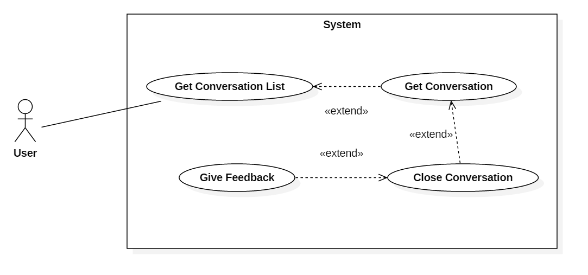

Figure 12: <User> Give Feedback (UC_HELPY33)

|  |  |  |  |
| --- | --- | --- | --- |
| **USE CASE – UC_HELPY33** | | | |
| **Use Case No.** | UC_HELPY33 | **Use Case Version** | 0.1 |
| **Use Case Name** | Give Feedback | | |
| **Author** | Lưu Nguyễn Ngọc Thư | | |
| **Date** | 09/11/2017 | **Priority** | High |
| **Actor:**   * User   **Summary:**   * This use case allows users to give feedback of the conversation.   **Goal:**   * To give feedback of the conversation.   **Triggers:**   * Actor sends the give feedback command.   **Preconditions:**   * Actor logged in as user role.   **Post conditions:**   * Success: Feedback was stored and system displays home page. * Fail: System displays error messages.   **Main Success Scenario:**   |  |  |  | | --- | --- | --- | | ***Step*** | ***Actor Action*** | ***System Response*** | | 1 | Actor clicks "Gửi" button in the feedback form after completing the conversation. |  | |  |  | [Exception no.1] [Exception no.2] System stored the feedback and displays home page. |   **Alternative Scenario: *N/A***  **Exceptions:**   |  |  |  | | --- | --- | --- | | ***No*** | ***Cause*** | ***System Response*** | | 1 | Internet connection lost. | System displays an error message: “Bạn đã ngắt kết nối. Vui lòng kiểm tra lại đường truyền mạng.” | | 2 | Feedback existed. | System displays an error message: “Cuộc trò chuyện này đã được bạn phản hồi.” |   **Relationships:**   * Extend from: Close Conversation.   **Business Rules:**   * The feedback of requester is rating the support expert. * The feedback of expert is rating the quality of conversation, such as video quality, call quality, etc. | | | |

Table 14: <User> Give Feedback (UC_HELPY33)

##### **2.3.2.9 <User> Logout**

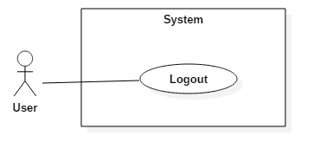

Figure 13: <User> Logout (UC_HELPY34)

|  |  |  |  |
| --- | --- | --- | --- |
| **USE CASE – UC_HELPY34** | | | |
| **Use Case No.** | UC_HELPY34 | **Use Case Version** | 0.2 |
| **Use Case Name** | Logout | | |
| **Author** | Nguyễn Ngô Đức Khải | | |
| **Date** | 09/11/2017 | **Priority** | High |
| **Actor:**   * User   **Summary:**   * This use case allows user to logout the system.   **Goal:**   * To logout the system.   **Triggers:**   * Actor sends logout command.   **Preconditions:**   * User logged in the system.   **Post conditions:**   * Success: User session is removed and system displays login page. * Fail: System displays error messages.   **Main Success Scenario:**   |  |  |  | | --- | --- | --- | | ***Step*** | ***Actor Action*** | ***System Response*** | | 1 | Actor clicks “Đăng xuất” button. |  | |  |  | [Exception no.1] User session is removed and system displays login page. |   **Alternative Scenario: *N/A***  **Exceptions:**   |  |  |  | | --- | --- | --- | | ***No*** | ***Cause*** | ***System Response*** | | 1 | Internet connection lost. | System displays an error message: “Bạn đã ngắt kết nối. Vui lòng kiểm tra lại đường truyền mạng.” |   **Relationships:** N/A  **Business Rules:**   * Actor had accessed to the system. | | | |

Table 15: <User> Logout (UC_HELPY34)

##### **2.3.2.10 <User> Get Conversation**

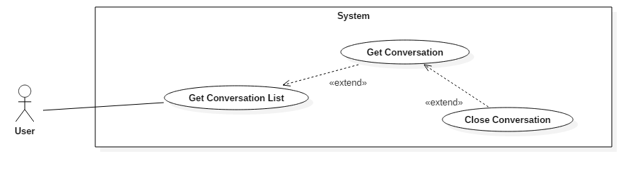

Figure 14: <User> Get Conversation (UC_HELPY35)

|  |  |  |  |
| --- | --- | --- | --- |
| **USE CASE - UC_HELPY35** | | | |
| **Use Case No.** | **UC_HELPY35** | **Use Case Version** | 0.5 |
| **Use Case Name** | Get Conversation | | |
| **Author** | Nguyễn Ngô Đức Khải | | |
| **Date** | 03/10/2017 | **Priority** | High |
| **Actor:**   * User   **Summary:**   * This use case allows users to view a specific conversation that he/she has joined.   **Goal:**   * Views a specific conversation that he/she has joined.   **Triggers:**   * Actor sends get conversation command.   **Preconditions:**   * Actor logged in as user role.   **Post conditions:**   * Success: Selected conversation is displayed. * Fail: System displays error messages.   **Main Success Scenario:**   |  |  |  | | --- | --- | --- | | ***Step*** | ***Actor Action*** | ***System Response*** | | 1 | Actor clicks a conversation title. |  | |  | [Exception no. 1]  [Exception no. 2]  System displays selected conversation in the conversation view with all messages has been sent. |   **Alternative Scenario: N/A**  **Exceptions:**   |  |  |  | | --- | --- | --- | | ***No*** | ***Cause*** | ***System Response*** | | 1 | Internet connection lost. | System displays an error message: “Bạn đã ngắt kết nối. Vui lòng kiểm tra lại đường truyền mạng.” | | 2 | Conversation no longer exists. | System displays an error message: “Cuộc trò chuyện đã kết thúc.” |   **Relationships:**   * Extend from: Get Conversation List. * Extended by: Close Conversation.   **Business Rules:**   * Actor must be a participant of the selected conversation. | | | |

Table 16: <User> Get Conversation (UC_HELPY35)

##### **2.3.2.11 <User> Update Profile**

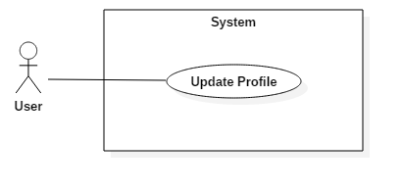

Figure 15: <User> Update Profile (UC_HELPY36)

|  |  |  |  |
| --- | --- | --- | --- |
| **USE CASE – UC_HELPY36** | | | |
| **Use Case No.** | UC_HELPY36 | **Use Case Version** | 0.2 |
| **Use Case Name** | Update Profile | | |
| **Author** | Nguyễn Ngô Đức Khải | | |
| **Date** | 09/11/2017 | **Priority** | High |
| **Actor:**   * User   **Summary:**   * This use case allows user to update his/her profile.   **Goal:**   * To update the profile.   **Triggers:**   * User sends update profile command.   **Preconditions:**   * Actor logged in as user role.   **Post conditions:**   * Success: Account is updated successfully, and system displays the user profile page. * Fail: System displays error messages.   **Main Success Scenario:**   |  |  |  | | --- | --- | --- | | ***Step*** | ***Actor Action*** | ***System Response*** | | 1 | Actor clicks “Cập nhật” button in the update profile form.  [Alternative no.1] |  | |  |  | [Exception no.1]  [Exception no.2] | |  |  | Account is updated successfully and system displays the user profile page. |   **Alternative Scenario:**   |  |  |  | | --- | --- | --- | | ***Step*** | ***Actor Action*** | ***System Response*** | | 1 | Actor does not fill the required information. |  | |  |  | System displays message: “Xin vui lòng điền các thông tin bắt buộc.” |   **Exceptions:**   |  |  |  | | --- | --- | --- | | ***No*** | ***Cause*** | ***System Response*** | | 1 | Internet connection lost. | System displays an error message: “Bạn đã ngắt kết nối. Vui lòng kiểm tra lại đường truyền mạng.” | | 2 | Guest input already exist email. | System shows warning message “Email đã tổn tại.” |     **Relationships:** N/A  **Business Rules:**   * Fistname is not null and maximum of 45 characters. * Lastname is not null and maximum of 45 characters. * Password must be at least 6 characters. * Email pattern should be: **[^[_A-Za-z0-9-\\+]+(\\.[_A-Za-z0-9-]+)*@"+"[A-Za-z0-9-]+(\\.[A-Za-z0-9]+)*(\\.[A-Za-z]{2,})$]** (following RFC 5322 standard). * Id number should be from 9 to 12 digits. * Tax number should be 10 digits. | | | |

Table 17: <User> Update Profile (UC_HELPY36)

#### **2.3.3 <Expert> Overview Use Case**

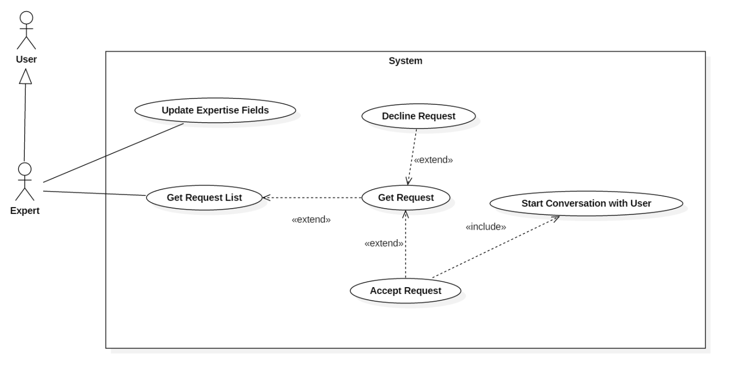

Figure 16: <Expert> Overview Use Case

##### **2.3.3.1 <Expert> Accept Request**

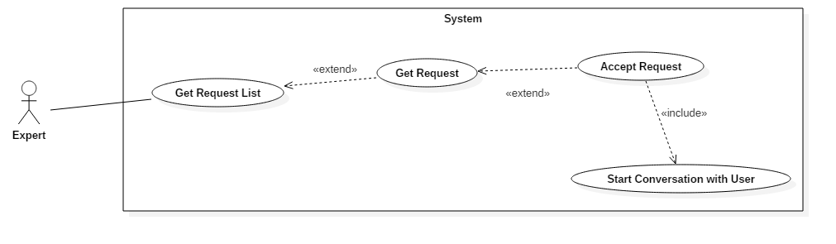

Figure 17: <Expert> Accept Request (UC_HELPY06)

|  |  |  |  |
| --- | --- | --- | --- |
| **USE CASE – UC_HELPY06** | | | |
| **Use Case No.** | UC_HELPY06 | **Use Case Version** | 0.3 |
| **Use Case Name** | Accept Request | | |
| **Author** | Lưu Nguyễn Ngọc Thư | | |
| **Date** | 23/09/2017 | **Priority** | High |
| **Actor:**   * Expert   **Summary:**   * This use case allows experts to accept a specific pending request for help of a user.   **Goal:**   * Start a conversation between expert and requester (actor who logged in as user role).   **Triggers:**   * Actor sends accept request command.   **Preconditions:**   * Actor logged in as expert role.   **Post conditions:**   * Success: a conversation between the assignee (expert) of request and the requester (user) view is displayed. * Fail: System displays error messages.   **Main Success Scenario:**   |  |  |  | | --- | --- | --- | | ***Step*** | ***Actor Action*** | ***System Response*** | | 1 | Actor clicks “Đồng ý giúp đỡ” button at the view of request information page. |  | |  |  | [Exception no. 1]  System starts new conversation between two participants:   * The requester: the user who create the request * The expert: who was assigned to requester’s request. | | 2 | Actor does start a conversation between him/her and the requester by doing actions of abstract use case “<User> Converse”. |  |   **Alternative Scenario: N/A**  **Exceptions:**   |  |  |  | | --- | --- | --- | | ***No.*** | ***Cause*** | ***System Response*** | | 1 | Internet connection lost. | System displays an error message: “Bạn đã ngắt kết nối. Vui lòng kiểm tra lại đường truyền mạng.” |   **Relationships:**   * Extend from: Get Request. * Include: Start conversation with User.   **Business Rules:**   * Topic of request must match with the expertise field of expert. * Accept request priority is given to the experts who do not have any ongoing conversations. | | | |

Table 18: <Expert> Accept Request (UC_HELPY06)

##### **2.3.3.2 <Expert> Decline Request**

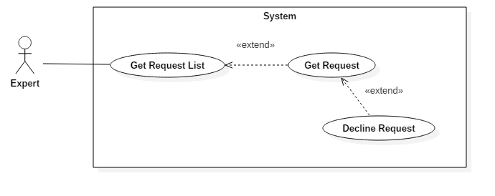

Figure 18: <Expert> Decline Request (UC_HELPY07)

|  |  |  |  |
| --- | --- | --- | --- |
| **USE CASE – UC_HELPY07** | | | |
| **Use Case No.** | UC_HELPY07 | **Use Case Version** | 0.2 |
| **Use Case Name** | Decline Request | | |
| **Author** | Lưu Nguyễn Ngọc Thư | | |
| **Date** | 09/13/2017 | **Priority** | High |
| **Actor:**   * Expert   **Summary:**   * This use case allows expert to decline request.   **Goal:**   * To decline request.   **Triggers:**   * Actor sends decline request command.   **Preconditions:**   * Actor logged in as expert role.   **Post conditions:**   * Success: Updated requests list is displayed. * Fail: System displays error messages.   **Main Success Scenario:**   |  |  |  | | --- | --- | --- | | ***Step*** | ***Actor Action*** | ***System Response*** | | 1 | Actor clicks “Từ chối” button of a request item in the list of requests page. |  | |  |  | [Exception no.1]  [Exception no.2] System shows confirm popup box. | | 2 | [Alternative no.1]  Actor clicks “Đồng ý” button in the confirm popup box. |  | |  |  | [Exception no.1]  [Exception no.2]  System displays updated requests list. |   **Alternative Scenario:**   |  |  |  | | --- | --- | --- | | ***No*** | ***Actor Action*** | ***System Response*** | | 1 | Actor clicks “Hủy” button in the confirm popup box. |  | |  |  | System closes the confirm popup box. |   **Exceptions:**   |  |  |  | | --- | --- | --- | | ***No*** | ***Cause*** | ***System Response*** | | 1 | Internet connection lost. | System displays an error message: “Bạn đã ngắt kết nối. Vui lòng kiểm tra lại đường truyền mạng.” | | 2 | Request no longer exists. | System displays an error message: “Yêu cầu bạn từ chối không tồn tại.” |   **Relationships:**   * Extend from: Get Request.   **Business Rules:**   * Topic of request must match with the expertise field of expert. | | | |

Table 19: <Expert> Decline Request (UC_HELPY07)

##### **2.3.3.3 <Expert> Get Request**

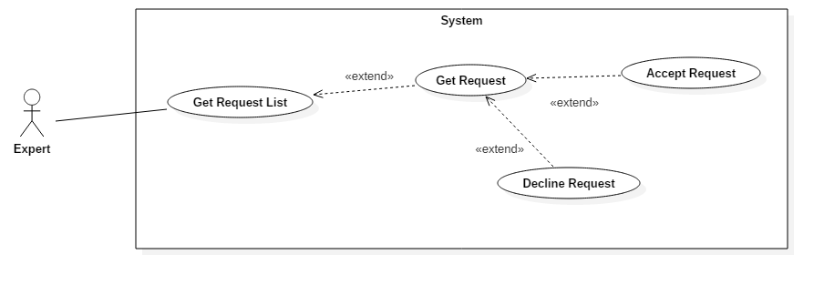

Figure 19: <Expert> Get Request (UC_HELPY08)

|  |  |  |  |
| --- | --- | --- | --- |
| **USE CASE – UC_HELPY08** | | | |
| **Use Case No.** | UC_HELPY08 | **Use Case Version** | 0.3 |
| **Use Case Name** | Get Request | | |
| **Author** | Nguyễn Ngô Đức Khải | | |
| **Date** | 23/09/2017 | **Priority** | High |
| **Actor:**   * Expert   **Summary:**   * This use case allows experts to view detail of a pending request which assigned to him/her.   **Goal:**   * View detail information of a specific pending request which assigned to actor.   **Triggers:**   * Actor sends get request command.   **Preconditions:**   * Actor logged in as expert role.   **Post conditions:**   * Success: Detail information of selected pending request (which assigned to actor) is displayed. * Fail: System displays error messages.   **Main Success Scenario:**   |  |  |  | | --- | --- | --- | | ***Step*** | ***Actor Action*** | ***System Response*** | | 1 | Actor clicks on request item in the list of pending requests view. |  | |  |  | [Exception no. 1]  [Exception no. 2]  System displays the request’s detail including following information:   * Requester name * Expertise Field Name * Description for the problem   System also displays two buttons: “Đồng ý gúp đỡ” and “Từ chối”. |   **Alternative Scenario: N/A**  **Exceptions:**   |  |  |  | | --- | --- | --- | | ***No.*** | ***Cause*** | ***System Response*** | | 1 | Internet connection lost. | System displays an error message: “Bạn đã ngắt kết nối. Vui lòng kiểm tra lại đường truyền mạng.” | | 2 | Actor sends a “get request command” which’s request no longer exists in database. | System displays an error message: “Trang bạn yêu cầu không tồn tại.” |   **Relationships:**   * Extend from: Get Request List * Extended by: Accept Request * Extended by: Decline Request   **Business Rules:**   * Request information must be validated. * Request has not been accepted by the expert yet (Pending request). * Topic of request must match with the expertise field of expert. | | | |

Table 20: <Expert> Get Request (UC_HELPY08)

##### **2.3.3.4 <Expert> Get Request List**

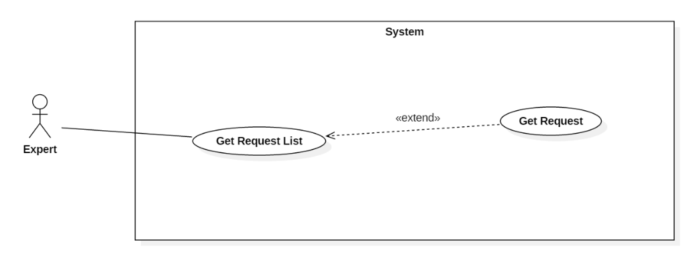

Figure 20: <Expert> Get Request List (UC_HELPY09)

|  |  |  |  |
| --- | --- | --- | --- |
| **USE CASE – UC_HELPY09** | | | |
| **Use Case No.** | UC_HELPY09 | **Use Case Version** | 0.3 |
| **Use Case Name** | Get Request List | | |
| **Author** | Nguyễn Ngô Đức Khải | | |
| **Date** | 23/09/2017 | **Priority** | High |
| **Actor:**   * Expert   **Summary:**   * This use case allows experts to view his/her pending request list.   **Goal:**   * To view list of pending requests.   **Triggers:**   * Actor sends get request list command.   **Preconditions:**   * Actor logged in as expert role.   **Post conditions:**   * Success: List of pending requests assigned to actor is displayed. * Fail: The system displays error messages.   **Main Success Scenario:**   |  |  |  | | --- | --- | --- | | ***Step*** | ***Actor Action*** | ***System Response*** | | 1 | Actor clicks on “Danh sách yêu cầu giúp đỡ”. |  | |  |  | [Exception no.1]  [Exception no.2]  System displays list of all pending requests that are assigned to actor. |   **Alternative Scenario:**N/A  **Exceptions:**   |  |  |  | | --- | --- | --- | | ***No.*** | ***Cause*** | ***System Response*** | | 1 | The Internet connection is lost. | System displays error message: “Bạn đã ngắt kết nối. Vui lòng kiểm tra lại đường truyền mạng.” | | 2 | Actor is not being assigned to any pending request. | System displays error message: “Bạn chưa nhận được yêu cầu nào.” |   **Relationships:**   * Extended by: Get Request   **Business Rules:**   * Pending requests are sorted by date in descending order. * Listed requests have not been accepted by the expert yet (Pending requests). * Request information must be validated. * Topic of request must match with the expertise field of expert. | | | |

Table 21: <Expert> Get Request List (UC_HELPY09)

##### **2.3.3.5 <Expert> Update Expertise Field**

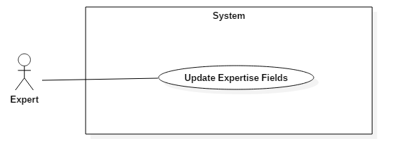

Figure 21: <Expert> Update Expertise Fields (UC_HELPY11)

|  |  |  |  |
| --- | --- | --- | --- |
| **USE CASE – UC_HELPY11** | | | |
| **Use Case No.** | UC_HELPY11 | **Use Case Version** | 0.1 |
| **Use Case Name** | Update Expertise Fields | | |
| **Author** | Nguyễn Viết Công Hậu | | |
| **Date** | 27/10/2017 | **Priority** | High |
| **Actor:**   * Expert   **Summary:**   * This use case allows expert to update expert information.   **Goal:**   * To update expert information.   **Triggers:**   * Expert sends update expert information command.   **Preconditions:**   * Actor logged in as expert role.   **Post conditions:**   * Success: Expert information is updated. * Fail: System displays error messages.   **Main Success Scenario:**   |  |  |  | | --- | --- | --- | | ***Step*** | ***Actor Action*** | ***System Response*** | | 1 | Actor clicks “Cập nhật” button in update expertise field form.  [Alternative no.1] |  | |  |  | [Exception no.1]  System updates the expert information of the user. |   **Alternative Scenario:**   |  |  |  | | --- | --- | --- | | ***No*** | ***Actor Action*** | ***System Response*** | | 1 | Actor does not fill the required information. |  | |  |  | System displays message: “Xin vui lòng điền các thông tin bắt buộc.” |   **Exceptions:**   |  |  |  | | --- | --- | --- | | ***No*** | ***Cause*** | ***System Response*** | | 1 | Internet connection lost. | System displays an error message: “Bạn đã ngắt kết nối. Vui lòng kiểm tra lại đường truyền mạng.” |   **Relationships:** N/A  **Business Rules:**   * Each expert has at least 1 expertise field, and at most 5 expertise fields. * The expert information is required. | | | |

Table 22: <Expert> Update Expertise Fields (UC_HELPY11)

#### **2.3.4 <Staff> Overview Use Case**

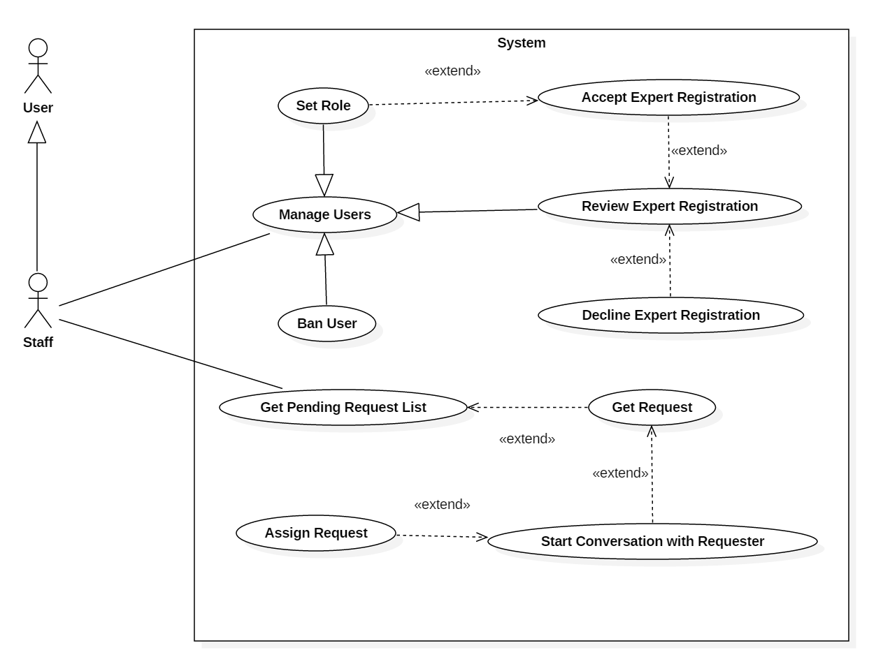

Figure 22: <Staff> Overview Use Case

##### **2.3.4.1 <Staff> Ban User**

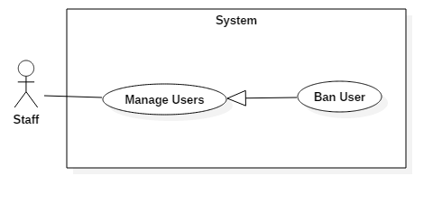

Figure 23: <Staff> Ban User (UC_HELPY14)

|  |  |  |  |
| --- | --- | --- | --- |
| **USE CASE – UC_HELPY14** | | | |
| **Use Case No.** | UC_HELPY14 | **Use Case Version** | 0.4 |
| **Use Case Name** | Ban User | | |
| **Author** | Lưu Nguyễn Ngọc Thư | | |
| **Date** | 09/11/2017 | **Priority** | High |
| **Actor:**   * Staff   **Summary:**   * This use case allows staff to ban user.   **Goal:**   * To remove users from system.   **Triggers:**   * Actor sends ban user command.   **Preconditions:**   * Actor logged in as staff role.   **Post conditions:**   * Success: User is deleted from system and updated users list is displayed. * Fail: System displays error messages.   **Main Success Scenario:**   |  |  |  | | --- | --- | --- | | ***Step*** | ***Actor Action*** | ***System Response*** | | 1 | Actor clicks “Khóa tài khoản” button of a user item in the list of users or from the user information page. |  | |  |  | [Exception no.1] [Exception no.2] User is deleted from system and updated users list is displayed. |   **Alternative Scenario: *N/A***  **Exceptions:**   |  |  |  | | --- | --- | --- | | ***No*** | ***Cause*** | ***System Response*** | | 1 | Internet connection lost. | System displays an error message: “Bạn đã ngắt kết nối. Vui lòng kiểm tra lại đường truyền mạng.” | | 2 | User no longer exists. | System displays an error message: “Người dùng không tồn tại.” |   **Relationships:**   * Abstract use case: Manager Users.   **Business Rules:**   * The user who also has staff role just can be banned by admin. | | | |

Table 23: <Staff> Ban User (UC_HELPY14)

##### **2.3.4.2 <Staff> Review Expert Registration**

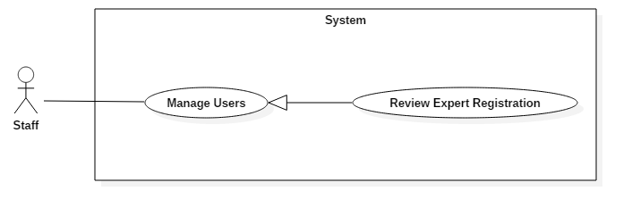

Figure 24: <Staff> Review Expert Registration (UC_HELPY15)

|  |  |  |  |
| --- | --- | --- | --- |
| **USE CASE – UC_HELPY15** | | | |
| **Use Case No.** | UC_HELPY15 | **Use Case Version** | 0.2 |
| **Use Case Name** | Review Expert Registration | | |
| **Author** | Nguyễn Ngô Đức Khải | | |
| **Date** | 09/11/2017 | **Priority** | High |
| **Actor:**   * Staff   **Summary:**   * This use case allows staff to review expert registration.   **Goal:**   * To review expert registration.   **Triggers:**   * Actor sends review expert registration command.   **Preconditions:**   * Actor logged in as staff role.   **Post conditions:**   * Success: Expert registration lists is displayed. * Fail: System displays error messages.   **Main Success Scenario:**   |  |  |  | | --- | --- | --- | | ***Step*** | ***Actor Action*** | ***System Response*** | | 1 | Actor clicks “Danh sách đăng ký chuyên gia” link in the menu. |  | |  |  | [Exception no.1] System displays the expert registrations list including following information:   * Username * Expert field * Role   System also displays two buttons: “Chấp nhận” and “Từ chối” |   **Alternative Scenario: *N/A***  **Exceptions:**   |  |  |  | | --- | --- | --- | | ***No*** | ***Cause*** | ***System Response*** | | 1 | Internet connection lost. | System displays an error message: “Bạn đã ngắt kết nối. Vui lòng kiểm tra lại đường truyền mạng.” |   **Relationships:**   * Abstract use case: Manager Users.   **Business Rules:**   * The expert information is required. * Expert registration has at least 1 expertise field, and at most 5 expertise fields. * The user sends the expert registration must have role as user. | | | |

Table 24: <Staff> Review Expert Registration (UC_HELPY15)

##### **2.3.4.3 <Staff> Set Role**

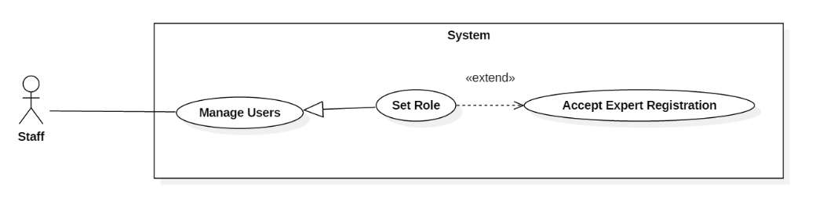

Figure 25: <Staff> Set Role (UC_HELPY16)

|  |  |  |  |
| --- | --- | --- | --- |
| **USE CASE – UC_HELPY16** | | | |
| **Use Case No.** | UC_HELPY16 | **Use Case Version** | 0.1 |
| **Use Case Name** | Set Role | | |
| **Author** | Lưu Nguyễn Ngọc Thư | | |
| **Date** | 25/10/2017 | **Priority** | High |
| **Actor:**   * Staff   **Summary:**   * This use case allows users to set role of other users.   **Goal:**   * To set role of other users.   **Triggers:**   * Actor sends the set role command.   **Preconditions:**   * Actor logged in as staff role.   **Post conditions:**   * Success: Updated user information page is displayed. * Fail: System displays error messages.   **Main Success Scenario:**   |  |  |  | | --- | --- | --- | | ***Step*** | ***Actor Action*** | ***System Response*** | | 1 | Actor clicks “Cập nhật phân quyền” button on user information page. |  | |  |  | [Exception no.1] [Exception no.2] System displays updated user information page that are updated role. |   **Alternative Scenario: *N/A***  **Exceptions:**   |  |  |  | | --- | --- | --- | | ***No*** | ***Cause*** | ***System Response*** | | 1 | Internet connection lost. | System displays an error message: “Bạn đã ngắt kết nối. Vui lòng kiểm tra lại đường truyền mạng.” | | 2 | User no longer exists. | System displays an error message: “Người dùng không tồn tại.” |   **Relationships:**   * Abstract use case: Manage Users. * Extend from: Accept Expert Registration.   **Business Rules:**   * The selected account is set to expert role if he/she is user, or user role if he/she is expert. * In case the selected account is set from expert role to user role, his/her expert information should not be removed. * In case the selected account is set from user role to expert role, his/her expert information is required. | | | |

Table 25: <Staff> Set Role (UC_HELPY16)

##### **2.3.4.4 <Staff> Accept Expert Registration**

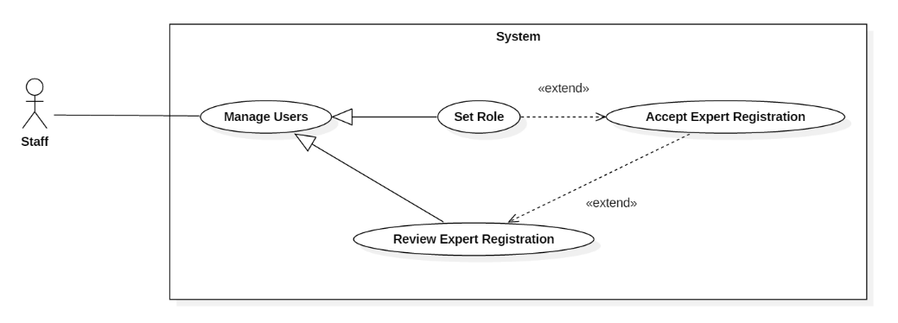

Figure 26: <Staff> Accept Expert Registration (UC_HELPY17)

|  |  |  |  |
| --- | --- | --- | --- |
| **USE CASE – UC_HELPY17** | | | |
| **Use Case No.** | UC_HELPY17 | **Use Case Version** | 0.1 |
| **Use Case Name** | Accept Expert Registration | | |
| **Author** | Lưu Nguyễn Ngọc Thư | | |
| **Date** | 25/10/2017 | **Priority** | High |
| **Actor:**   * Staff   **Summary:**   * This use case allows users to accept expert registration of other users.   **Goal:**   * To accept expert registration of other users.   **Triggers:**   * Actor sends the accept expert registration command.   **Preconditions:**   * Actor logged in as staff role.   **Post conditions:**   * Success: Updated user information page is displayed. * Fail: System displays error messages.   **Main Success Scenario:**   |  |  |  | | --- | --- | --- | | ***Step*** | ***Actor Action*** | ***System Response*** | | 1 | Actor clicks “Xác nhận” button of an expert registration item in the list of expert registrations or from the expert registration information page. |  | |  |  | [Exception no.1] [Exception no.2] [Exception no.3] System displays accepted user information page that are updated role and expertise field. |   **Alternative Scenario: *N/A***  **Exceptions:**   |  |  |  | | --- | --- | --- | | ***No*** | ***Cause*** | ***System Response*** | | 1 | Internet connection lost. | System displays an error message: “Bạn đã ngắt kết nối. Vui lòng kiểm tra lại đường truyền mạng.” | | 2 | Expert registration no longer exists. | System displays an error message: “Đơn đăng ký chuyên gia không tồn tại.” | | 3 | Register no longer exists. | System displays an error message: “Người dùng không tồn tại.” |   **Relationships:**   * Extended by: Set Role. * Extend from: Review Expert Registration.   **Business Rules:**   * The expert information is required. * The expertise information should have at least 1, and at most 5 expertise fields. | | | |

Table 26: <Staff> Accept Expert Registration (UC_HELPY17)

##### **2.3.4.5 <Staff> Assign Request**

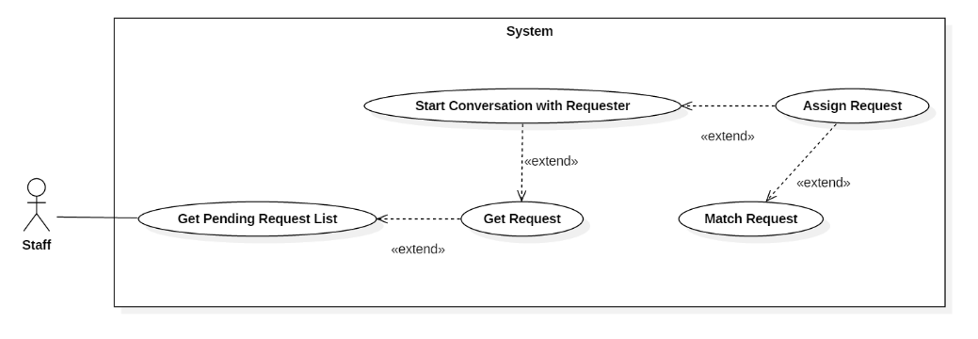

Figure 27: <Staff> Assign Request (UC_HELPY18)

|  |  |  |  |
| --- | --- | --- | --- |
| **USE CASE – UC_HELPY18** | | | |
| **Use Case No.** | UC_HELPY18 | **Use Case Version** | 0.1 |
| **Use Case Name** | Assign Request | | |
| **Author** | Lưu Nguyễn Ngọc Thư | | |
| **Date** | 25/10/2017 | **Priority** | High |
| **Actor:**   * Staff   **Summary:**   * This use case allows users to assign request for other users.   **Goal:**   * To assign request for other users.   **Triggers:**   * Actor sends the assign request command.   **Preconditions:**   * Actor logged in as staff role.   **Post conditions:**   * Success: Updated request information page is displayed. * Fail: System displays error messages.   **Main Success Scenario:**   |  |  |  | | --- | --- | --- | | ***Step*** | ***Actor Action*** | ***System Response*** | | 1 | Actor clicks “Ủy quyền” button from experts list on request information page. |  | |  |  | [Exception no.1] [Exception no.2] [Exception no.3] System displays updated request information page that are updated the assignee. |   **Alternative Scenario: *N/A***  **Exceptions:**   |  |  |  | | --- | --- | --- | | ***No*** | ***Cause*** | ***System Response*** | | 1 | Internet connection lost. | System displays an error message: “Bạn đã ngắt kết nối. Vui lòng kiểm tra lại đường truyền mạng.” | | 2 | Expert no longer exists. | System displays an error message: “Chuyên gia không tồn tại.” | | 3 | Request no longer exists. | System displays an error message: “Yêu cầu không tồn tại.” |   **Relationships:**   * Extend from: Start Conversation with Requester. * Extend from: Match Request.   **Business Rules:**   * Topic of request must match with the expertise field of expert. * Accept request priority is given to the experts who do not have any ongoing conversations. | | | |

Table 27: <Staff> Assign Request (UC_HELPY18)

##### **2.3.4.6 <Staff> Decline Expert Registration**

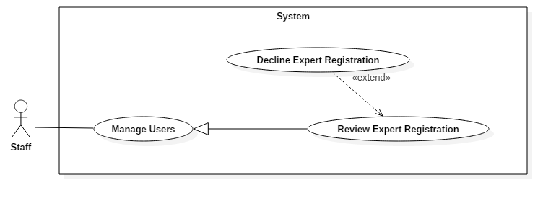

Figure 28: <Staff> Decline Expert Registration (UC_HELPY19)

|  |  |  |  |
| --- | --- | --- | --- |
| **USE CASE – UC_HELPY19** | | | |
| **Use Case No.** | UC_HELPY19 | **Use Case Version** | 0.2 |
| **Use Case Name** | Decline Expert Registration | | |
| **Author** | Lưu Nguyễn Ngọc Thư | | |
| **Date** | 09/11/2017 | **Priority** | High |
| **Actor:**   * Staff   **Summary:**   * This use case allows staff to decline expert registration of other users.   **Goal:**   * To decline expert registration of other users.   **Triggers:**   * Actor sends request decline registration command.   **Preconditions:**   * Actor logged in as staff role.   **Post conditions:**   * Success: Updated expert registration list is displayed. * Fail: System displays error messages.   **Main Success Scenario:**   |  |  |  | | --- | --- | --- | | ***Step*** | ***Actor Action*** | ***System Response*** | | 1 | Actor clicks “Từ chối” button of an expert registration item in the list of expert registrations or from the expert registration information page. |  | |  |  | [Exception no.1]  [Exception no.2]  [Exception no.3] System displays the updated expert registrations list. |   **Alternative Scenario: *N/A***  **Exceptions:**   |  |  |  | | --- | --- | --- | | ***No*** | ***Cause*** | ***System Response*** | | 1 | Internet connection lost. | System displays an error message: “Bạn đã ngắt kết nối. Vui lòng kiểm tra lại đường truyền mạng.” | | 2 | User no longer exists. | System displays an error message: “Người dùng không tồn tại.” | | 3 | Expert registration no longer exists. | System displays an error message: “Đơn đăng ký chuyên gia không tồn tại.” |   **Relationships:**   * Extend from: Review Expert Registration.   **Business Rules:**   * The expert information is required. * The expertise information should have at least 1, and at most 5 expertise fields. | | | |

Table 28: <Staff> Decline Expert Registration (UC_HELPY19)

##### **2.3.4.7 <Staff> Get Pending Request List**

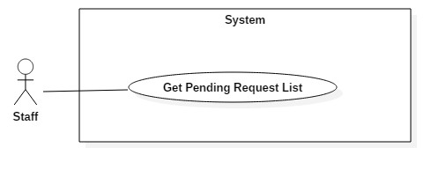

Figure 29: <Staff> Get Pending Request List (UC_HELPY20)

|  |  |  |  |
| --- | --- | --- | --- |
| **USE CASE – UC_HELPY20** | | | |
| **Use Case No.** | UC_HELPY20 | **Use Case Version** | 0.2 |
| **Use Case Name** | Get Pending Request List | | |
| **Author** | Nguyễn Ngô Đức Khải | | |
| **Date** | 09/11/2017 | **Priority** | High |
| **Actor:**   * Staff   **Summary:**   * This use case allows staff to get pending requests list.   **Goal:**   * To get pending requests list.   **Triggers:**   * Actor sends get pending request list command.   **Preconditions:**   * Actor logged in as staff role.   **Post conditions:**   * Success: Updated pending requests list is displayed. * Fail: System displays error messages.   **Main Success Scenario:**   |  |  |  | | --- | --- | --- | | ***Step*** | ***Actor Action*** | ***System Response*** | | 1 | Actor clicks “Danh sách yêu cầu chưa giải quyết'” link in the menu. |  | |  |  | [Exception no.1] Should change to:  System displays pending requests list including following information:   * Requester * Topic * Assignee * Date created   System also displays two buttons: “Assign” and “Decline”. |   **Alternative Scenario: *N/A***  **Exceptions:**   |  |  |  | | --- | --- | --- | | ***No*** | ***Cause*** | ***System Response*** | | 1 | Internet connection lost. | System displays an error message: “Bạn đã ngắt kết nối. Vui lòng kiểm tra lại đường truyền mạng.” |   **Relationships:** N/A  **Business Rules:**   * Listed requests have not been accepted by the expert yet (Pending requests). | | | |

Table 29: <Staff> Get Pending Request List (UC_HELPY20)

##### **2.3.4.8 <Staff> Get Request**

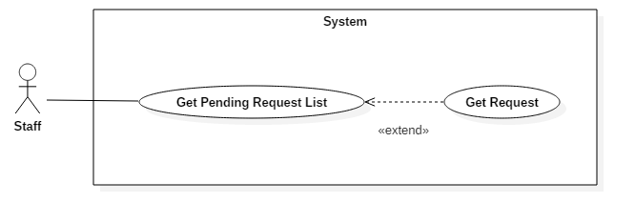

Figure 30: <Staff> Get Request (UC_HELPY21)

|  |  |  |  |
| --- | --- | --- | --- |
| **USE CASE – UC_HELPY21** | | | |
| **Use Case No.** | UC_HELPY21 | **Use Case Version** | 0.2 |
| **Use Case Name** | Get Request | | |
| **Author** | Nguyễn Ngô Đức Khải | | |
| **Date** | 09/11/2017 | **Priority** | High |
| **Actor:**   * Staff   **Summary:**   * This use case allows staff to get request information.   **Goal:**   * To get request information.   **Triggers:**   * Actor sends get request command.   **Preconditions:**   * Actor logged in as staff role.   **Post conditions:**   * Success: Request information is displayed. * Fail: System displays error messages.   **Main Success Scenario:**   |  |  |  | | --- | --- | --- | | ***Step*** | ***Actor Action*** | ***System Response*** | | 1 | Actor clicks on request name in the list of requests. |  | |  |  | [Exception no.1]  [Exception no.2]  Should change to: System displays information of selected request, including following information:   * Requester * Assignee * Topic * Status * Date created   System also displays two buttons “Assign” and “Decline” in case the selected request is pending. |   **Alternative Scenario: *N/A***  **Exceptions:**   |  |  |  | | --- | --- | --- | | ***No*** | ***Cause*** | ***System Response*** | | 1 | Internet connection lost. | System displays an error message: “Bạn đã ngắt kết nối. Vui lòng kiểm tra lại đường truyền mạng.” | | 2 | Request no longer exists. | System displays an error message: “Yêu cầu không tồn tại.” |   **Relationships:**   * Extend from: Get Pending Request List.   **Business Rules:**   * The request information must be validated. | | | |

Table 30: <Staff> Get Request (UC_HELPY21)

##### **2.3.4.9 <Staff> Start Conversation with Requester**

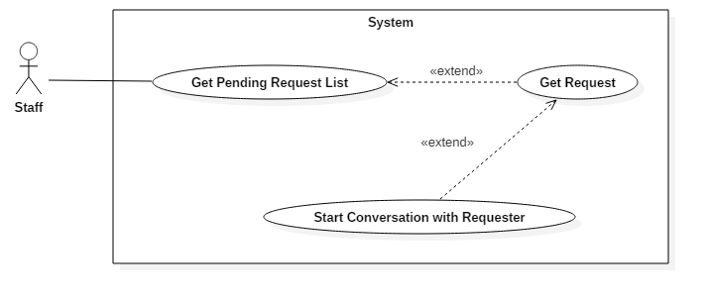

Figure 31: <Staff> Start Conversation with Requester (UC_HELPY22)

|  |  |  |  |
| --- | --- | --- | --- |
| **USE CASE – UC_HELPY22** | | | |
| **Use Case No.** | UC_HELPY22 | **Use Case Version** | 0.1 |
| **Use Case Name** | Start Conversation with Requester | | |
| **Author** | Nguyễn Viết Công Hậu | | |
| **Date** | 09/11/2017 | **Priority** | High |
| **Actor:**   * Staff   **Summary:**   * This use case allows staff to start conversation with requester.   **Goal:**   * To start conversation with requester.   **Triggers:**   * Actor sends start conversation with requester command.   **Preconditions:**   * Actor logged in as staff role.   **Post conditions:**   * Success: Conversation view between actor and requester is displayed. * Fail: System displays error messages.   **Main Success Scenario:**   |  |  |  | | --- | --- | --- | | ***Step*** | ***Actor Action*** | ***System Response*** | | 1 | Actor clicks “Chat” button in request information page. |  | |  |  | [Exception no.1]  [Exception no.2] [Exception no.3] Conversation view between actor and requester is displayed. |   **Alternative Scenario: *N/A***  **Exceptions:**   |  |  |  | | --- | --- | --- | | ***No*** | ***Cause*** | ***System Response*** | | 1 | Internet connection lost. | System displays an error message: “Bạn đã ngắt kết nối. Vui lòng kiểm tra lại đường truyền mạng.” | | 2 | User no longer exists. | System displays an error message: “Người dùng không tồn tại.” | | 3 | Request no longer exists. | System displays an error message: “Yêu cầu không tồn tại.” |   **Relationships:**   * Extend from: Get Request.   **Business Rules:** N/A | | | |

Table 31: <Staff> Start Conversation with Requester (UC_HELPY22)

#### **2.3.5 <Admin> Overview Use Case**

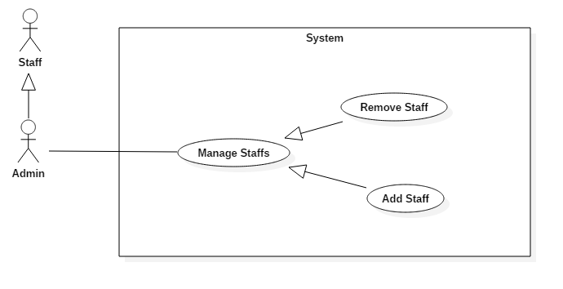

Figure 32: <Admin> Overview Use Case

##### **2.3.5.1 <Admin> Add Staff**

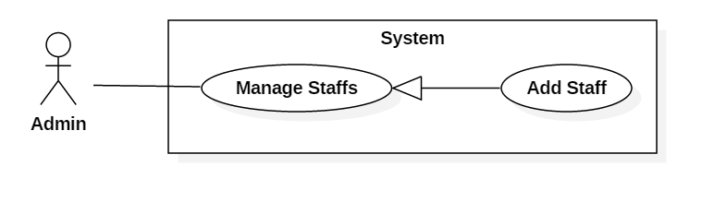

Figure 33: <Admin> Add Staff (UC_HELPY01)

|  |  |  |  |
| --- | --- | --- | --- |
| **USE CASE – UC_HELPY01** | | | |
| **Use Case No.** | UC_HELPY01 | **Use Case Version** | 0.2 |
| **Use Case Name** | Add Staff | | |
| **Author** | Lưu Nguyễn Ngọc Thư | | |
| **Date** | 09/11/2017 | **Priority** | High |
| **Actor:**   * Admin   **Summary:**   * This use case allows users to add staff.   **Goal:**   * To add staff.   **Triggers:**   * Actor sends the add staff command.   **Preconditions:**   * Actor logged in as admin role.   **Post conditions:**   * Success: System adds role staff to the selected user and displays updated staffs list. * Fail: System displays error messages.   **Main Success Scenario:**   |  |  |  | | --- | --- | --- | | ***Step*** | ***Actor Action*** | ***System Response*** | | 1 | Actor clicks “Cập nhật phân quyền” button in the users list of admin page. |  | |  |  | [Exception no.1]  [Exception no.2]  [Exception no.3] System adds role staff to the selected user and displays updated staffs list. |   **Alternative Scenario: *N/A***  **Exceptions:**   |  |  |  | | --- | --- | --- | | ***No*** | ***Cause*** | ***System Response*** | | 1 | Internet connection lost. | System displays an error message: “Bạn đã ngắt kết nối. Vui lòng kiểm tra lại đường truyền mạng.” | | 2 | Staff existed. | System displays an error message: “Người dùng đã là Hỗ trợ viên.” | | 3 | User no longer exists. | System displays an error message: “Người dùng không tồn tại.” |   **Relationships:**   * Abstract use case: Manage Staffs.   **Business Rules:**   * The account which is set staff role is not staff at the loading time. | | | |

Table 32: <Admin> Add Staff (UC_HELPY01)

##### **2.3.5.2 <Admin> Remove Staff**

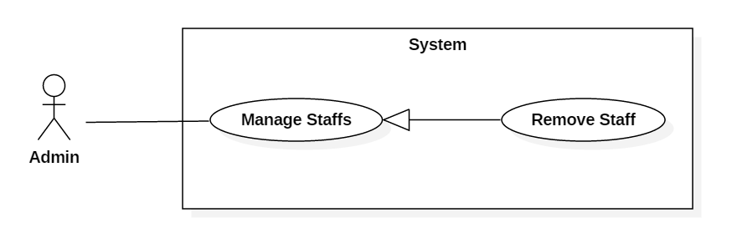

Figure 34: <Admin> Remove Staff (UC_HELPY03)

|  |  |  |  |
| --- | --- | --- | --- |
| **USE CASE – UC_HELPY03** | | | |
| **Use Case No.** | UC_HELPY03 | **Use Case Version** | 0.1 |
| **Use Case Name** | Remove Staff | | |
| **Author** | Lưu Nguyễn Ngọc Thư | | |
| **Date** | 10/11/2017 | **Priority** | High |
| **Actor:**   * Admin   **Summary:**   * This use case allows users to remove staff.   **Goal:**   * To remove staff.   **Triggers:**   * Actor sends the remove staff command.   **Preconditions:**   * Actor logged in as admin role.   **Post conditions:**   * Success: System removes staff successfully and displays updated staffs list. * Fail: System displays error messages.   **Main Success Scenario:**   |  |  |  | | --- | --- | --- | | ***Step*** | ***Actor Action*** | ***System Response*** | | 1 | Actor clicks on “Khóa tài khoản” button in the staffs list of admin page. |  | |  |  | [Exception no.1] [Exception no.2] System removes role staff of the selected user and displays updated staffs list. |   **Alternative Scenario: *N/A***  **Exceptions:**   |  |  |  | | --- | --- | --- | | ***No*** | ***Cause*** | ***System Response*** | | 1 | Internet connection lost. | System displays an error message: “Bạn đã ngắt kết nối. Vui lòng kiểm tra lại đường truyền mạng.” | | 2 | Staff no longer exists. | System displays an error message: “Hỗ trợ viên không tồn tại.” |   **Relationships:**   * Abstract use case: Manage Staffs.   **Business Rules:**   * The account which is removed staff role is not staff at the loading time. | | | |

Table 33: <Admin> Remove Staff (UC_HELPY03)

#### **2.3.6 <System> Overview Use Case**

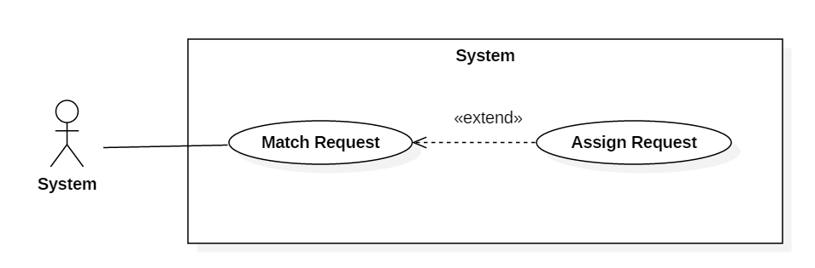

Figure 35: <System> Overview Use Case

##### 2.3.6.1 <System> Assign Request



Figure 36: <System> Assign Request (UC_HELPY23)

|  |  |  |  |
| --- | --- | --- | --- |
| **USE CASE – UC_HELPY23** | | | |
| **Use Case No.** | UC_HELPY23 | **Use Case Version** | 0.1 |
| **Use Case Name** | Assign Request | | |
| **Author** | Nguyễn Viết Công Hậu | | |
| **Date** | 10/11/2017 | **Priority** | High |
| **Actor:**   * System   **Summary:**   * This use case allows system to assign request to suitable assignee.   **Goal:**   * To assign request of user to suitable assignee.   **Triggers:**   * Actor receives assign request command.   **Preconditions: N/A**  **Post conditions:**   * Success: System assign request of user to suitable assignee successfully. * Fail: System displays error messages.   **Main Success Scenario:**   |  |  |  | | --- | --- | --- | | ***Step*** | ***Actor Action*** | ***System Response*** | | 1 | Actor receives assign request command. |  | |  |  | [Exception no.1] [Exception no.2]  [Exception no.3]  System assign request of user to suitable assignee successfully. |   **Alternative Scenario: N/A**  **Exceptions:**   |  |  |  | | --- | --- | --- | | ***No*** | ***Cause*** | ***System Response*** | | 1 | Internet connection lost. | System displays an error message: “Bạn đã ngắt kết nối. Vui lòng kiểm tra lại đường truyền mạng.” | | 2 | Requester no longer exists. | System displays an error message: “Người gửi yêu cầu không tồn tại.” | | 3 | Request no longer exists. | System displays an error message: “Yêu cầu không tồn tại.” |   **Relationships:**   * Extend from: Match Request.   **Business Rules:**   * Topic of request must match with the expertise field of expert. * Accept request priority is given to the experts who do not have any ongoing conversations. | | | |

Table 34: <System> Assign Request (UC_HELPY23)

##### **2.3.6.2 <System> Match Request**



Figure 37: <System> Match Request (UC_HELPY24)

|  |  |  |  |
| --- | --- | --- | --- |
| **USE CASE – UC_HELPY24** | | | |
| **Use Case No.** | UC_HELPY24 | **Use Case Version** | 0.1 |
| **Use Case Name** | Match Request | | |
| **Author** | Nguyễn Viết Công Hậu | | |
| **Date** | 10/11/2017 | **Priority** | High |
| **Actor:**   * System   **Summary:**   * This use case allows system to match the request with suitable assignee.   **Goal:**   * To match the request with suitable assignee.   **Triggers:**   * Actor receives match request command.   **Preconditions: N/A**  **Post conditions:**   * Success: System match request with suitable assignee successfully. * Fail: System displays error messages.   **Main Success Scenario:**   |  |  |  | | --- | --- | --- | | ***Step*** | ***Actor Action*** | ***System Response*** | | 1 | Actor receives match request command. |  | |  |  | [Exception no.1] [Exception no.2]  [Exception no.3]  [Alternative no.1] System match request with suitable assignee successfully. |   **Alternative Scenario:**   |  |  |  | | --- | --- | --- | | ***No*** | ***Cause*** | ***System Response*** | | 1 | System cannot find suitable assignee. | System sends the request information to staff. |   **Exceptions:**   |  |  |  | | --- | --- | --- | | ***No*** | ***Cause*** | ***System Response*** | | 1 | Internet connection lost. | System displays an error message: “Bạn đã ngắt kết nối. Vui lòng kiểm tra lại đường truyền mạng.” | | 2 | Requester no longer exists. | System displays an error message: “Người gửi yêu cầu không tồn tại.” | | 3 | Request no longer exists. | System displays an error message: “Yêu cầu không tồn tại.” |   **Relationships:**   * Extended by: Assign Request.   **Business Rules:**   * Topic of request must match with the expertise field of expert. * Accept request priority is given to the experts who do not have any ongoing conversations. | | | |

Table 35: <System> Match Request (UC_HELPY24)

#### **2.3.7 <Chat Bot> Overview Use Case**

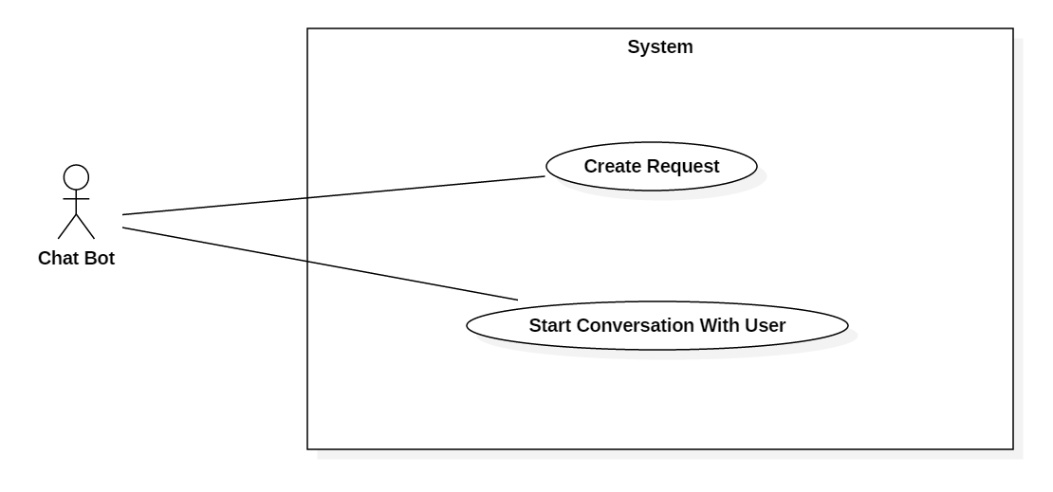

Figure 38: <Chat Bot> Overview Use Case

##### **2.3.7.1 <Chat Bot> Create Request**

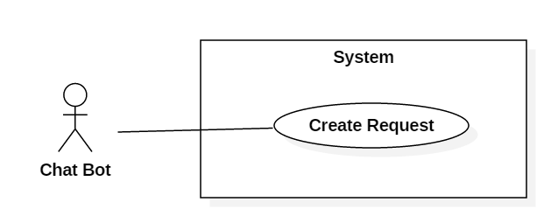

Figure 39: <Chat Bot> Create Request (UC_HELPY04)

|  |  |  |  |
| --- | --- | --- | --- |
| **USE CASE – UC_HELPY04** | | | |
| **Use Case No.** | UC_HELPY04 | **Use Case Version** | 0.1 |
| **Use Case Name** | Create Request | | |
| **Author** | Nguyễn Viết Công Hậu | | |
| **Date** | 10/11/2017 | **Priority** | High |
| **Actor:**   * Chat Bot   **Summary:**   * This use case allows chat bot to assign request of user to suitable assignee.   **Goal:**   * To assign request of user to suitable assignee.   **Triggers:**   * Actor receives create request command from user.   **Preconditions: N/A**  **Post conditions:**   * Success: System assign request of user to suitable assignee successfully. * Fail: System displays error messages.   **Main Success Scenario:**   |  |  |  | | --- | --- | --- | | ***Step*** | ***Actor Action*** | ***System Response*** | | 1 | Actor receives create request command from other users. |  | |  |  | [Exception no.1] [Exception no.2]  [Exception no.3] System assign request of user to suitable assignee successfully. |   **Alternative Scenario: *N/A***  **Exceptions:**   |  |  |  | | --- | --- | --- | | ***No*** | ***Cause*** | ***System Response*** | | 1 | Internet connection lost. | System displays an error message: “Bạn đã ngắt kết nối. Vui lòng kiểm tra lại đường truyền mạng.” | | 2 | Requester no longer exists. | System displays an error message: “Người gửi yêu cầu không tồn tại.” | | 3 | Request no longer exists. | System displays an error message: “Yêu cầu không tồn tại.” |   **Relationships:** N/A  **Business Rules:**   * Topic of request must match with the expertise field of expert. * Accept request priority is given to the experts who do not have any ongoing conversations. | | | |

Table 36: <Chat Bot> Create Request (UC_HELPY04)

##### **2.3.7.2 <Chat Bot> Start Conversation with User**

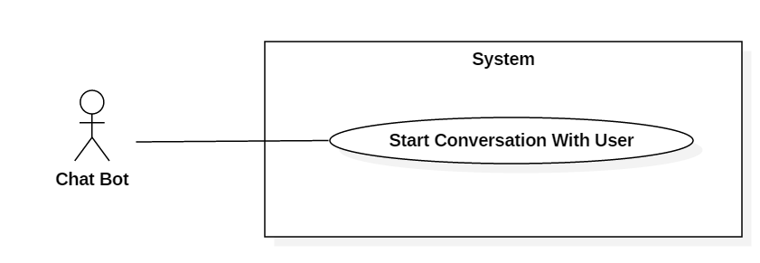

Figure 40: <Chat Bot> Start Conversation with User (UC_HELPY05)

|  |  |  |  |
| --- | --- | --- | --- |
| **USE CASE – UC_HELPY05** | | | |
| **Use Case No.** | UC_HELPY05 | **Use Case Version** | 0.1 |
| **Use Case Name** | Start Conversation with User | | |
| **Author** | Nguyễn Viết Công Hậu | | |
| **Date** | 10/11/2017 | **Priority** | High |
| **Actor:**   * Chat Bot   **Summary:**   * This use case allows chat bot to start conversation with users.   **Goal:**   * To start conversation between user and chat bot.   **Triggers:**   * Actor receives start conversation request.   **Preconditions: N/A**  **Post conditions:**   * Success: System starts the conversation between the requester and chat bot. * Fail: System displays error messages.   **Main Success Scenario:**   |  |  |  | | --- | --- | --- | | ***Step*** | ***Actor Action*** | ***System Response*** | | 1 | Actor receives start conversation request from another user. |  | |  |  | [Exception no.1] [Exception no.2]  System starts the conversation between the requester and chat bot. |   **Alternative Scenario: *N/A***  **Exceptions:**   |  |  |  | | --- | --- | --- | | ***No*** | ***Cause*** | ***System Response*** | | 1 | Internet connection lost. | System displays an error message: “Bạn đã ngắt kết nối. Vui lòng kiểm tra lại đường truyền mạng.” | | 2 | User started the conversation no longer exists. | System displays an error message: “Người dùng không tồn tại.” |   **Relationships:** N/A  **Business Rules:**   * User must choose the topic before starting the conversation with the Chat Bot. | | | |

Table 37: <Chat Bot> Start Conversation with User (UC_HELPY05)

## 3. Software System Attribute

### **3.1 Usability**

#### **3.1.1 Graphic User Interface**

All the texts, labels, alerts and messages will be written in Vietnamese

#### **3.1.2 Usability**

The system usability is easy to use that users generally don’t need to look at the document to use them.

The system will need about 1 hour for training admin or staff to use the website to take manage user.

### **3.2 Reliability**

The data should be backed up every day.

### **3.3 Availability**

The web application must be available 24/7.

### **3.4 Security**

* Admin or staff can grant permission to other roles.
* Only admin can set role staff for user.

### **3.5 Maintainability**

System is divided into modules.

### **3.6 Portability**

The software itself is a web application, therefore it can be used in any platform that has a web browser and can connect to the internet.

### **3.7 Performance**

Requests from users are responded in less than 10 seconds at 5 Mbps bandwidth speed.

## 4. Conceptual Diagram

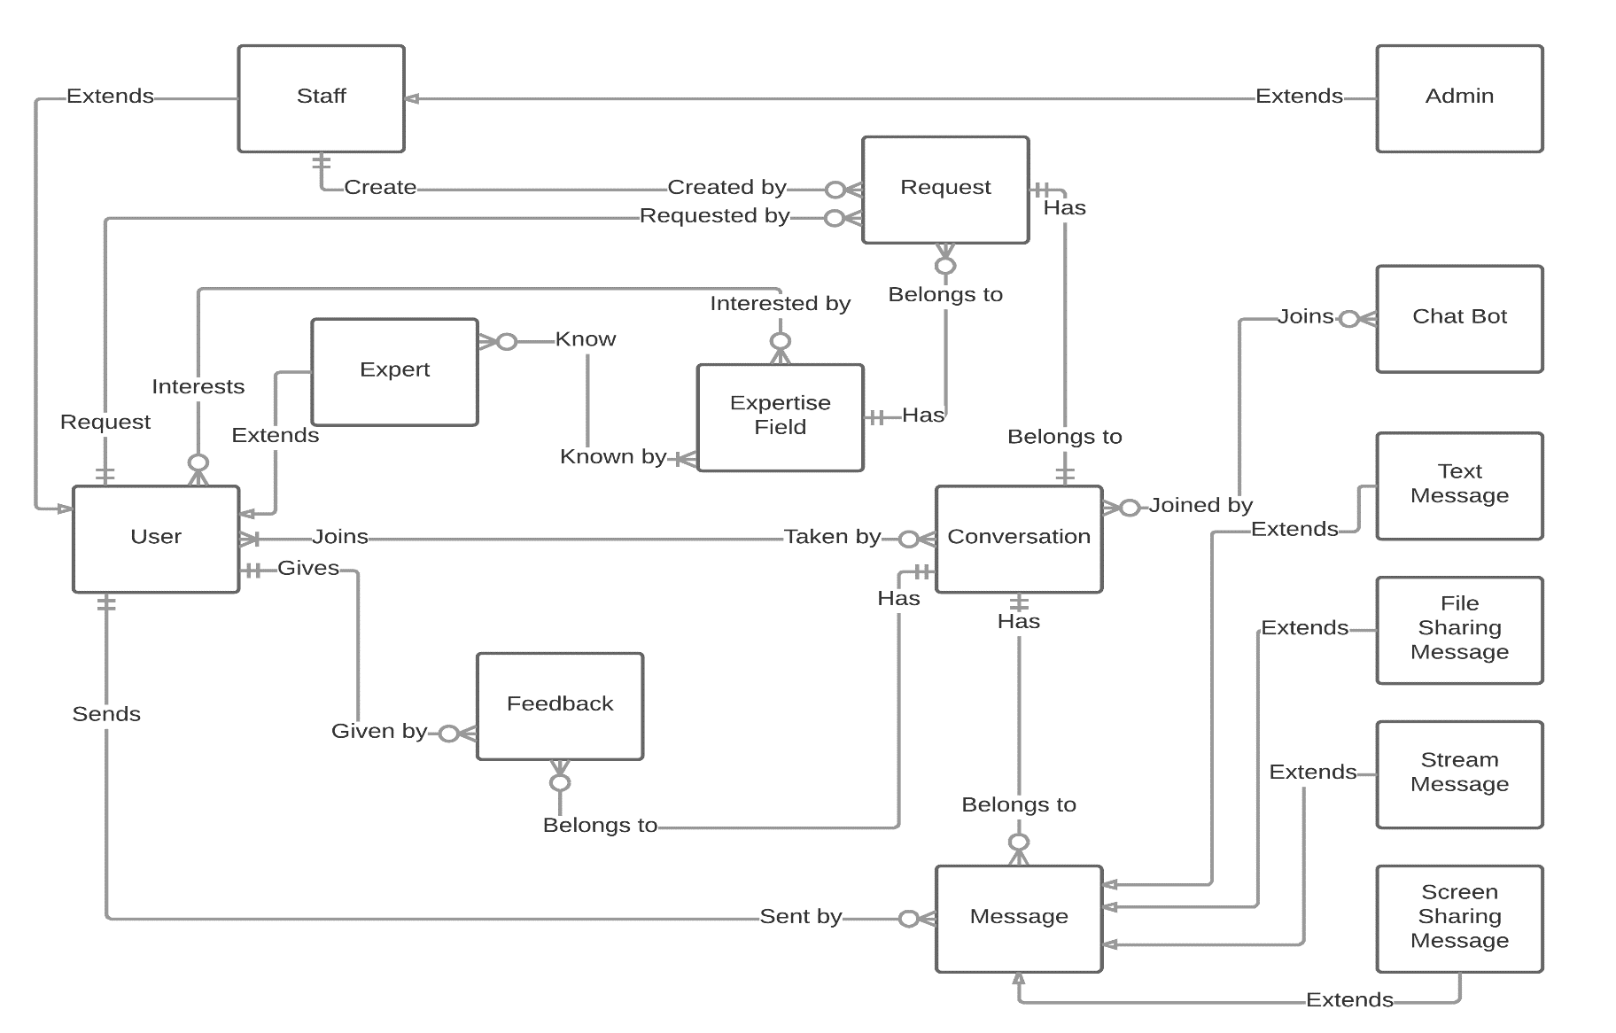

Figure 41: Conceptual Diagram

**Data Dictionary**

|  |  |
| --- | --- |
| **Entity Name** | **Description** |
| User | Person who requests for help, joins conversation, gives feedback for conversation. Contain all information of all users of the system. |
| Expert | Person who login to the system to help the other problems by his knowledge in a field of expertise. |
| Staff | Person who reviews a user’s expertise to accept or decline his/her expert registration application. Create “request” for user when system cannot match automatically an expert to request. |
| Admin | Person who manages staff. |
| Expertise Field | Contains information of a field of expertise that a user is interested in or an expert knowledge in a subject of an expert. |
| Request | Contains information of a request for help by a user. |
| Conversation | Contains information by a conversation between some participators (users, staffs, experts, or a chat bot). |
| Feedback | Contains information of a feedback by a participator to a conversation. |
| Message | Contains information of a message which be sent by a conversation participator. |
| Text Message | A type of Message Entity which main context contains only text. |
| File Sharing Message | A type of Message Entity which main context refers to a file which is uploaded by a conversation participator to the file sharing system. |
| Stream Message | A type of Message Entity which main context refers to a stream (audio/video) in the streaming server for a video/audio calling. |
| Screen Sharing Message | A type of Message Entity which main context refers to a screen sharing stream id for a screen sharing calling. |
| Chat Bot | A proram that joins to a conversation to help the system get necessary information for the system to match an expert to the request automatically. |

Table 38: Conceptual Diagram Data Dictionary

# D. SOFTWARE DESIGN DESCRIPTION

## 1. Design Overview

This document describes the technical and user interface design of Helpy Web Application. It includes the architectural design, the detailed design of common functions and business functions and the design of database model.

The architectural design describes the overall architecture of the system and the architecture of each main component and subsystem.

The detailed design describes static and dynamic structure for each component and functions. It includes class diagrams, class explanations and sequence diagrams for each use cases.

The database design describes the relationships between entities and details of each entity.

Document overview:

Section 2: gives an overall description of the system architecture design.

Section 3: gives component diagrams that describe the connection and integration of the system.

Section 4: gives the detail design description which includes class diagram, class explanation, and sequence diagram to details the application functions.

Section 5: describe screens design.

Section 6: describe a fully attributed ERD.

Section 7: describe algorithms.

## 2. System Architectural Design

### **2.1 System Architecture Overview**

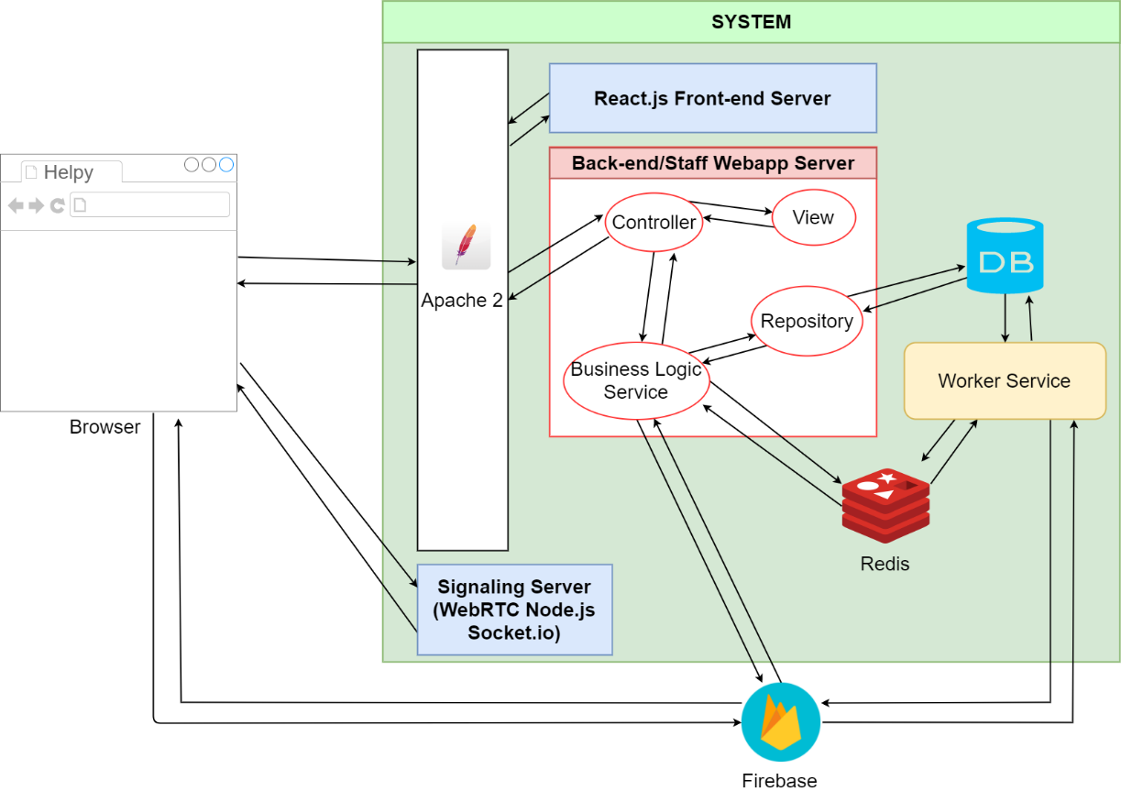

Figure 42 System Architecture Overview

### **2.2 Web Service Architecture Description**

|  |  |
| --- | --- |
| *Annotation* | |
|  | *Send* |
|  | *Call* |
|  | *Return* |
|  | *Query/Update* |

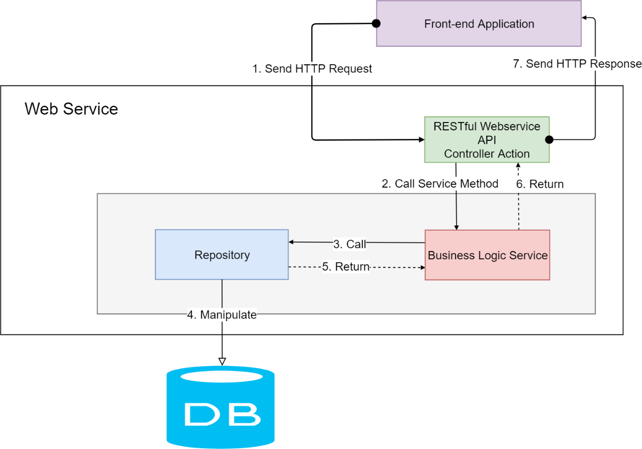

Figure 43 Web Service Architecture

### **2.3 Front-end Application Architecture Description**

|  |  |
| --- | --- |
| *Annotation* | |
|  | *Send* |
|  | *Call* |
|  | *Return* |

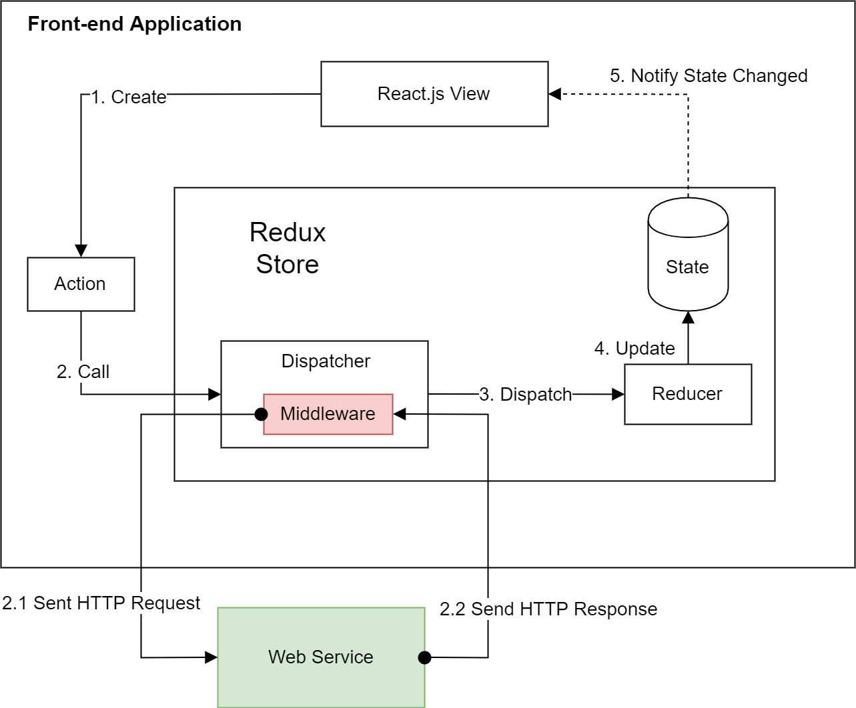

Figure 44 Front-end Application Architecture

**Acknowledgements**  
This architecture is referenced and modified from the concept of Flux Application Architecture by Facebook Inc. (© 2014-2015 Facebook Inc.). See the detail description here: [https://facebook.github.io/flux/docs/in-depth-overview.html#content](https://facebook.github.io/flux/docs/in-depth-overview.html) .

React.js is a library from Facebook Inc.

Redux.js is a library from Dan Abramov.

## 3. Component Diagram

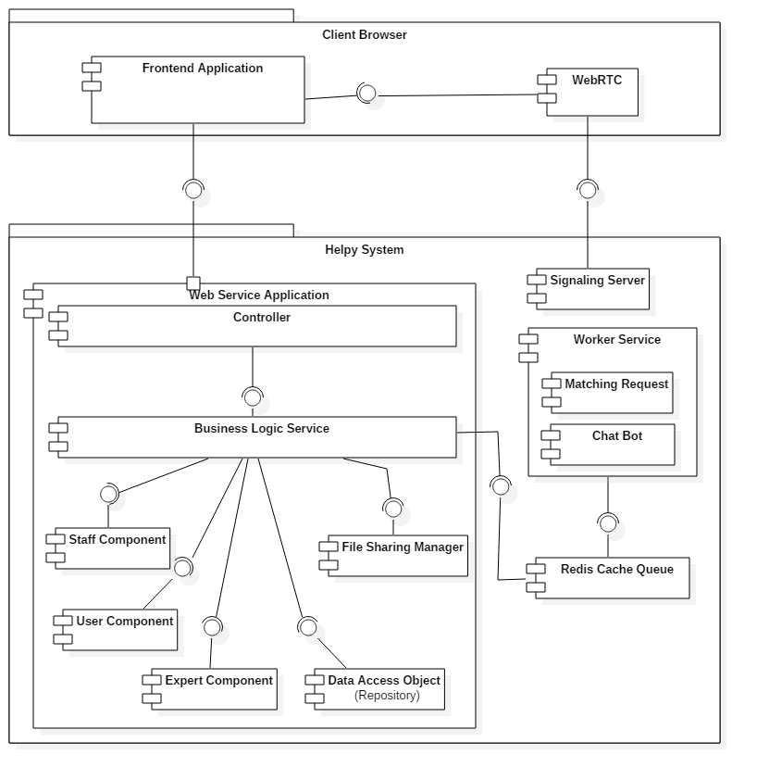

Figure 45 Component Diagram

|  |  |
| --- | --- |
| *Component Dictionary: Describe Components* | |
| *Client Browser* | *A browser instance that user open to access Helpy Website.* |
| *Frontend Application* | *An instance of Front-end Application run on the Client Browser instance.* |
| *WebRTC* | *A component of browser that implements WebRTC protocols.* |
| *Helpy System* | *A REALTIME Help Desk System via Video Call System.* |
| *Web Service Application* | *A Web Application of Helpy’s RESTful Web Service.* |
| *Signaling Server* | *Web Socket Server for WebRTC Signaling.* |
| *Worker Service* | *A background service that does matching requests to experts and chat bot.* |
| *Redis Cache Queue* | *A queue that store commands need to be processed by the Worker Service.* |

## 4. Detailed Description

### **4.1 Class Diagram**

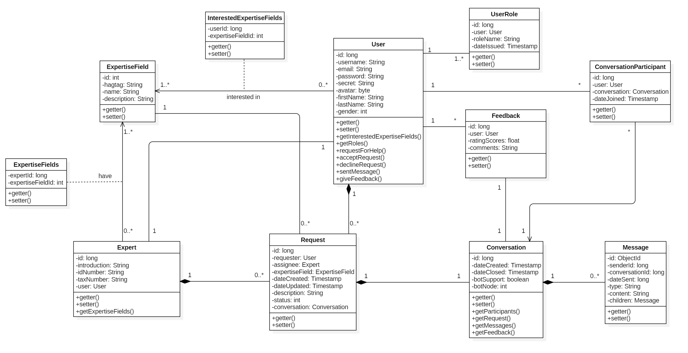

Figure 46 Class Diagram

|  |  |  |
| --- | --- | --- |
| *Class Dictionary: Describe Class* | | |
| Class name | **Mapping column with Conceptual diagram** | **Description** |
| *User Entity* | *User* | *User who login to the system.* |
| *Expert Entity* | *Expert* | *Contains information of the expert.* |
| *User Role Entity* | *N/A* | *Contains information of roles of the user in the system.* |
| *Expertise Field Entity* | *N/A* | Contains information of a field of expertise in the system. |
| *Interested Expertise Fields Entity* | *N/A* | Contains information of interested topic of user in the system. |
| *Expertise Fields Entity* | *N/A* | Contains information of expertise field of expert in the system. |
| *Request Entity* | *Request* | Contains information of request in the system. |
| *Conversation Entity* | *Conversation* | Contains information of conversation between participants in the system. |
| *Conversation Participant Entity* | *N/A* | Contains information of participant of a conversation. |
| *Message Entity* | *Message* | Contains information of a message which be sent by a conversation participant. |
| *Feedback Entity* | *Feedback* | Contains information of a feedback by a participant to a conversation. |

Table 39 Class dictionary

### **4.2 Class Diagram Explanation**

#### **4.2.1 User**

**Attributes**

|  |  |  |  |
| --- | --- | --- | --- |
| *Attribute* | *Type* | *Visibility* | *Description* |
| *id* | *Long* | *Private* | *Unique id of user* |
| *username* | *String* | *Private* | *Username of user* |
| *password* | *String* | *Private* | *Password of user* |
| *secret* | *String* | *Private* | *Secret of user* |
| *avatar* | *Byte[]* | *Private* | *Avatar of user* |
| *firstName* | *String* | *Private* | *First name of user* |
| *lastName* | *String* | *Private* | *Last name of user* |
| *gender* | *Integer* | *Private* | *Gender of user* |

Table 40: User Attributes

**Methods**

|  |  |  |  |
| --- | --- | --- | --- |
| *Method* | *Return type* | *Visibility* | *Description* |
| *getter* | *Attribute type* | *Public* | *Get attribute value* |
| *setter* | *Void* | *Public* | *Set value of attribute* |

Table 41: User Methods

#### **4.2.2 Expert**

**Attributes**

|  |  |  |  |
| --- | --- | --- | --- |
| *Attribute* | *Type* | *Visibility* | *Description* |
| *id* | *Long* | *Private* | *Unique id of expert* |
| *introduction* | *String* | *Private* | *Introduction of expert* |
| *idNumber* | *String* | *Private* | *Identity number of expert* |
| *taxNumber* | *String* | *Private* | *Tax number of expert* |
| *user* | *User* | *Private* | *User who is expert* |

Table 42: Expert Attributes

**Methods**

|  |  |  |  |
| --- | --- | --- | --- |
| *Method* | *Return type* | *Visibility* | *Description* |
| *getter* | *Attribute type* | *Public* | *Get attribute value* |
| *setter* | *Void* | *Public* | *Set value of attribute* |

Table 43: Expert Methods

#### **4.2.3 User Role**

**Attributes**

|  |  |  |  |
| --- | --- | --- | --- |
| *Attribute* | *Type* | *Visibility* | *Description* |
| *id* | *Long* | *Private* | *Unique id of role* |
| *user* | *User* | *Private* | *User who has role* |
| *roleName* | *String* | *Private* | *Name of role* |
| *dateIssued* | *Timestamp* | *Private* | *Date update role* |

Table 44: User Role Attributes

**Methods**

|  |  |  |  |
| --- | --- | --- | --- |
| *Method* | *Return type* | *Visibility* | *Description* |
| *getter* | *Attribute type* | *Public* | *Get attribute value* |
| *setter* | *Void* | *Public* | *Set value of attribute* |

Table 45: User Role Methods

#### **4.2.4 Expertise Field**

**Attributes**

|  |  |  |  |
| --- | --- | --- | --- |
| *Attribute* | *Type* | *Visibility* | *Description* |
| *id* | *Integer* | *Private* | *Unique id of expertise field* |
| *hagtag* | *String* | *Private* | *Hagtag of expertise field* |
| *name* | *String* | *Private* | *Name of expertise field* |
| *description* | *String* | *Private* | *Description of expertise field* |

Table 46: Expertise Field Attributes

**Methods**

|  |  |  |  |
| --- | --- | --- | --- |
| *Method* | *Return type* | *Visibility* | *Description* |
| *getter* | *Attribute type* | *Public* | *Get attribute value* |
| *setter* | *Void* | *Public* | *Set value of attribute* |

Table 47: Expertise Field Methods

#### **4.2.5 Interested Expertise Fields**

**Attributes**

|  |  |  |  |
| --- | --- | --- | --- |
| *Attribute* | *Type* | *Visibility* | *Description* |
| *userId* | *Long* | *Private* | *Id of user who interested in topic* |
| *expertiseFieldId* | *Integer* | *Private* | *Id of topic which was interested by user* |

Table 48: Interested Expertise Fields Attributes

**Methods**

|  |  |  |  |
| --- | --- | --- | --- |
| *Method* | *Return type* | *Visibility* | *Description* |
| *getter* | *Attribute type* | *Public* | *Get attribute value* |
| *setter* | *Void* | *Public* | *Set value of attribute* |

Table 49: Interested Expertise Fields Methods

#### **4.2.6 Expertise Fields**

**Attributes**

|  |  |  |  |
| --- | --- | --- | --- |
| *Attribute* | *Type* | *Visibility* | *Description* |
| *expertId* | *Long* | *Private* | *Id of expert who has expertise in a field* |
| *expertiseFieldId* | *Integer* | *Private* | *Id of expertise that user has* |

Table 50: Expertise Fields Attributes

**Methods**

|  |  |  |  |
| --- | --- | --- | --- |
| *Method* | *Return type* | *Visibility* | *Description* |
| *getter* | *Attribute type* | *Public* | *Get attribute value* |
| *setter* | *Void* | *Public* | *Set value of attribute* |

Table 51: Expertise Fields Methods

#### **4.2.7 Request**

**Attributes**

|  |  |  |  |
| --- | --- | --- | --- |
| *Attribute* | *Type* | *Visibility* | *Description* |
| *id* | *Long* | *Private* | *Unique id of request* |
| *requester* | *User* | *Private* | *Requester of request* |
| *assignee* | *Expert* | *Private* | *Assignee of request* |
| *expertiseField* | *ExpertiseField* | *Private* | *Topic of request* |
| *dateCreated* | *Timestamp* | *Private* | *Created date of request* |
| *dateUpdated* | *Timestamp* | *Private* | *Updated date of request* |
| *description* | *String* | *Private* | *Description of request* |
| *status* | *Integer* | *Private* | *Status of request* |
| *conversation* | *Conversation* | *Private* | *Conversation of request* |

Table 52: Request Attributes

**Methods**

|  |  |  |  |
| --- | --- | --- | --- |
| *Method* | *Return type* | *Visibility* | *Description* |
| *getter* | *Attribute type* | *Public* | *Get attribute value* |
| *setter* | *Void* | *Public* | *Set value of attribute* |

Table 53: Request Methods

#### **4.2.8 Conversation**

**Attributes**

|  |  |  |  |
| --- | --- | --- | --- |
| *Attribute* | *Type* | *Visibility* | *Description* |
| *id* | *Long* | *Private* | *Unique id of conversation* |
| *dateCreated* | *Timestamp* | *Private* | *Created date of conversation* |
| *dateClosed* | *Timestamp* | *Private* | *Closed date of conversation* |
| *botSupport* | *Boolean* | *Private* | *Support Bot of conversation* |
| *botNode* | *Integer* | *Private* | *Node of Bot of conversation* |

Table 54: Conversation Attributes

**Methods**

|  |  |  |  |
| --- | --- | --- | --- |
| *Method* | *Return type* | *Visibility* | *Description* |
| *getter* | *Attribute type* | *Public* | *Get attribute value* |
| *setter* | *Void* | *Public* | *Set value of attribute* |

Table 55: Conversation Methods

#### **4.2.9 Conversation Participant**

**Attributes**

|  |  |  |  |
| --- | --- | --- | --- |
| *Attribute* | *Type* | *Visibility* | *Description* |
| *id* | *Long* | *Private* | *Unique of conversation participant* |
| *user* | *User* | *Private* | *User who in conversation* |
| *conversation* | *Conversation* | *Private* | *Conversation that user participates* |
| *dateJoined* | *Timestamp* | *Private* | *Date user joined in the conversation* |

Table 56: Conversation Participant Attributes

**Methods**

|  |  |  |  |
| --- | --- | --- | --- |
| *Method* | *Return type* | *Visibility* | *Description* |
| *getter* | *Attribute type* | *Public* | *Get attribute value* |
| *setter* | *Void* | *Public* | *Set value of attribute* |

Table 57: Conversation participant Methods

#### **4.2.10 Message**

**Attributes**

|  |  |  |  |
| --- | --- | --- | --- |
| *Attribute* | *Type* | *Visibility* | *Description* |
| *id* | *ObjectId* | *Private* | *Unique id of message* |
| *senderId* | *Long* | *Private* | *Id of sender of message* |
| *conversationId* | *Long* | *Private* | *Id of conversation* |
| *dateSent* | *Long* | *Private* | *Date message sent* |
| *type* | *String* | *Private* | *Type of message* |
| *content* | *String* | *Private* | *Content of message* |
| *children* | *Message* | *Private* | *Children of message* |

Table 58: Message Attributes

**Methods**

|  |  |  |  |
| --- | --- | --- | --- |
| *Method* | *Return type* | *Visibility* | *Description* |
| *getter* | *Attribute type* | *Public* | *Get attribute value* |
| *setter* | *Void* | *Public* | *Set value of attribute* |

Table 59: Message Methods

#### **4.2.11 Feedback**

**Attributes**

|  |  |  |  |
| --- | --- | --- | --- |
| *Attribute* | *Type* | *Visibility* | *Description* |
| *id* | *Long* | *Private* | *Unique id of feedback* |
| *user* | *User* | *Private* | *User who gives feedback* |
| *ratingScores* | *Float* | *Private* | *Rating score of feedback* |
| *comments* | *String* | *Private* | *Comment of feedback* |

Table 60: Feedback Attributes

**Methods**

|  |  |  |  |
| --- | --- | --- | --- |
| *Method* | *Return type* | *Visibility* | *Description* |
| *getter* | *Attribute type* | *Public* | *Get attribute value* |
| *setter* | *Void* | *Public* | *Set value of attribute* |

Table 61: Feedback Methods

### **4.3 Interaction Diagram**

#### **4.3.1 User**

##### **4.3.1.1 Chat**

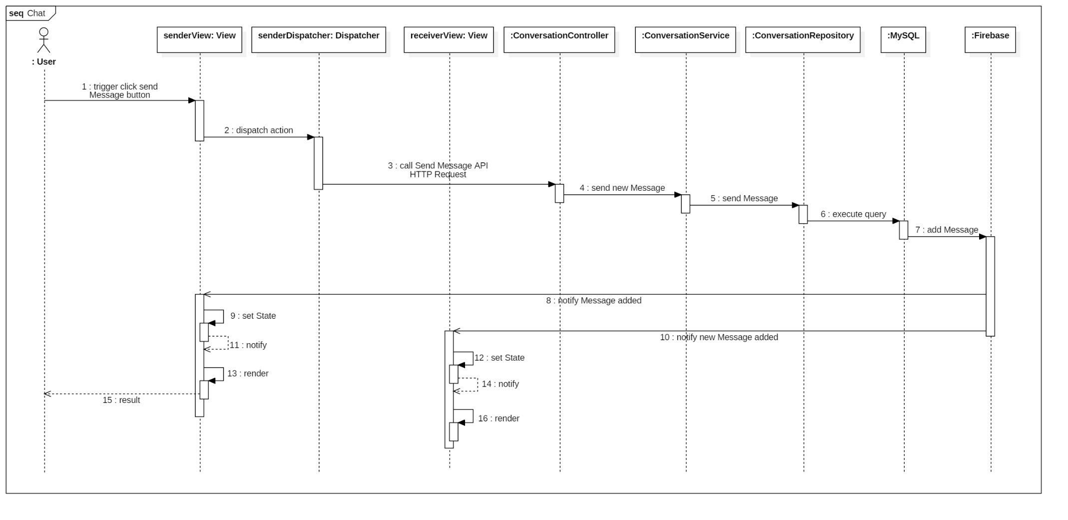

Figure 47: Sequence diagram - <User> Chat

##### **4.3.1.2 Close Conversation**

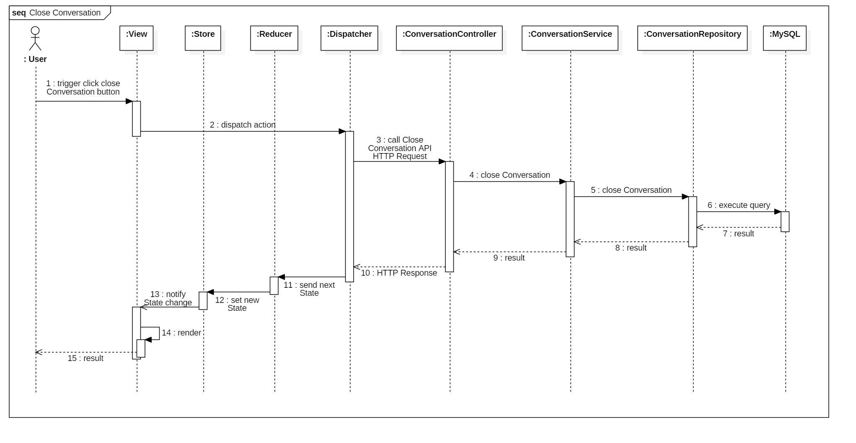

Figure 48: Sequence diagram - <User> Close Conversation

##### **4.3.1.3 Get Conversation List**

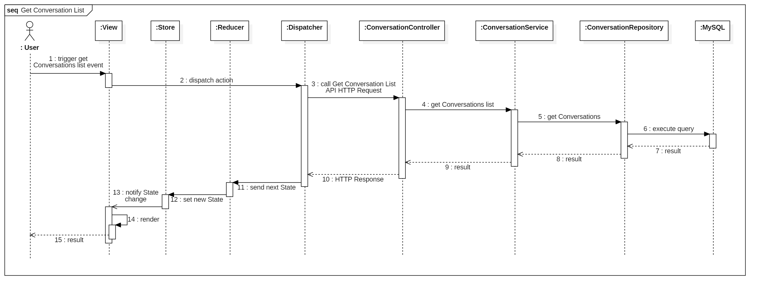

Figure 49: Sequence diagram - <User> Get Conversation List

##### **4.3.1.4 Get Conversation**

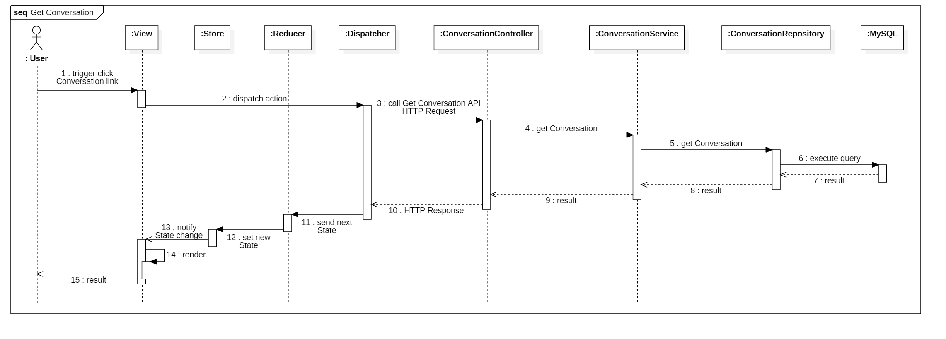

Figure 50: Sequence diagram – <User> Get Conversation

##### **4.3.1.5 Give Feedback**

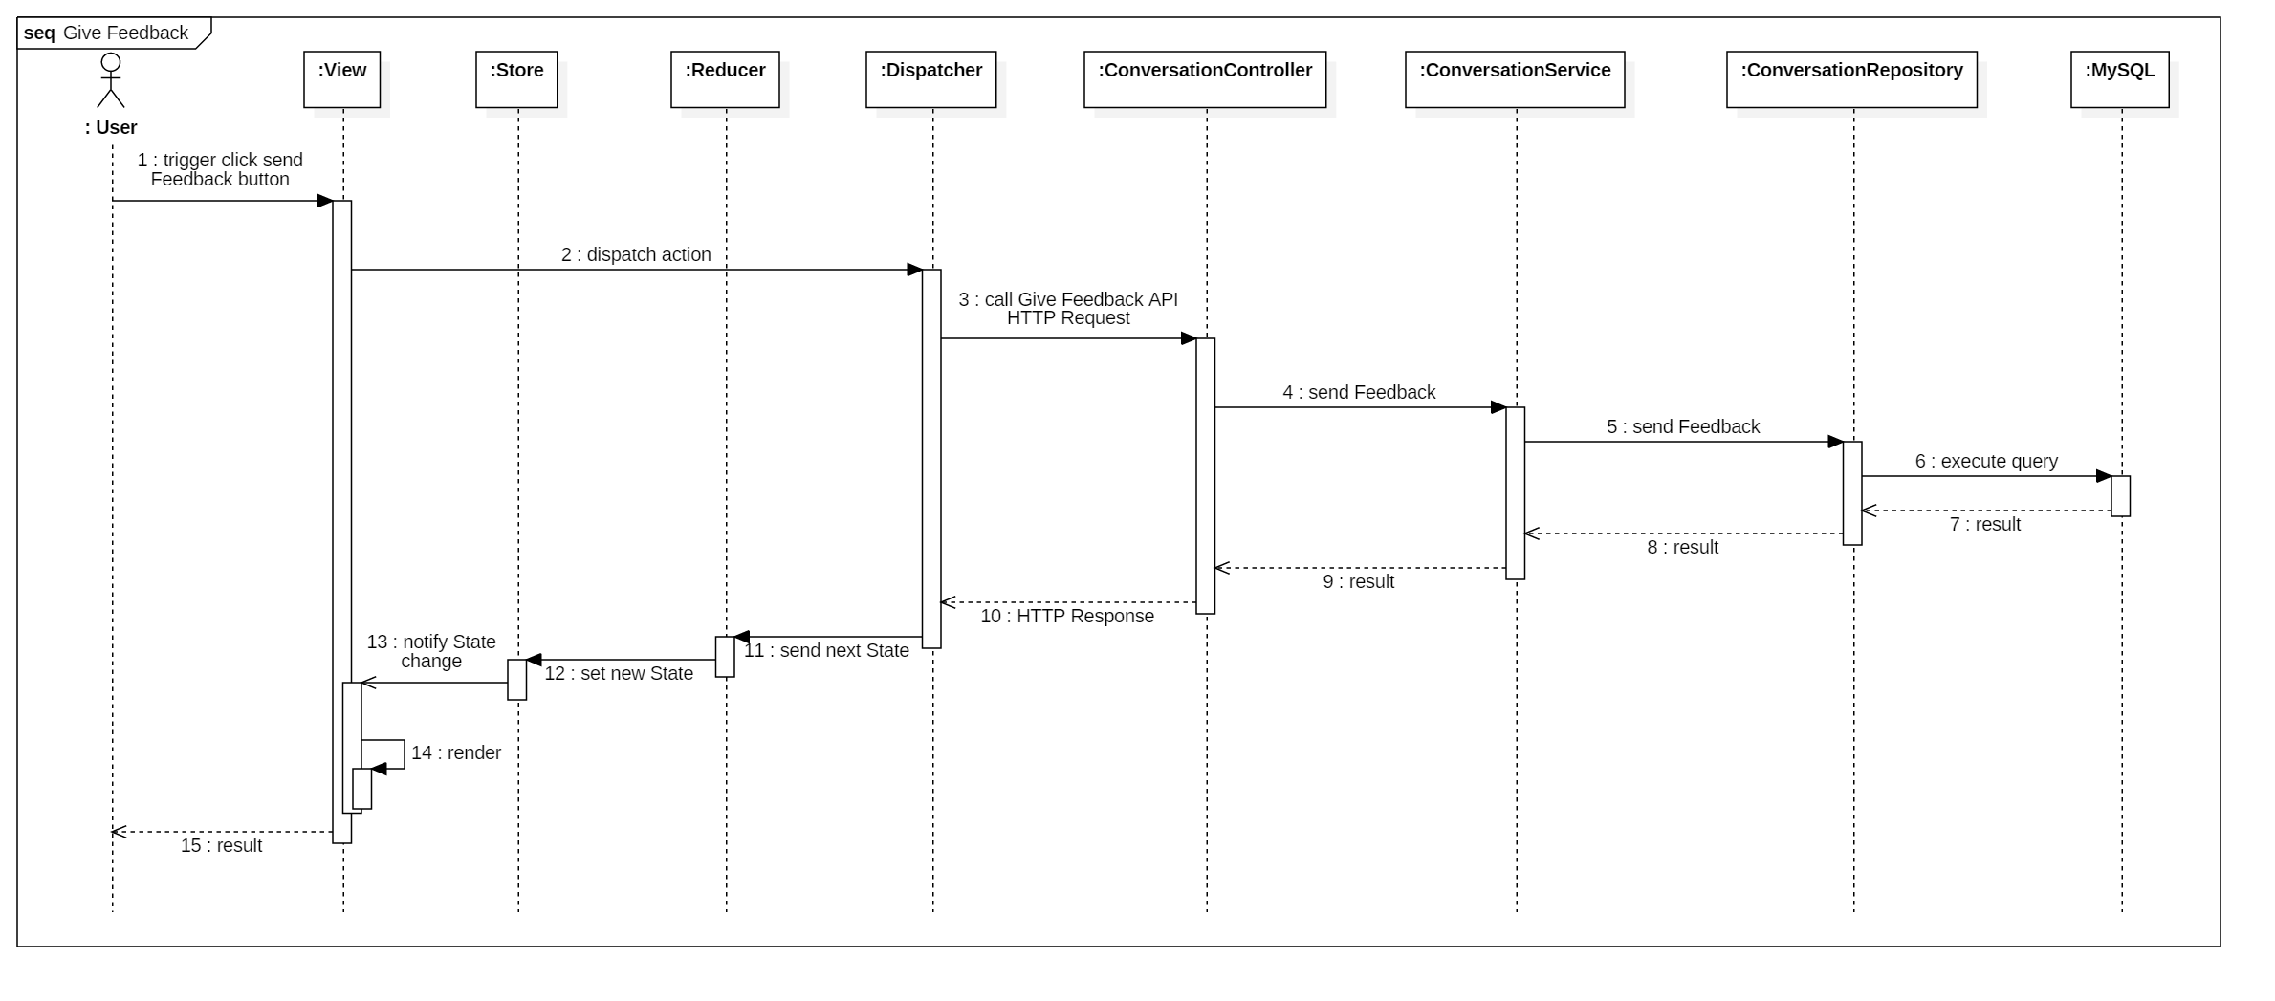

Figure 51: Sequence diagram - <User> Give Feedback

#### **4.3.2 Expert**

##### **4.3.2.1 Accept Request**

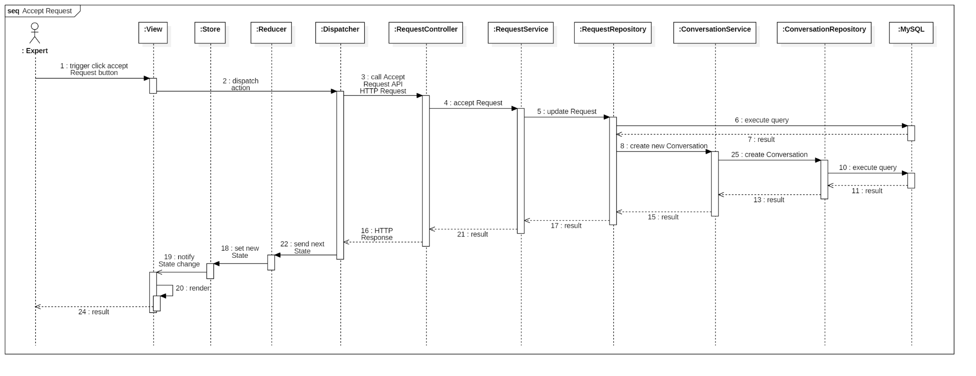

Figure 52: Sequence diagram - <Expert> Accept Request

##### **4.3.2.2 Decline Request**

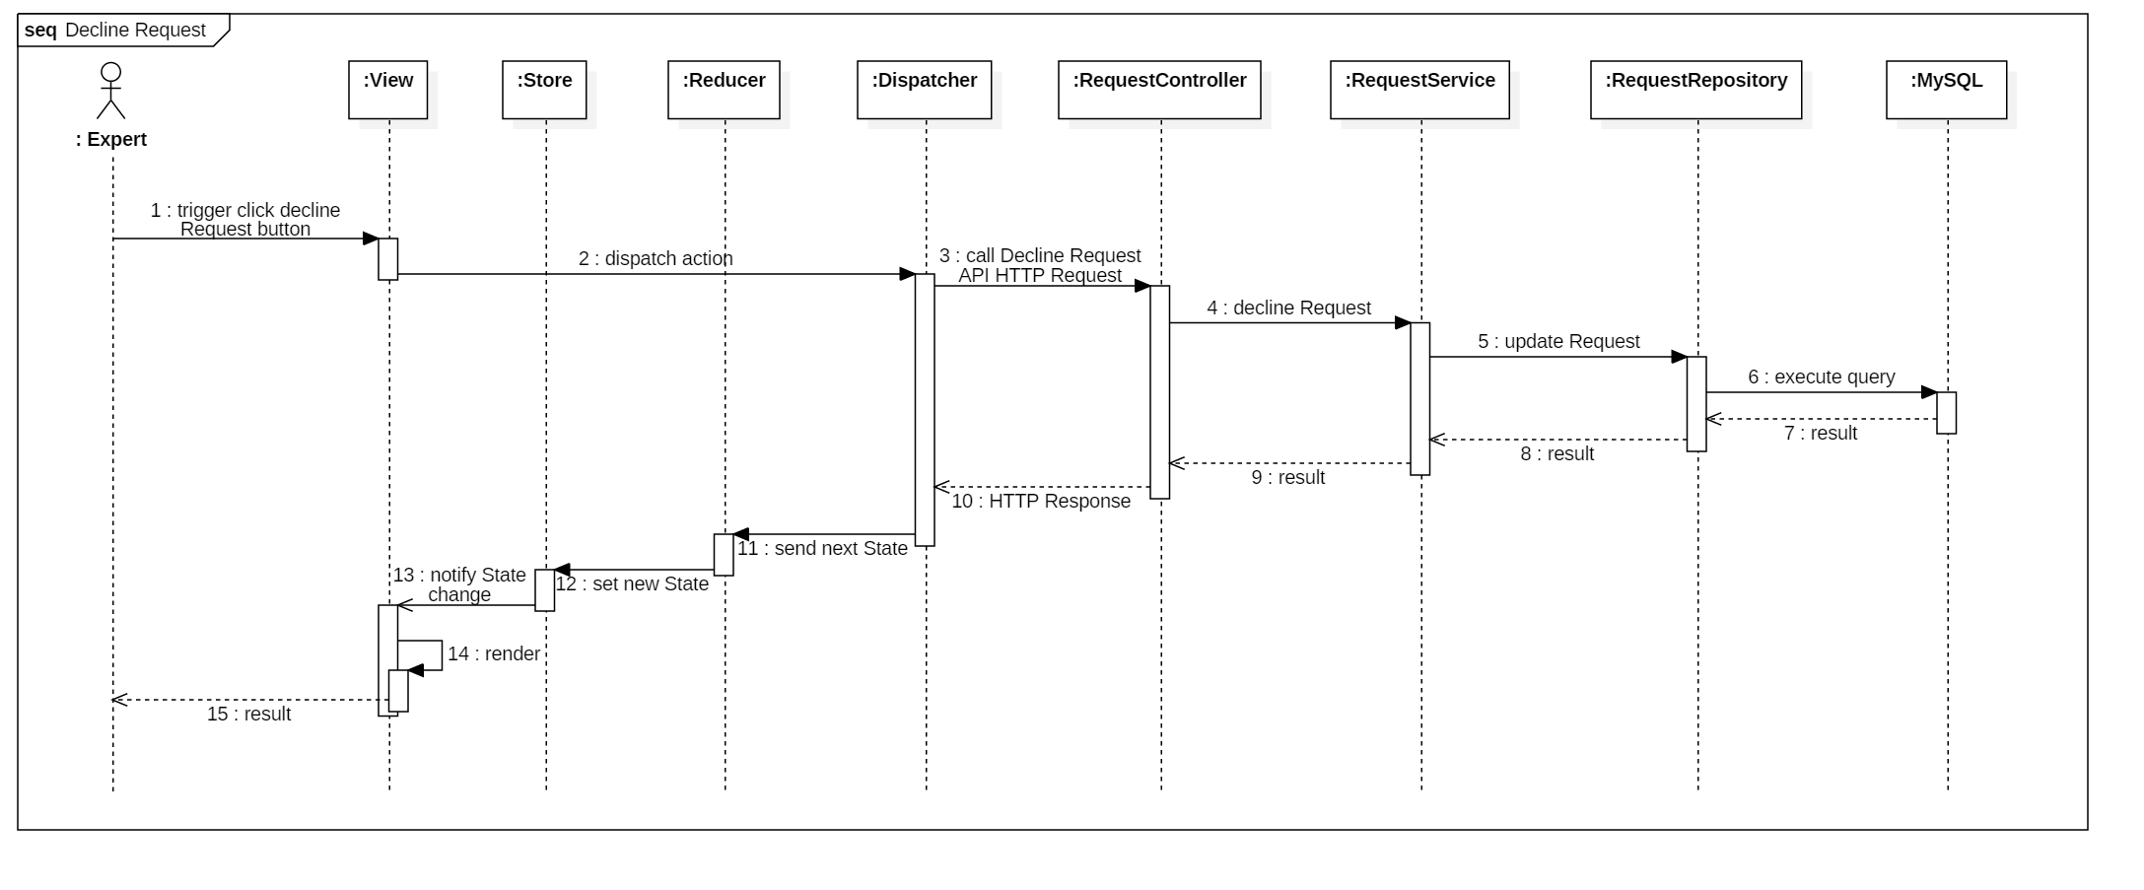

Figure 53: Sequence diagram - <Expert> Decline Request

##### **4.3.2.3 Get Request List**

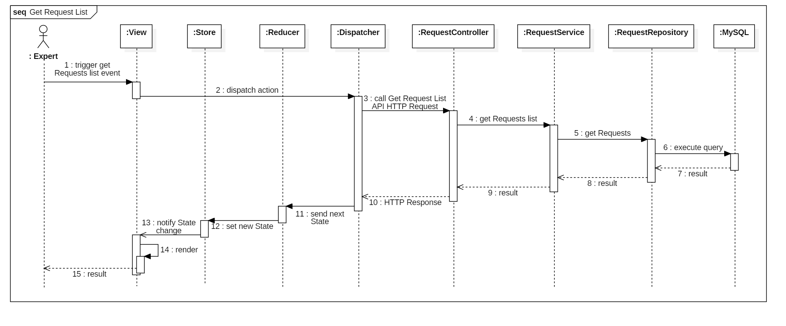

Figure 54: Sequence diagram - <Expert> Get Request List

##### **4.3.2.4 Get Request**

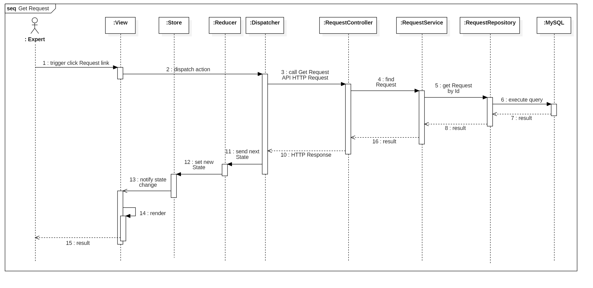

Figure 55: Sequence diagram - <Expert> Get Request

##### **4.3.2.5 Start Conversation with User**

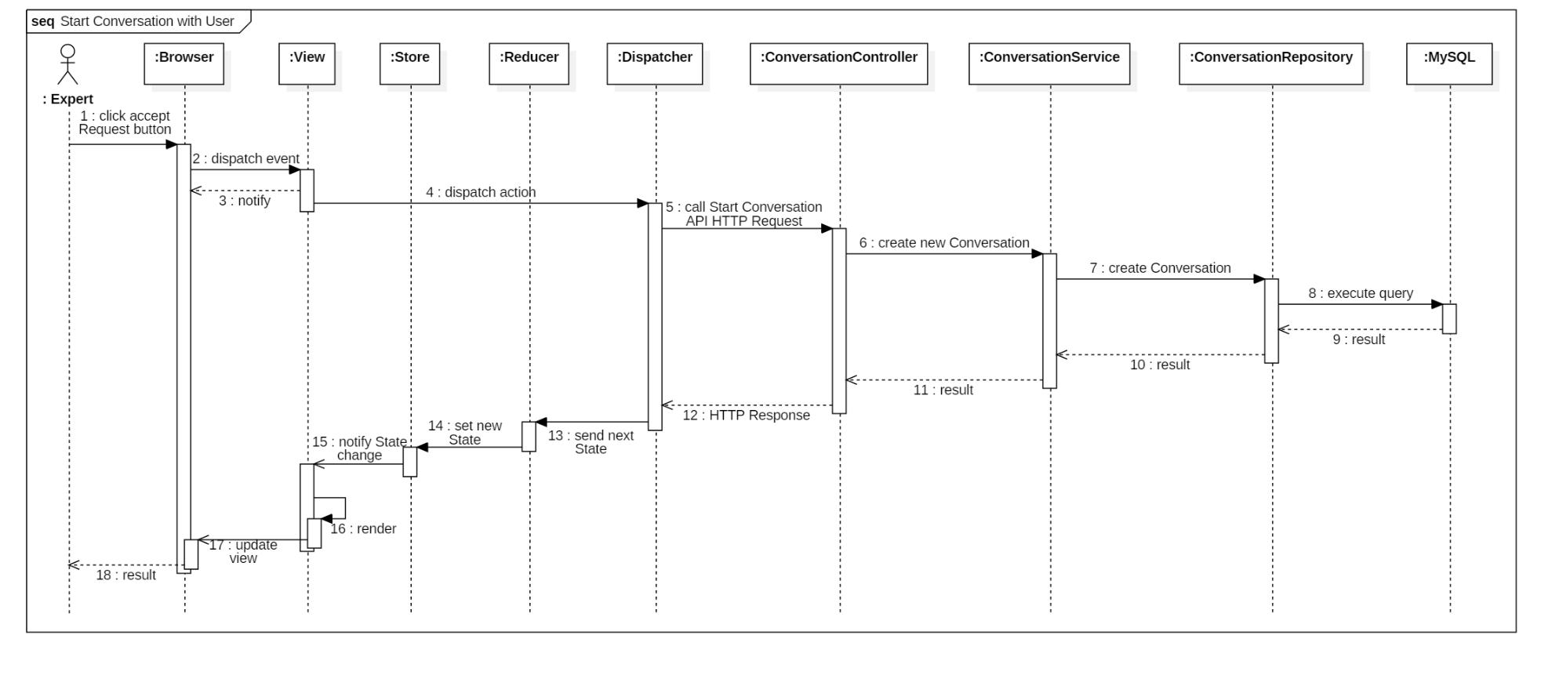

Figure 56: Sequence diagram - <User> Start Conversation with User

## 5. Interface

### **5.1 Guest Interface Design**

#### **5.1.1 Signup Interface**

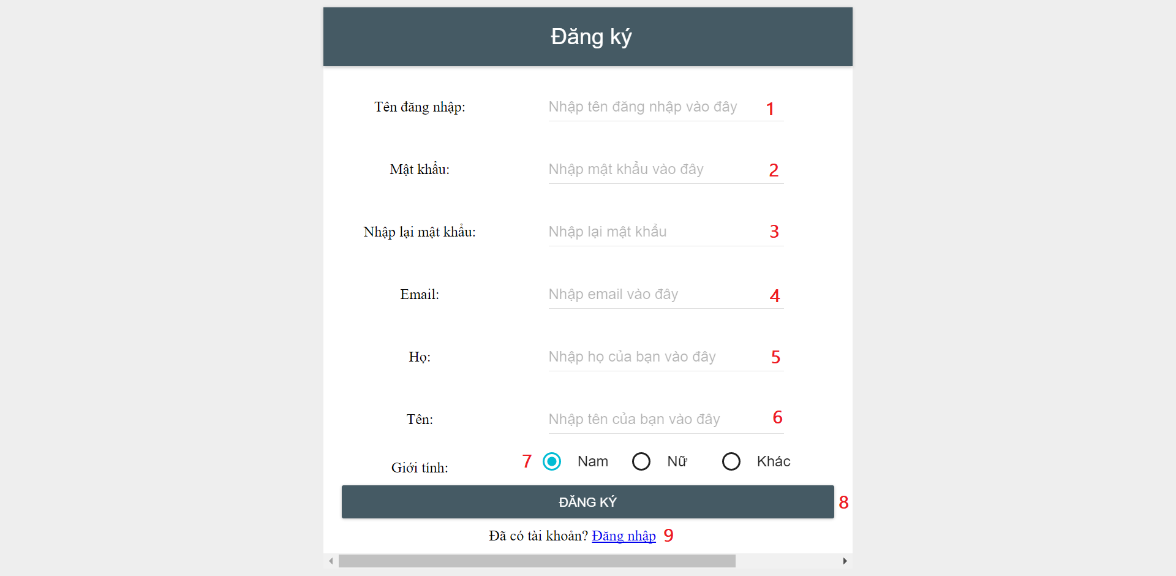

**Fields**

|  |  |  |  |  |  |  |  |
| --- | --- | --- | --- | --- | --- | --- | --- |
| *No* | *Field Name* | *Description* | *Read only* | *Mandatory* | *Control Type* | *Data Type* | *Length* |
| *1* | *txtUsername* | *Username of account* | *No* | *Yes* | *Textbox* | *String* | *4 – 45* |
| *2* | *txtPassword* | *Password of account* | *No* | *Yes* | *Textbox* | *String* | *6 – 128* |
| *3* | *txtRePassword* | *Re-check password* | *No* | *Yes* | *Textbox* | *String* | *6 – 128* |
| *4* | *txtEmail* | *Email of account* | *No* | *Yes* | *Textbox* | *String* | *N/A* |
| *5* | *txtLastName* | *Last name of use* | *No* | *Yes* | *Textbox* | *String* | *0 – 45* |
| *6* | *txtFirstName* | *First name of user* | *No* | *Yes* | *Textbox* | *String* | *0 – 45* |
| *7* | *rdGender* | *Gender of user* | *No* | *Yes* | *Radio button* | *Int* | *N/A* |

**Buttons/Hyperlinks**

|  |  |  |  |  |
| --- | --- | --- | --- | --- |
| *No* | *Function* | *Description* | *Validation* | *Outcome* |
| *8* | *btnRegister* | *Send register command.* | *Validation all required fields before submit.* | *Submit register form.* |
| *9* | *linkLogin* | *Show login page.* | *N/A* | *Show login page.* |

#### **5.1.2 Login Interface**

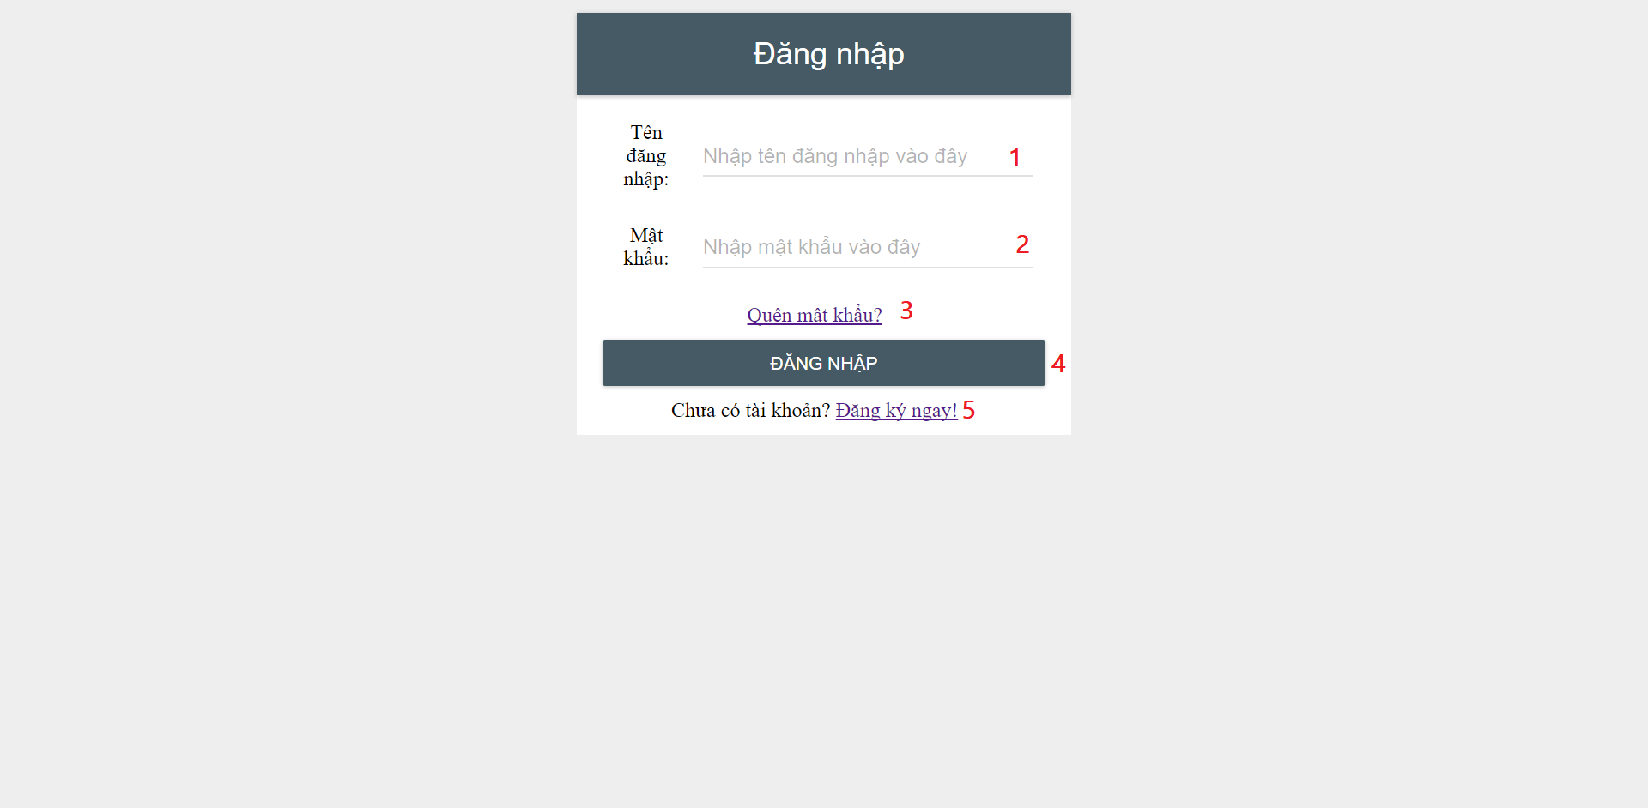

**Fields**

|  |  |  |  |  |  |  |  |
| --- | --- | --- | --- | --- | --- | --- | --- |
| *No* | *Field Name* | *Description* | *Read only* | *Mandatory* | *Control Type* | *Data Type* | *Length* |
| *1* | *txtUsername* | *Username of account* | *No* | *Yes* | *Textbox* | *String* | *4 – 45* |
| *2* | *txtPassword* | *Password of account* | *No* | *Yes* | *Textbox* | *String* | *6 – 128* |

**Buttons/Hyperlinks**

|  |  |  |  |  |
| --- | --- | --- | --- | --- |
| *No* | *Function* | *Description* | *Validation* | *Outcome* |
| *3* | *linkForgetPass* | *Show forget password page.* | *N/A* | *Show forget password page.* |
| *4* | *btnLogin* | *Send login command.* | *Validation all required fields before submit.* | *Submit login form.* |
| *5* | *linkRegister* | *Show register page.* | *N/A* | *Show register page.* |

### **5.2 User Interface Design**

#### **5.2.1 Chat Interface**

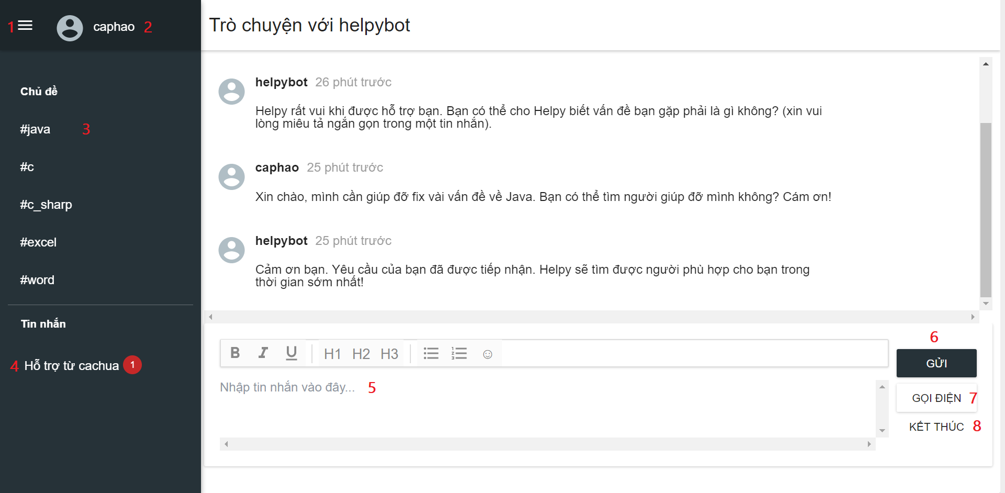

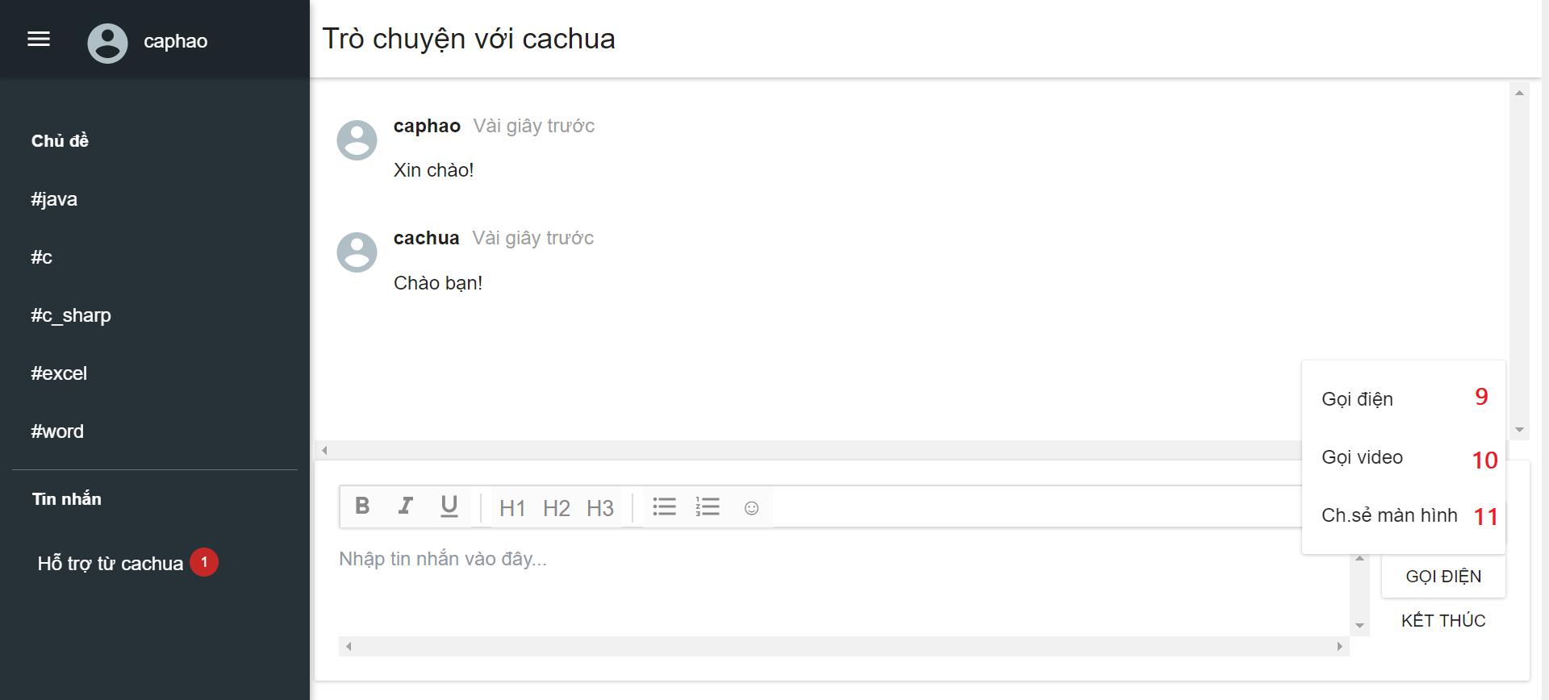

**Fields**

|  |  |  |  |  |  |  |  |
| --- | --- | --- | --- | --- | --- | --- | --- |
| *No* | *Field Name* | *Description* | *Read only* | *Mandatory* | *Control Type* | *Data Type* | *Length* |
| *5* | *txtMessage* | *Message content.* | *No* | *Yes* | *Textarea* | *String* | *3 – 200* |

**Buttons/Hyperlinks**

|  |  |  |  |  |
| --- | --- | --- | --- | --- |
| *No* | *Function* | *Description* | *Validation* | *Outcome* |
| *1* | *navDrawer* | *Drawer slide in from the left side* | *N/A* | *Show/Hide left slide.* |
| *2* | *linkUserInfo* | *Show user information dropdown.* | *N/A* | *Show user information dropdown.* |
| *3* | *linkRequestHelp* | *Show request for help page (start conversation with chatbot).* | *N/A* | *Show request for help page.* |
| *4* | *linkConversation* | *Show conversation page.* | *N/A* | *Show conversation page.* |
| *6* | *btnSendMess* | *Send message command.* | *Validation message before submit.* | *Send message and update conversation interface.* |
| *7* | *btnCallMethod* | *Show call methods list (Call/Video call/ Share screen)* | *N/A* | *Display call methods list.* |
| *8* | *btnEndConver* | *Send close conversation command.* | *N/A* | *Display feedback form.* |
| *9* | *btnCall* | *Send call command* | *N/A* | *Display call interface.* |
| *10* | *btnVideoCall* | *Send video call command* | *N/A* | *Display video call interface.* |
| *11* | *btnShareScreen* | *Send share screen command* | *N/A* | *Display share screen interface.* |

#### **5.2.2 Call Interface**

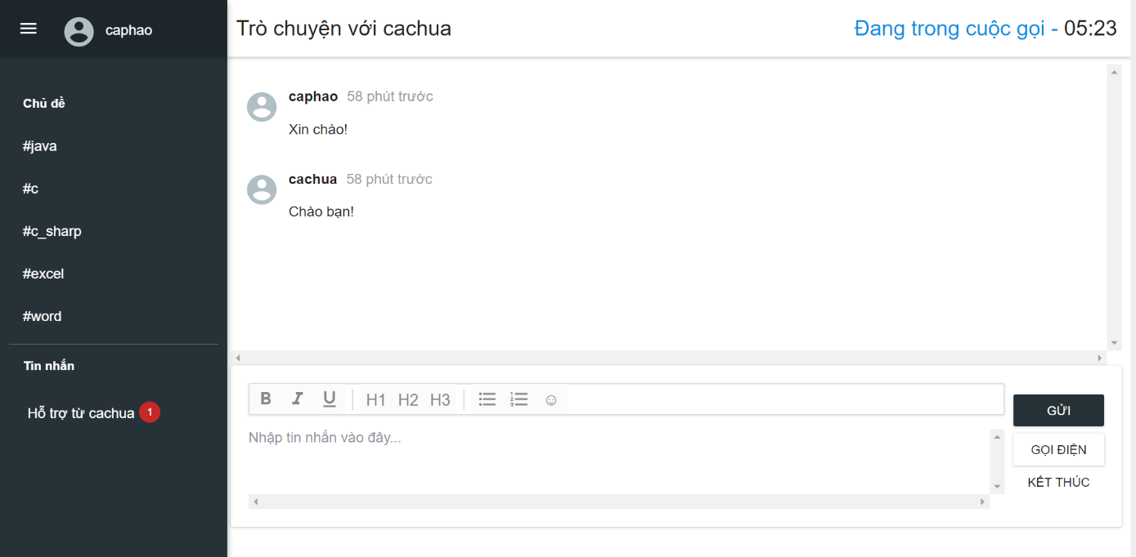

#### **5.2.3 Video Call Interface**

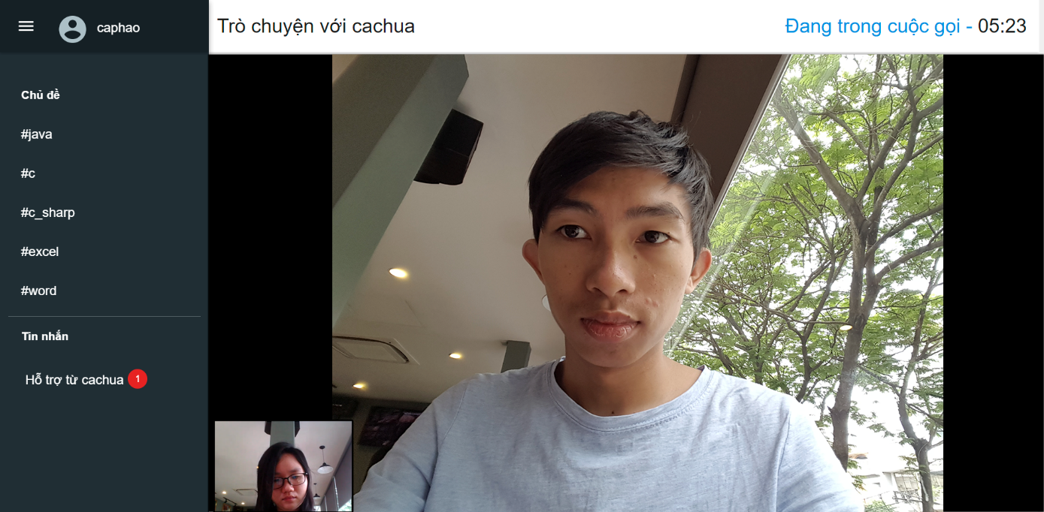

#### **5.2.4 Share Screen Interface**

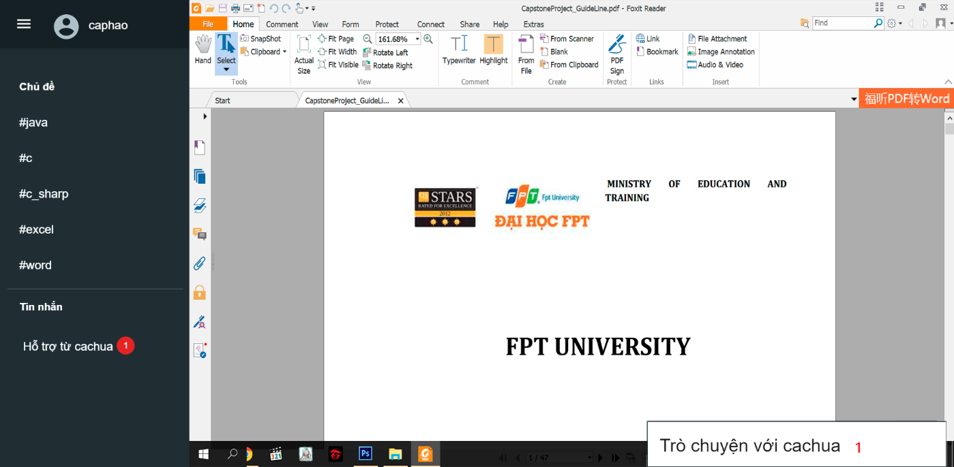

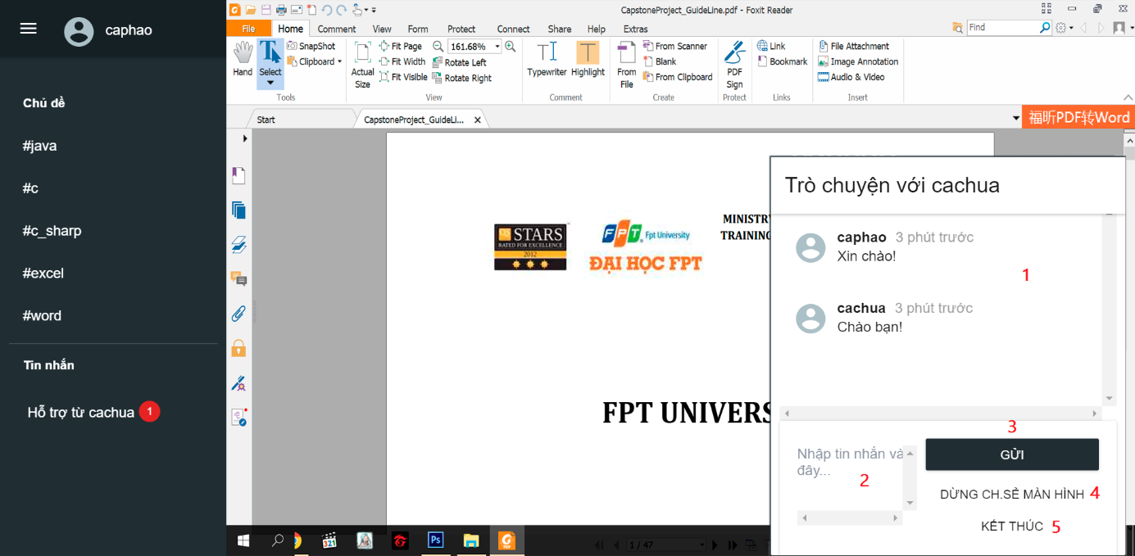

**Fields**

|  |  |  |  |  |  |  |  |
| --- | --- | --- | --- | --- | --- | --- | --- |
| *No* | *Field Name* | *Description* | *Read only* | *Mandatory* | *Control Type* | *Data Type* | *Length* |
| *2* | *txtMessage* | *Message content.* | *No* | *Yes* | *Textarea* | *String* | *3 – 200* |

**Buttons/Hyperlinks**

|  |  |  |  |  |
| --- | --- | --- | --- | --- |
| *No* | *Function* | *Description* | *Validation* | *Outcome* |
| *1* | *btnChatBox* | *Show/Hide chat box* | *N/A* | *Show/Hide chat box.* |
| *3* | *btnSendMess* | *Send message command.* | *Validation message before submit.* | *Send message and update conversation interface.* |
| *4* | *btnEndShare* | *Send end share screen command* | *N/A* | *Close share screen interface.* |
| *5* | *btnEndConver* | *Send close conversation command.* | *N/A* | *Display feedback form.* |

#### **5.2.3 Feedback Interface**

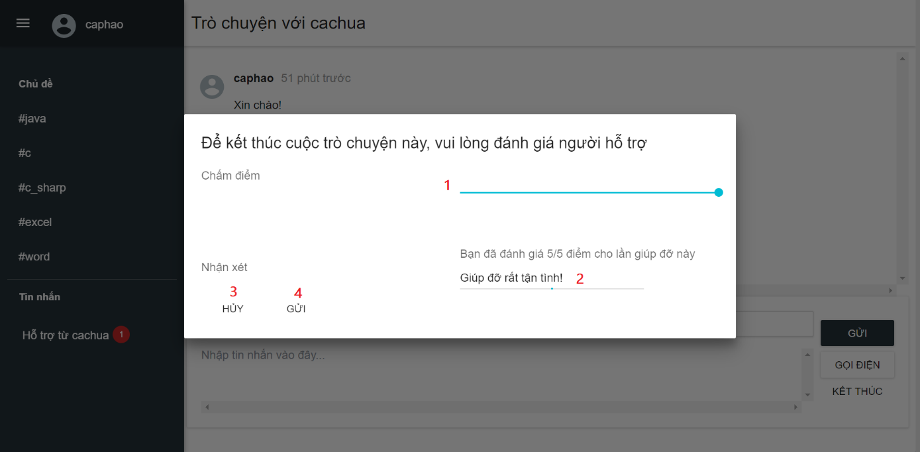

**Fields**

|  |  |  |  |  |  |  |  |
| --- | --- | --- | --- | --- | --- | --- | --- |
| *No* | *Field Name* | *Description* | *Read only* | *Mandatory* | *Control Type* | *Data Type* | *Length* |
| *1* | *barRating* | *Rating bar* | *No* | *Yes* | *Rating bar* | *Float* | *0-5* |
| *2* | *txtComment* | *Message content* | *No* | *No* | *Textfield* | *String* | *3 – 200* |

**Buttons/Hyperlinks**

|  |  |  |  |  |
| --- | --- | --- | --- | --- |
| *No* | *Function* | *Description* | *Validation* | *Outcome* |
| *1* | *btnCancel* | *Cancel close conversation command* | *N/A* | *Close feedback form.* |
| *2* | *btnSend* | *Send feedback command* | *N/A* | *Close conversation interface.* |

### **5.3 Expert Interface Design**

#### **5.3.1 Requests List Interface**

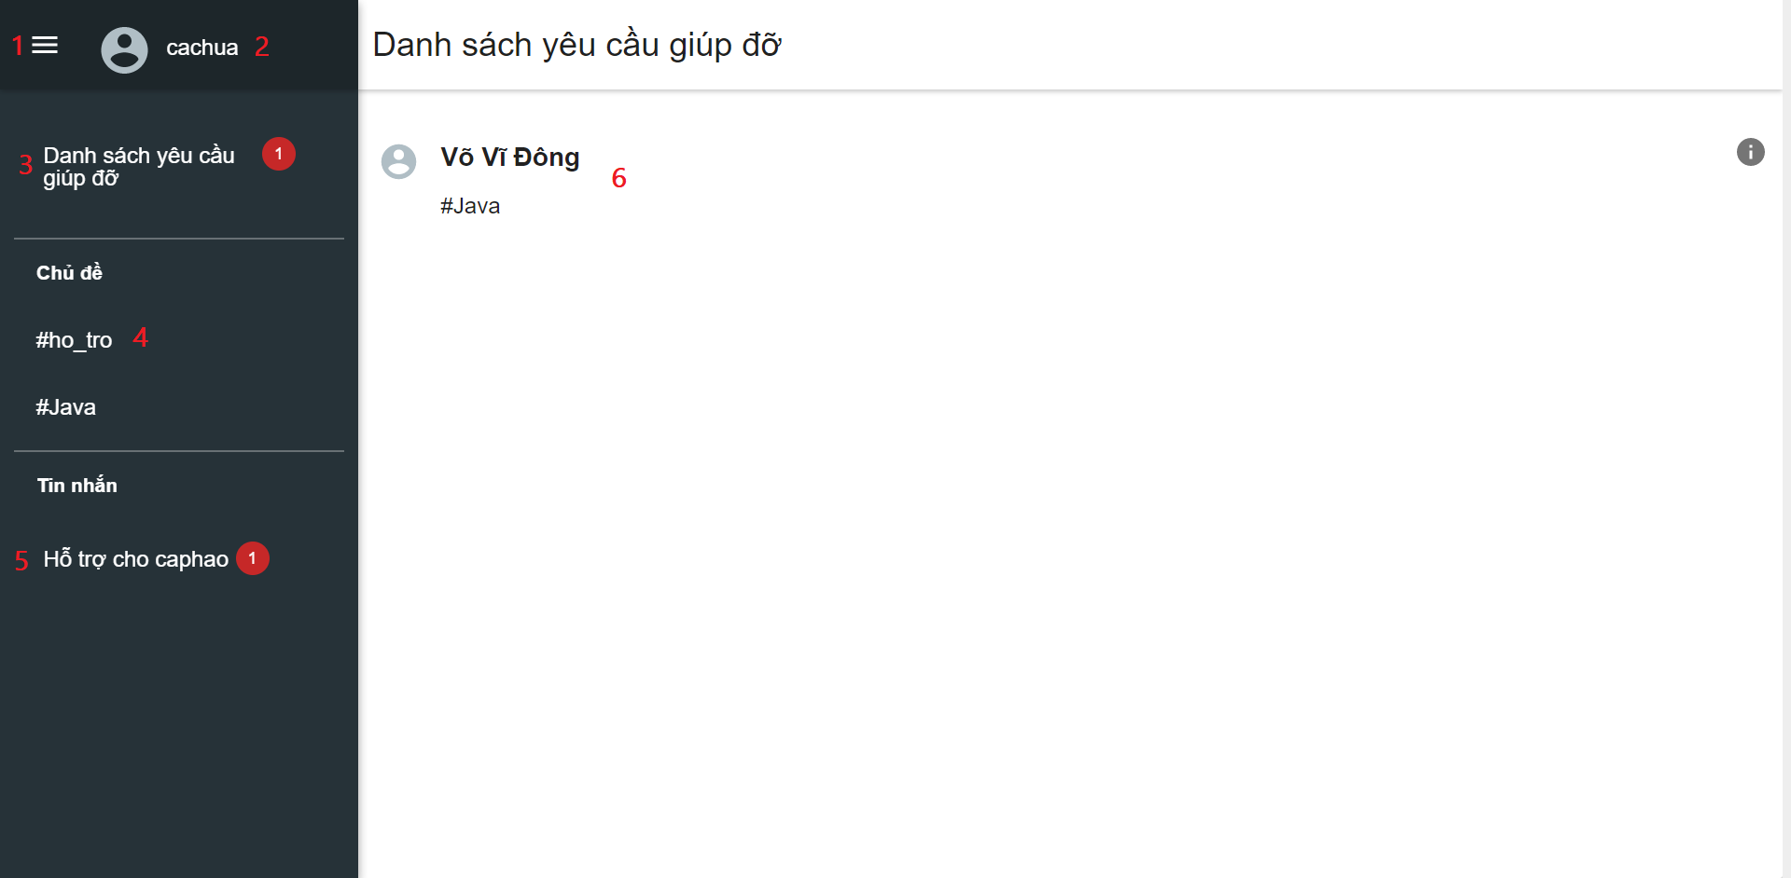

#### **5.3.2 Request Detail Interface**

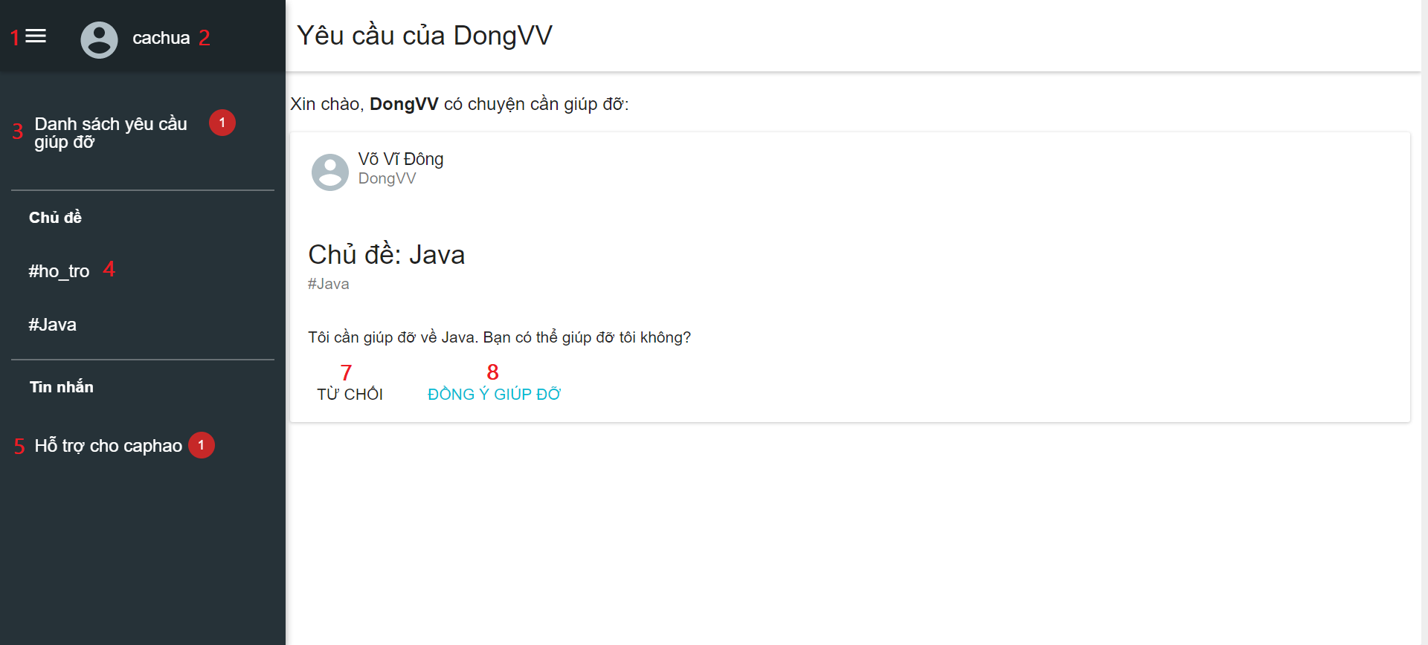

**Buttons/Hyperlinks**

|  |  |  |  |  |
| --- | --- | --- | --- | --- |
| *No* | *Function* | *Description* | *Validation* | *Outcome* |
| *1* | *navDrawer* | *Drawer slide in from the left side* | *N/A* | *Show/Hide left slide.* |
| *2* | *linkUserInfo* | *Show user information dropdown.* | *N/A* | *Show user information dropdown.* |
| *3* | *linkRequestList* | *Show requests list page.* | *N/A* | *Show requests list page.* |
| *4* | *linkRequestHelp* | *Show request for help page (start conversation with chatbot).* | *N/A* | *Show request for help page.* |
| *5* | *linkConversation* | *Show conversation page.* | *N/A* | *Show conversation page.* |
| *6* | *linkRequest* | *Show request detail page.* | *N/A* | *Show request detail page.* |
| *7* | *btnDeclineRequest* | *Send decline request command.* | *N/A* | *Update request information.* |
| *8* | *btnAcceptRequest* | *Send decline accept command.* | *Validation required information before submit.* | *Show conversation page.* |

## 6. Database Design

### **6.1 Entity Relationship Diagram (ERD)**

## 

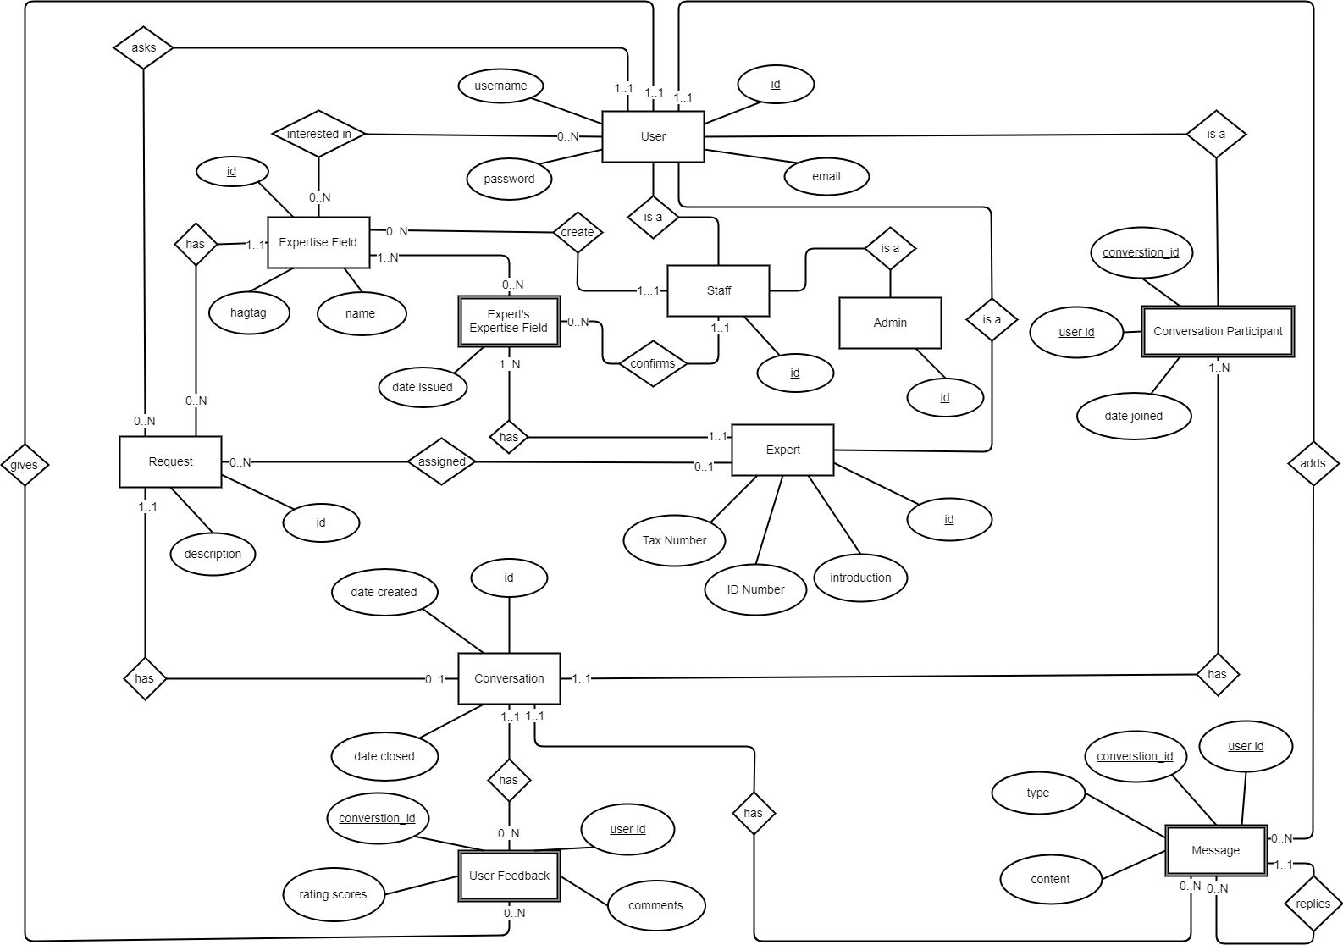

Figure 57 Entity Relation Diagram­­­­

### 

### **6.2 Data Dictionary**

|  |  |
| --- | --- |
| *Entity Data Dictionary: Describe Content of All Entities* | |
| Entity Name | **Description** |
| *User* | *Contains the user information.* |
| *Expert* | *Contains the expert information.* |
| *Staff* | *Contains the staff information.* |
| *Admin* | *Contains the admin information.* |
| *Request* | *Contains the request information.* |
| *Conversation* | *Contains the conversation information.* |
| *Expertise Field* | *Contains the expertise information.* |
| *Expert’s Expertise Field* | *Contains expertise information of each expert.* |
| *User Feedback* | *Contains feedback of the user about the request’s assignee or the conversation.* |
| *Conversation participant* | *Contains the conversation participant information.* |
| *Message* | *Contain the message of conversation.* |

Table 62: Describe Content of All Entities

|  |  |  |  |  |
| --- | --- | --- | --- | --- |
| *Entity Name* | *Attributes* | *Description* | *Domain* | *Null* |
| *User* | *id {PK}* | *Unique identifier of User.* | *BIGINT(20)* | *N* |
| *username* | *Username of account.* | *VARCHAR(45)* | *N* |
| *password* | *Password of account.* | *VARCHAR(128)* | *N* |
| *email* | *Email of account.* | *VARCHAR(128)* | *N* |
| *Expert* | *id {PK}* | *Unique identifier of Expert.* |  |  |
| *ID Number* | *Identity number of expert.* | *VARCHAR(45)* | *N* |
| *Tax Number* | *Tax number of expert.* | *VARCHAR(45)* | *N* |
| *introduction* | *Introduction of expert.* | *MEDIUMTEXT* | *Y* |
| *Staff* | *id {PK}* | *Identity number of Staff.* | *VARCHAR(45)* | *N* |
| *Admin* | *id {PK}* | *Identity number of Admin.* | *VARCHAR(45)* | *N* |
| *Request* | *id {PK}* | *Unique identifier of Request.* | *BIGINT(20)* | *N* |
| *description* | *Description of request.* | *MEDIUMTEXT* | *N* |
| *Conversation* | *id {PK}* | *Unique identifier of Conversation.* | *BIGINT(20)* | *N* |
| *date created* | *Conversation created date.* | *TIMESTAMP* | *N* |
| *date closed* | *Conversation closed date.* | *TIMESTAMP* | *Y* |
| *Expertise Field* | *id {PK}* | *Unique identifier of Expertise Field.* | *INT(11)* | *N* |
| *name* | *Name of expertise field.* | *VARCHAR(45)* | *N* |
| *hagtag* | *Hagtag of expertise field.* | *VARCHAR(45)* | *N* |
| *Expert’s Expertise Field* | *date issued* | *Expert’s expertise field updated date.* | *TIMESTAMP* | *Y* |
| *User Feedback* | *user id {PK}* | *User identifier of User Feedback.* | *BIGINT(20)* | *N* |
| *conversation_id {PK}* | *Conversation identifier of User Feedback.* | *BIGINT(20)* | *N* |
| *comments* | *Comment of feedback.* | *MEDIUMTEXT* | *Y* |
| *rating scores* | *Rating scores of feedback.* | *FLOAT* | *N* |
| *Conversation participant* | *user id {PK}* | *User identifier of Conversation Participant.* | *BIGINT(20)* | *N* |
| *conversation_id {PK}* | *Conversation identifier of Conversation Participant.* | *BIGINT(20)* | *N* |
| *date joined* | *Conversation’s participant joined date.* | *TIMESTAMP* | *N* |
| *Message* | *user id {PK}* | *User identifier of Message.* | *BIGINT(20)* | *N* |
| *conversation_id {PK}* | *Conversation identifier of Message.* | *BIGINT(20)* | *N* |
| *type* | *Type of message.* | *JSON* | *Y* |
| *content* | *Content of message.* | *JSON* | *Y* |

Table 63: Detail Data Dictionary

## 7. Algorithms

**Recommendation for matching experts to requests for help**

### **7.1 Definition**

Recommendation is the way to get matching experts for a user request for help. When a request for help is created, a worker service will create a recommendation expert list for this request. Then, this worker service will assign an expert for this request from the recommendation list.

### **7.2 Define Problem**

The requirement is the system should assign automatically an expert to users' requests for help.

We must ensure that new experts or experts who have not supported anyone yet have opportunity to approach potential requests for help of users.

### **7.4 Solution**

We build the dataset for recommendation by considering all expert scores that are given by users in all expertise fields or a particular field.

The score a user gives to an expert is the average of all scores given by the user for all times. The score for each support time is in range 0 - 5.0. Therefore, the score a user give to an expert is also range from 0 to 5.0.

When a new request for help created, we use the following methods to assign an expert to this request:

1. Discover the set of similar users the user who asks this request based on the officers' scores in all time.

2. In the set of similar users, find the suggested list of experts of the request's expertise field. To do this, we need to score experts, who have not supported the user ask request yet, by producing a weighted score that gave by the similar users. Then sort this list by the weighted descending.

3. Assign the expert from the top of the suggested list - expert that has best score.

### **7.5 Complexity**

In total, the complexity of the user-based recommendation is **N2.**

### **7.6 Flowchart**

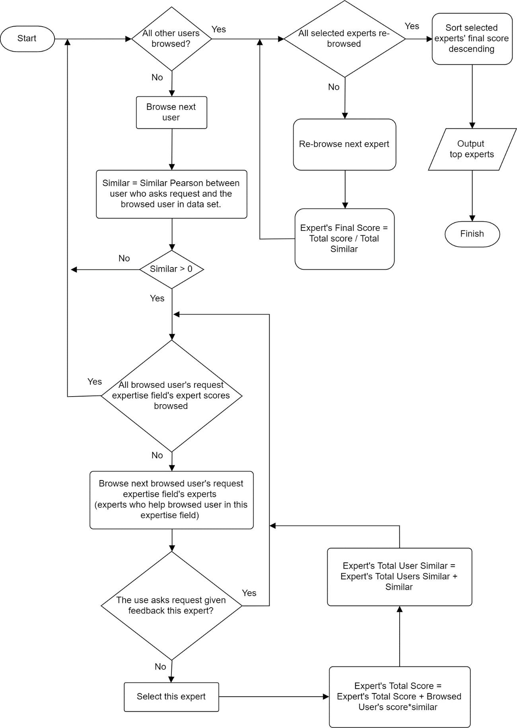

Figure 58 User-Based Recommendation Flow Chart

### **7.7 Example**

Assume that we have a dataset of users’ feedbacks’ scores to experts each supporting time as the table below:

|  |  |  |  |
| --- | --- | --- | --- |
| User | Expert | Expertise Field | Score |
| 1 | 1 | 1 | 3.4 |
| 1 | 1 | 1 | 3.2 |
| 1 | 1 | 2 | 1.4 |
| 1 | 2 | 2 | 3.3 |
| 1 | 2 | 3 | 4.3 |
| 1 | 3 | 1 | 3.1 |
| 1 | 3 | 2 | 3.2 |
| 1 | 5 | 3 | 4.3 |
| 1 | 5 | 3 | 4.4 |
| 1 | 8 | 2 | 4.3 |
| 1 | 8 | 2 | 2.4 |
| 1 | 8 | 3 | 3.6 |
| 2 | 1 | 2 | 3.4 |
| 2 | 1 | 3 | 0.8 |
| 2 | 1 | 1 | 4.3 |
| 2 | 2 | 2 | 3.3 |
| 2 | 2 | 1 | 4.7 |
| 2 | 3 | 1 | 3.1 |
| 2 | 3 | 2 | 3.6 |
| 2 | 9 | 2 | 4.2 |
| 2 | 9 | 3 | 3.6 |
| 3 | 1 | 2 | 4.3 |
| 3 | 1 | 3 | 3.1 |
| 3 | 1 | 1 | 1.3 |
| 3 | 2 | 2 | 4.3 |
| 3 | 2 | 1 | 5 |
| 3 | 3 | 1 | 4.3 |
| 3 | 3 | 2 | 2.4 |
| 3 | 3 | 3 | 3.6 |
| 3 | 6 | 3 | 2.3 |
| 3 | 6 | 2 | 4.5 |
| 3 | 9 | 2 | 2.6 |
| 3 | 9 | 3 | 4.7 |
| 4 | 3 | 2 | 3.15 |
| 4 | 3 | 3 | 3.15 |
| 4 | 3 | 1 | 3.5 |
| 4 | 5 | 2 | 4.35 |
| 4 | 5 | 1 | 4.8 |
| 4 | 8 | 3 | 4 |
| 4 | 8 | 3 | 3.4 |
| 4 | 8 | 2 | 3.4 |
| 4 | 9 | 2 | 4.3 |
| 4 | 9 | 3 | 3.3 |

Table 64 Dataset sample of users’ feedback scores

Calculate the average scores of experts for each user, we got this data set:

|  |  |  |
| --- | --- | --- |
| User | Expert | Score |
| 1 | 1 | 0.844444 |
| 1 | 2 | 3.8 |
| 1 | 3 | 3.15 |
| 1 | 5 | 4.35 |
| 1 | 8 | 3.433333 |
| 2 | 1 | 2.833333 |
| 2 | 2 | 4 |
| 2 | 3 | 3.35 |
| 2 | 9 | 3.9 |
| 3 | 1 | 2.9 |
| 3 | 2 | 4.65 |
| 3 | 3 | 3.433333 |
| 3 | 6 | 3.4 |
| 3 | 9 | 3.65 |
| 4 | 3 | 3.266667 |
| 4 | 5 | 4.575 |
| 4 | 8 | 3.6 |
| 4 | 9 | 3.8 |

Table 65 Dataset samples for experts average scores for each user

Assume that user “4” asks a request for help of expertise field 1. We need to do following steps to find expert for this request.

After applying the formula to calculate the Similar Pearson between the user “4” and each other user, we have this dataset:

|  |  |
| --- | --- |
| User | Similar with User 4 |
| 1 | 0.999803 |
| 2 | 1 |
| 3 | 1 |

Table 66 Dataset samples for Similar Users

Finally, we list out the scores of all experts who has expertise field of the request given by the similar users.

|  |  |  |  |  |
| --- | --- | --- | --- | --- |
| Expert |  |  |  |  |
| User | 1 | 2 | 3 | 5 |
| 1 | 0.84444444 | 3.8 | 3.15 | 4.35 |
| 2 | 2.83333333 | 4 | 3.35 |  |
| 3 | 2.9 | 4.65 | 3.433333 |  |
| total | 6.57777778 | 12.45 |  |  |
| sim sum | 2.99980321 | 2.999803213 |  |  |
| total/sim sum | 2.19273643 | 4.15027224 |  |  |

Table 67 Use-Base Recommendation Result Example

With the above result, we could see that user “4” have not given feedback’s score for expert “1”, expert “2. It means that expert “1” and “2” have not supported the user “4” yet. Therefore, we calculate the score “Total Score” / “Similar Sum” and get the sorted list for suggested experts could help the user “4” in the request.

1. Expert 2

2. Expert 1

Now, the worker service could assign the expert 2 to the request for help of user “4”.

# E. SYSTEM IMPLEMENTATION & TEST

## 1. Introduction

### **1.1 Overview**

This section describes the approach and methodologies our group used to plan, organize and manage the testing of Helpy Web Application. It provides in detail all necessary information about the implementation and testing procedure of the system included test plans, test cases, test result, test environments, pass/fail criteria and risks estimations as well as a checklist to cover all possible cases.

### **1.2 Test Approach**

* **Goal:** Test all features in the system based on the core flow.
* **Method:** black-box testing
* **Technique:** check list

The testing for Helpy project will consists of Integration System test level. Testing the program which was integrated and as a complete system to ensure that the software requirements have been met.

Integration testing would be performed by all member of team and approved by team leader.

System testing is focused on assessing the system’s reliability. This process is concerned with finding errors that result from unanticipated interactions between components and component interface problems.

## 2. Database Relationship Diagram

### 

### **2.1 Physical Diagram**

**­­­**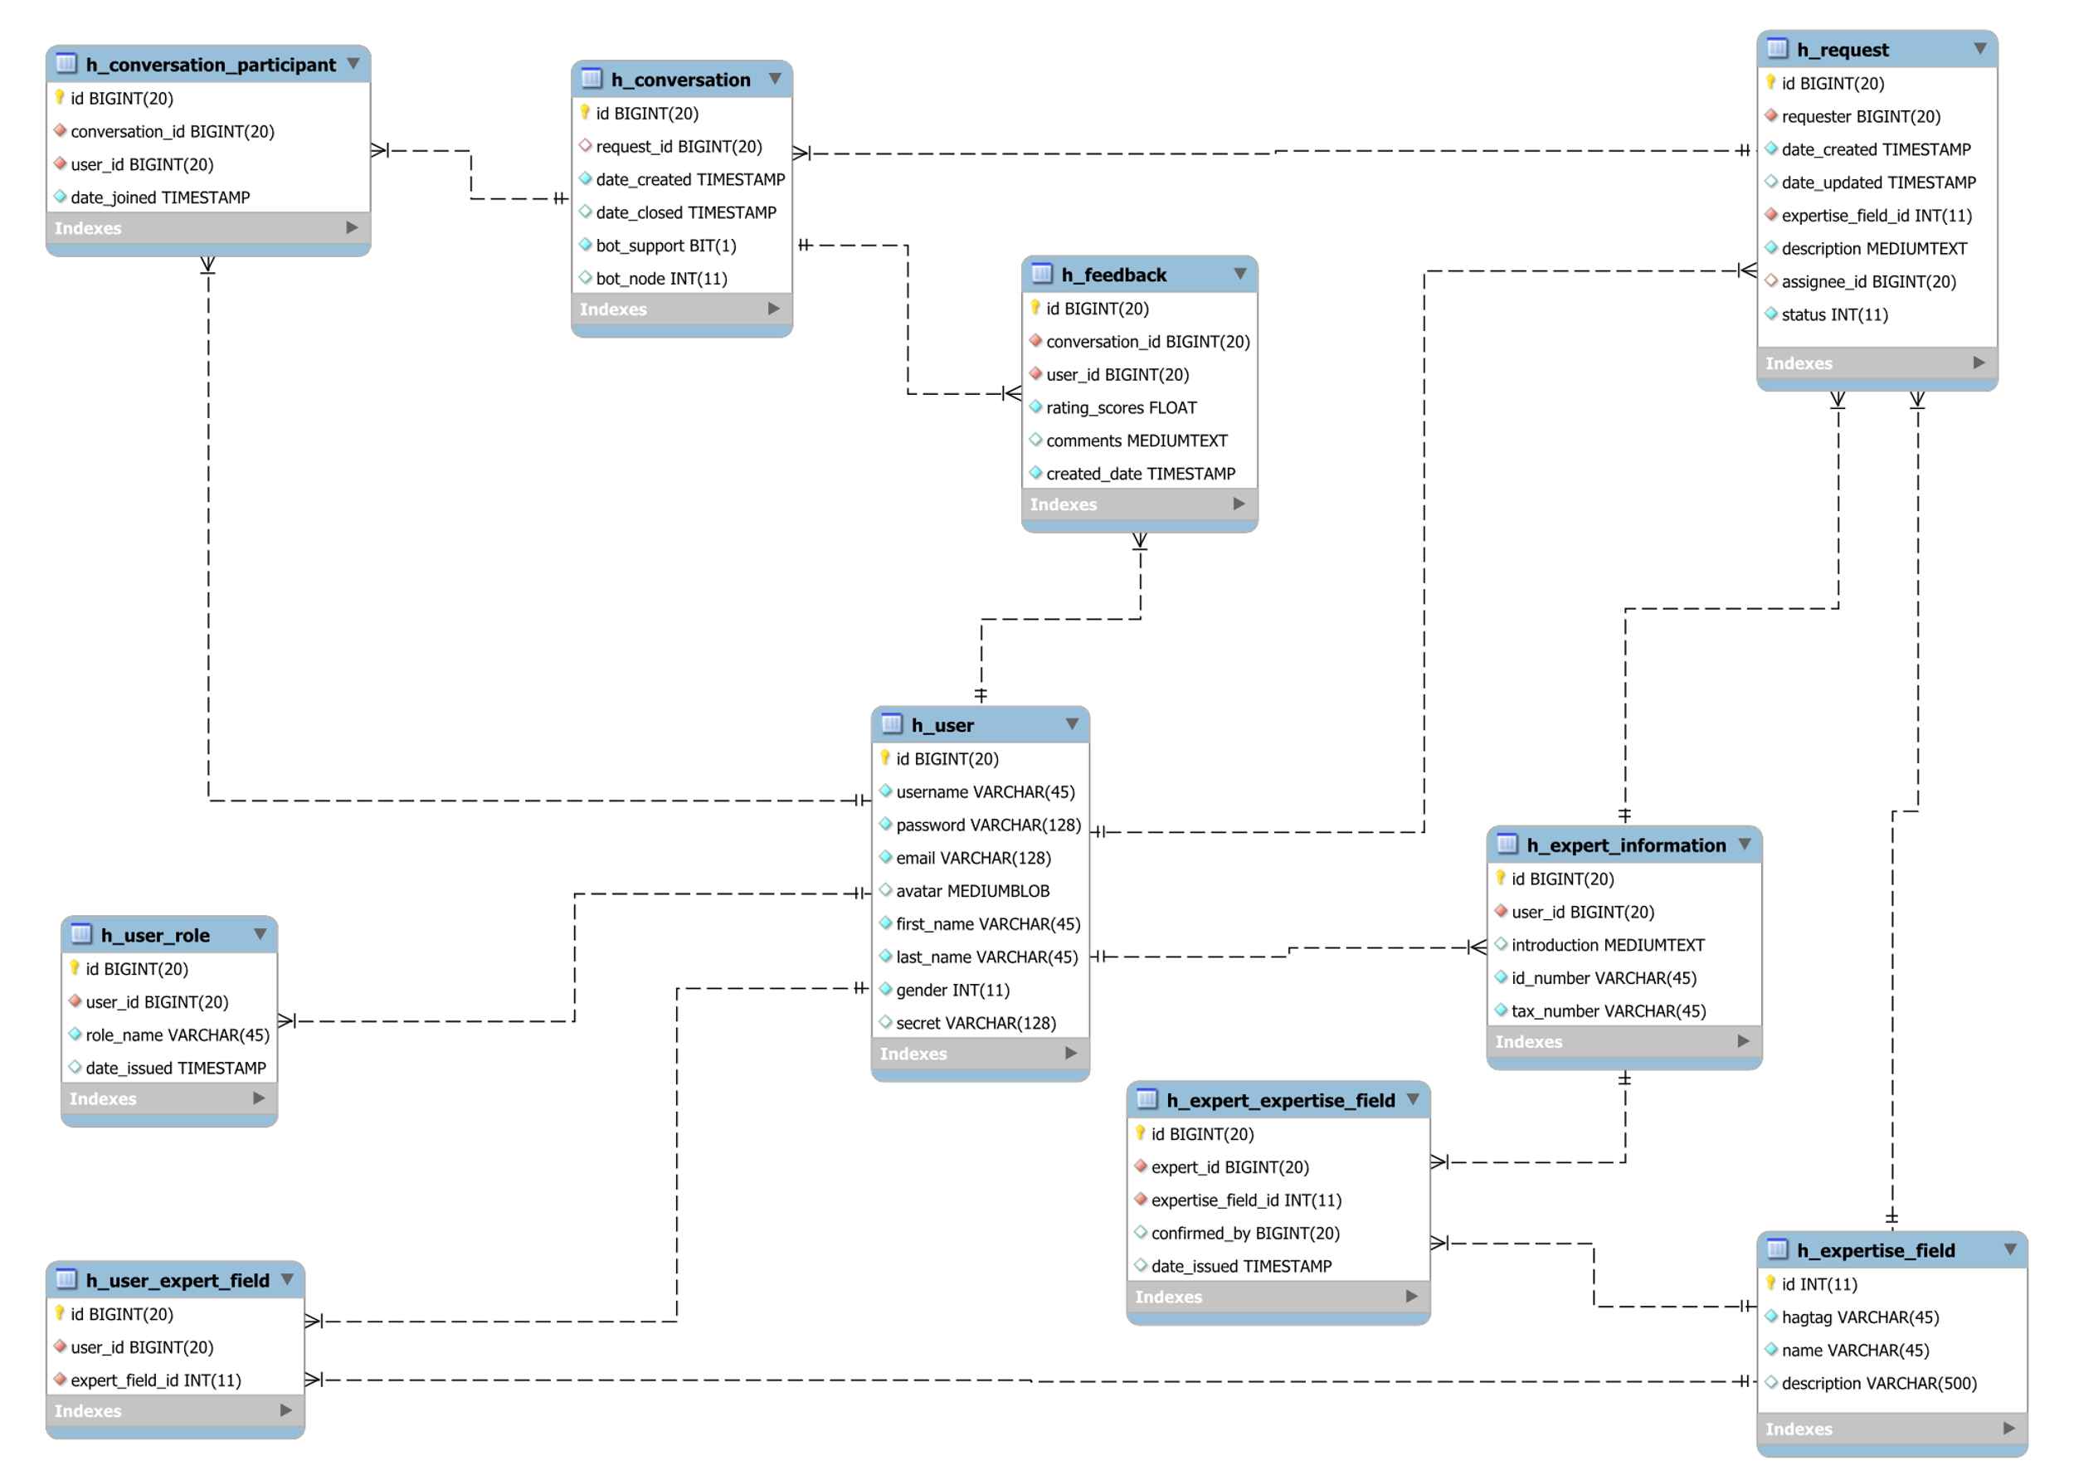

Figure 59 Physical Diagram

### 

### **2.2 Data Dictionary**

|  |  |
| --- | --- |
| *Data Dictionary: Describe Content of All Tables* | |
| Table Name | **Description** |
| *h_user* | *Stores user’s information of the system.* |
| *h_user_role* | *Specifies role of the user, has 4 types: User, Expert, Admin, Staff.* |
| *h_expert_information* | *Stores expert information of user in the system.* |
| *h_user_expert_field* | *Specifies the user who registers to become expert and his/her expertise field.* |
| *h_expert_expertise_field* | *Stored expertise field’s information of expert in the system.* |
| *h_expertise_field* | *Store expertise field’s information of the system.* |
| *h_request* | *Store support request’s information of the system.* |
| *h_conversation* | *Store conversation’s information of the system.* |
| *h_conversation_participant* | *Specifies participant of conversation.* |
| *h_feedback* | *Store feedback’s information of conversation.* |

|  |  |  |  |  |
| --- | --- | --- | --- | --- |
| *Table Name* | *Attributes* | *Description* | *Domain* | *Null* |
| *h_user* | *id {PK}* | *Unique identifier of h_user.* | *BIGINT(20)* | *N* |
| *username* | *Username of account.* | *VARCHAR(45)* | *N* |
| *password* | *Password of account.* | *VARCHAR(128)* | *N* |
| *email* | *Email of account.* | *VARCHAR(128)* | *N* |
| *avatar* | *Avatar of account.* | *MEDIUMBLOB* | *Y* |
| *first_name* | *First name of user of account.* | *VARCHAR(45)* | *N* |
| *last_name* | *Last name of user of account.* | *VARCHAR(45)* | *N* |
| *gender* | *Gender of user of account.* | *INT(11)* | *N* |
| *secret* | *Secret of account.* | *VARCHAR(128)* | *Y* |
| *h_user_role* | *id {PK}* | *Unique identifier of h_user_role.* | *BIGINT(20)* | *N* |
| *user_id* | *User identifier of h_user_role* | *BIGINT(20)* | *N* |
| *role_name* | *Role of account.* | *VARCHAR(45)* | *N* |
| *date_issued* | *User’s role updated date.* | *TIMESTAMP* | *Y* |
| *h_expert_information* | *id {PK}* | *Unique identifier of h_expert_information.* | *BIGINT(20)* | *N* |
| *user_id* | *User identifier of h_expert_information.* | *BIGINT(20)* | *N* |
| *introduction* | *Introduction of expert.* | *MEDIUMTEXT* | *Y* |
| *id_number* | *Identity number of expert.* | *VARCHAR(45)* | *N* |
| *tax_number* | *Tax number of expert.* | *VARCHAR(45)* | *N* |
| *h_user_expert_field* | *id {PK}* | *Unique identifier of h_user_expert_field.* | *BIGINT(20)* | *N* |
| *user_id* | *User identifier of h_user_expert_field.* | *BIGINT(20)* | *N* |
| *expert_field_id* | *Expertise field identifier of h_user_expert_field.* | *INT(11)* | *N* |
| *h_expert_expertise_field* | *id {PK}* | *Unique identifier of h_expert_expertise_field.* | *BIGINT(20)* | *N* |
| *expert_id* | *Expert identifier of h_expert_expertise_field.* | *BIGINT(20)* | *N* |
| *expertise_field_id* | *Expertise field identifier of h_expert_expertise_field.* | *INT(11)* | *N* |
| *confirmed_by* | *Staff identifier of h_expert_expertise_field.* | *BIGINT(20)* | *Y* |
| *date_issued* | *Expert’s expertise field updated date.* | *TIMESTAMP* | *Y* |
| *h_expertise_field* | *id {PK}* | *Unique identifier of h_expertise_field.* | *INT(11)* | *N* |
| *hagtag* | *Hagtag of expertise field.* | *VARCHAR(45)* | *N* |
| *name* | *Name of expertise field.* | *VARCHAR(45)* | *N* |
| *description* | *Description of expertise field.* | *VARCHAR(500)* | *Y* |
| *h_request* | *id {PK}* | *Unique identifier of h_request.* | *BIGINT(20)* | *N* |
| *requester* | *Requester identifier of h_request.* | *BIGINT(20)* | *N* |
| *date_created* | *Request created date.* | *TIMESTAMP* | *N* |
| *date_updated* | *Request updated date.* | *TIMESTAMP* | *Y* |
| *expertise_field_id* | *h_expertise_field identifier of h_request.* | *INT(11)* | *N* |
| *description* | *Description of request.* | *MEDIUMTEXT* | *N* |
| *assignee_id* | *Assignee identifier of h_request.* | *BIGINT(20)* | *Y* |
| *status* | *Status of request.* | *INT(11)* | *N* |
| *h_conversation* | *id {PK}* | *Unique identifier of h_conversation.* | *BIGINT(20)* | *N* |
| *request_id* | *Request identifier of h_conversation.* | *BIGINT(20)* | *N* |
| *date_created* | *Conversation created date.* | *TIMESTAMP* | *N* |
| *date_closed* | *Conversation closed date.* | *TIMESTAMP* | *Y* |
| *bot_support* | *Support bot of conversation* | *BIT(1)* | *N* |
| *bot_node* | *Node of bot of conversation* | *INT(11)* | *N* |
| *h_conversation_participant* | *id {PK}* | *Unique identifier of h_conversation_participant.* | *BIGINT(20)* | *N* |
| *conversation_id* | *Conversation identifier of h_conversation_participant.* | *BIGINT(20)* | *N* |
| *user_id* | *User identifier of h_conversation_participant.* | *BIGINT(20)* | *N* |
| *date_joined* | *Conversation’s participant joined date.* | *TIMESTAMP* | *N* |
| *h_feedback* | *id {PK}* | *Unique identifier of h_feedback.* | *BIGINT(20)* | *N* |
| *conversation_id* | *Conversation identifier of h_feedback.* | *BIGINT(20)* | *N* |
| *user_id* | *User identifier of h_feedback.* | *BIGINT(20)* | *N* |
| *rating_scores* | *Rating scores of feedbacks.* | *FLOAT* | *N* |
| *comments* | *Comment of feedback.* | *JSON* | *Y* |
| *created_date* | *Created date of feedback.* | *TIMESTAMP* | *N* |

Table 68: Attribute Data Dictionary

## 3. Test Plan

The purpose of this section is to verify and ensure that Helpy meets its design specification and other requirements from user. The following part will describe which features to be tested and which will not.

### **4.1 Features to be tested**

* Register
* Login
* Chat with Chat Bot
* Chat/Call/Video call/Share screen
* Give feedback
* View profile
* Update user information
* Update expert information

### **4.2 Features not to be tested**

* Staff/Admin functions

## 4. System Testing Test Case

### **4.1 Guest Test Case**

#### **4.1.1 Register**

|  |  |  |  |  |  |  |
| --- | --- | --- | --- | --- | --- | --- |
| *ID* | *Test Case Description* | *Test Case Procedure* | *Expected Output* | *Pre-condition* | *Result* | *Test Date* |
| *TC01* | *Register* | *- Go to register page*  *- Input username “DongVV”, password “123456”, re-password “123456”, email “dongvv@gmail.com”, last name “Võ”, first name “Vĩ Đông” and gender “Male”*  *- Click “Đăng ký” button* | *Show login page* | *N/A* | *Pass* | *From 27/11/2017 to 01/12/2017* |
| *TC02* | *Register without input username, password, email, last name and first name* | *- Go to register page*  *- Input re-password “123456”*  *- Click “Đăng ký” button* | *Show messages:*  *- Không được bỏ trống tên đăng nhập!*  *- Không được bỏ trống mật khẩu!*  *- Mật khẩu nhập lại không đúng!*  *- Không được bỏ trống email!*  *- Không được bỏ trống họ!*  *- Không được bỏ trống tên!* | *N/A* | *Pass* | *From 27/11/2017 to 01/12/2017* |
| *TC03* | *Register with username, password lower than allowed range, and email is invalid format* | *- Go to register page*  *- Input username “aaa”, password “12345”, re-password “12345”, email “dongvv@gmail”, last name “Võ”, first name “Vĩ Đông” and gender “Male”*  *- Click “Đăng ký” button* | *Show messages:*  *- Tên đăng nhập không được ít hơn 4 ký tự!*  *- Mật khẩu không được ít hơn 6 ký tự!*  *- Email sai định dạng!* | *N/A* | *Pass* | *From 27/11/2017 to 01/12/2017* |
| *TC04* | *Register with username, password, first name and last name greater than allowed range* | *- Go to register page*  *- Input username “aaa…” (46 characters), password “aaa…” (129 characters), password “aaa…” (129 characters), last name “aaa…” (46 characters), first name “aaa…” (46 characters) and gender “Nam”*  *- Click “Đăng ký” button* | *Show messages:*  *- Tên đăng nhập không được nhiều hơn 45 ký tự!*  *- Mật khẩu không được nhiều hơn 128 ký tự!*  *- Họ không được nhiều hơn 45 ký tự!*  *- Tên không được nhiều hơn 45 ký tự!* | *N/A* | *Pass* | *From 27/11/2017 to 01/12/2017* |
| *TC05* | *Register with existed username and existed email* | *- Go to register page*  *- Input username “cachua”, password “123456”, re-password “123456”, email “cachua@gmail.com”, last name “Võ”, first name “Vĩ Đông” and gender “Male”*  *- Click “Đăng ký” button* | *Show messages:*  *- Tên đăng nhập đã tồn tại!*  *- Email đăng ký đã tồn tại!* | *N/A* | *Pass* | *From 27/11/2017 to 01/12/2017* |

#### **4.1.2 Login**

|  |  |  |  |  |  |  |
| --- | --- | --- | --- | --- | --- | --- |
| *ID* | *Test Case Description* | *Test Case Procedure* | *Expected Output* | *Pre-condition* | *Result* | *Test Date* |
| *TC06* | *Login* | *- Go to login page*  *- Input username “cachua” and password “123456”*  *- Click “Đăng nhập” button* | *Show homepage* | *N/A* | *Pass* | *From 27/11/2017 to 01/12/2017* |
| *TC07* | *Login with wrong username* | *- Go to login page*  *- Input username “aaaaa” and password “123456”*  *- Click “Đăng nhập” button* | *Show messages: “Tên đăng nhập không tồn tại!”* | *N/A* | *Pass* | *From 27/11/2017 to 01/12/2017* |
| *TC08* | *Login with wrong password* | *- Go to login page*  *- Input username “cachua” and password “1234567”*  *- Click “Đăng nhập” button* | *Show messages: “Sai mật khẩu!”* | *N/A* | *Pass* | *From 27/11/2017 to 01/12/2017* |
| *TC09* | *Login without input username and password* | *- Go to login page*  *- Click “Đăng nhập” button* | *Show messages:*  *- Không được bỏ trống tên đăng nhập!*  *- Không được bỏ trống mật khẩu!* | *N/A* | *Pass* | *From 27/11/2017 to 01/12/2017* |
| *TC10* | *Login with username and password lower than allowed range* | *- Go to login page*  *- Input username “aaa” and password “12345”*  *- Click “Đăng nhập” button* | *Show messages:*  *- Tên đăng nhập không được ít hơn 4 ký tự!*  *- Mật khẩu không được ít hơn 6 ký tự!* | *N/A* | *Pass* | *From 27/11/2017 to 01/12/2017* |

### **4.2 User Test Case**

#### **4.2.1 Chat with Chat Bot**

|  |  |  |  |  |  |  |
| --- | --- | --- | --- | --- | --- | --- |
| *ID* | *Test Case Description* | *Test Case Procedure* | *Expected Output* | *Pre-condition* | *Result* | *Test Date* |
| *TC11* | *Sent message is lower than allowed range* | *- Click “Java” topic from topics list*  *- Input message “Hi”*  *- Click “Gửi” button* | *Show messages: Tin nhắn không được ít hơn 3 ký tự.* | *N/A* | *Pass* | *From 27/11/2017 to 01/12/2017* |
| *TC12* | *Sent message does not provide enough information* | *- Click “Java” topic from topics list*  *- Input message “Help me”*  *- Click “Gửi” button* | *Chat Bot replies: Mô tả của bạn quá ngắn! Xin vui lòng cung cấp thêm thông tin!* | *N/A* | *Pass* | *From 27/11/2017 to 01/12/2017* |
| *TC13* | *Sent request for help message with enough information* | *- Click “Java” topic from topics list*  *- Input message “Hello! Can you help me find a java expert to help me?”*  *- Click “Gửi” button* | *Chat Bot replies: Tôi đang tìm chuyên gia phù hợp để giúp đỡ bạn. Xin hãy chờ trong giây lát...* | *N/A* | *Pass* | *From 27/11/2017 to 01/12/2017* |

#### **4.2.2 Chat**

|  |  |  |  |  |  |  |
| --- | --- | --- | --- | --- | --- | --- |
| *ID* | *Test Case Description* | *Test Case Procedure* | *Expected Output* | *Pre-condition* | *Result* | *Test Date* |
| *TC14* | *Sent message is lower than allowed range* | *- Input message “Hi”*  *- Click “Gửi” button* | *Show messages: Tin nhắn không được ít hơn 3 ký tự.* | *User participates in a conversation* | *Pass* | *From 27/11/2017 to 01/12/2017* |
| *TC15* | *Send messages* | *- Input message “Hello, can you help me please?”*  *- Click “Gửi” button* | *The conversation interface update with new message.* | *User participates in a conversation* | *Pass* | *From 27/11/2017 to 01/12/2017* |
| *TC35* | *Send message while sharing screen* | *- Input message “Hello, can you help me please?”*  *- Click “Gửi” button* | *The conversation interface update with new message.* | *User is in share screen process* | *Pass* | *From 27/11/2017 to 01/12/2017* |

#### **4.2.3 Call/Video call/Share screen**

|  |  |  |  |  |  |  |
| --- | --- | --- | --- | --- | --- | --- |
| *ID* | *Test Case Description* | *Test Case Procedure* | *Expected Output* | *Pre-condition* | *Result* | *Test Date* |
| *TC23* | *Call* | *- Click dropdown list*  *- Click “Gọi”* | *The conversation interface starts call.* | *User participates in a conversation* | *Pass* | *From 27/11/2017 to 01/12/2017* |
| *TC32* | *End call* | *- Click “Kết thúc cuộc gọi” button* | *Call interface is closed.* | *User is in call process* | *Pass* | *From 27/11/2017 to 01/12/2017* |
| *TC24* | *Video call* | *- Click dropdown list*  *- Click “Gọi video”* | *The conversation interface starts video call.* | *User participates in a conversation* | *Pass* | *From 27/11/2017 to 01/12/2017* |
| *TC33* | *End video call* | *- Click “Kết thúc cuộc gọi” button* | *Video call interface is closed.* | *User is in video call process* | *Pass* | *From 27/11/2017 to 01/12/2017* |
| *TC25* | *Share screen* | *- Click dropdown list*  *- Click “Chia sẻ màn hình”* | *The conversation interface starts share screen.* | *User participates in a conversation* | *Pass* | *From 27/11/2017 to 01/12/2017* |
| *TC34* | *End share screen* | *- Click “Kết thúc chia sẻ” button* | *Share screen interface is closed.* | *User is in share screen process* | *Pass* | *From 27/11/2017 to 01/12/2017* |

#### **4.2.4 Give feedback**

|  |  |  |  |  |  |  |
| --- | --- | --- | --- | --- | --- | --- |
| *ID* | *Test Case Description* | *Test Case Procedure* | *Expected Output* | *Pre-condition* | *Result* | *Test Date* |
| *TC16* | *Send feedback* | *- Input rating and comment*  *- Click “Gửi” button* | *Feedback form closes and the homepage displays.* | *User closes a conversation* | *Pass* | *From 27/11/2017 to 01/12/2017* |
| *TC17* | *Send feedback without input rating.* | *- Click “Gửi” button* | *Show message: Xin hãy chọn điểm đánh giá.* | *User closes a conversation* | *Pass* | *From 27/11/2017 to 01/12/2017* |

#### **4.2.5 View user profile**

|  |  |  |  |  |  |  |
| --- | --- | --- | --- | --- | --- | --- |
| *ID* | *Test Case Description* | *Test Case Procedure* | *Expected Output* | *Pre-condition* | *Result* | *Test Date* |
| *TC18* | *View existed user profile* | *Click on user “caphao”* | *Profile of user caphao displays.* | *N/A* | *Pass* | *From 27/11/2017 to 01/12/2017* |
| *TC31* | *View existed expert profile* | *Click on user “cachua”* | *Profile of user cachua displays (including information of expertise fields).* | *N/A* | *Pass* | *From 27/11/2017 to 01/12/2017* |
| *TC19* | *View non-existed user profile* | *Access link ./profile/aa* | *Show message: Người dùng không tồn tại* | *N/A* | *Pass* | *From 27/11/2017 to 01/12/2017* |

#### **4.2.6 Update profile**

|  |  |  |  |  |  |  |
| --- | --- | --- | --- | --- | --- | --- |
| *ID* | *Test Case Description* | *Test Case Procedure* | *Expected Output* | *Pre-condition* | *Result* | *Test Date* |
| *TC20* | *Update profile* | *- Click on update profile link*  *- Input new email “cachua12@gmail.com”, first name “Thị Cà Chua”, last name “Lê” and gender “Female”*  *- Click “Cập nhật” button* | *Shows profile page with updated information.* | *N/A* | *Pass* | *From 27/11/2017 to 01/12/2017* |
| *TC21* | *Update profile with email, first name, last name empty* | *- Click on update profile link*  *- Input new email “”, first name “”, last name “*  *- Click “Cập nhật” button* | *Shows messages:*  *- Không được bỏ trống email!*  *- Không được bỏ trống họ!*  *- Không được bỏ trống tên!* | *N/A* | *Pass* | *From 27/11/2017 to 01/12/2017* |
| *TC22* | *Update profile with existed email* | *- Click on update profile link*  *- Input new email “caphao@gmail.com”*  *- Click “Cập nhật” button* | *Show message: Email đăng ký đã tồn tại!* | *N/A* | *Pass* | *From 27/11/2017 to 01/12/2017* |

### **4.3 Expert Test Case**

#### **4.3.1 Decline/Accept request**

|  |  |  |  |  |  |  |
| --- | --- | --- | --- | --- | --- | --- |
| *ID* | *Test Case Description* | *Test Case Procedure* | *Expected Output* | *Pre-condition* | *Result* | *Test Date* |
| *TC26* | *Decline request* | *- Click “Từ chối” button* | *Shows updated requests list page.* | *User views detail of a request* | *Pass* | *From 27/11/2017 to 01/12/2017* |
| *TC27* | *Accept request* | *- Click “Đồng ý giúp đỡ” button* | *Shows conversation page.* | *User views detail of a request* | *Pass* | *From 27/11/2017 to 01/12/2017* |

#### **4.3.2 Update expertise**

|  |  |  |  |  |  |  |
| --- | --- | --- | --- | --- | --- | --- |
| *ID* | *Test Case Description* | *Test Case Procedure* | *Expected Output* | *Pre-condition* | *Result* | *Test Date* |
| *TC28* | *Update expertise* | *- Go to update expertise page*  *- Input id number “11111”, tax number “11111” and expertise field “Java”*  *- Click “Cập nhật” button* | *Shows updated profile page.* | *N/A* | *Pass* | *From 27/11/2017 to 01/12/2017* |
| *TC29* | *Update expertise without input id number, tax number, and expertise field* | *- Go to update expertise page*  *- Input id number “”, tax number “” and expertise field “”*  *- Click “Cập nhật” button* | *Shows message:*  *- Không được bỏ trống số chứng minh!*  *- Không được bỏ trống mã số thuế*  *- Xin chọn ít nhất 1 chuyên ngành.* | *N/A* | *Pass* | *From 27/11/2017 to 01/12/2017* |
| *TC30* | *Update expertise with number of expertise fields is greater than allowed range (5 expertise fields)* | *- Go to update expertise page*  *- Input id number “11111”, tax number “11111” and expertise field “Java, C, C#, Python, Microsoft Excel, C++”*  *- Click “Cập nhật” button* | *Shows message:*  *- Bạn chỉ có thể chọn nhiều nhất 5 chuyên ngành.* | *N/A* | *Pass* | *From 27/11/2017 to 01/12/2017* |

# F. SOFTWARE USER’S MANUAL

## 1. Installation Guide

### **1.1 Setting up environment at server side**

The specifications are based on the dependencies requirements and performance test result from previous section of this document.

#### **Hardware requirement**

**- For server:**

|  |  |
| --- | --- |
| *Criteria* | *Minimum Requirements* |
| *Internet Connection* | *Cable (4 Mbps)* |
| *Computer Processor* | *64-bit CPU 1.4GHz with 2 cores* |
| *Computer Memory* | *4 GB RAM* |

Table 69: Hardware requirement for server

**- For client:**

|  |  |
| --- | --- |
| *Criteria* | *Minimum Requirements* |
| *Internet Connection* | *Cable (1 Mbps or higher)* |
| *Computer Processor* | *Intel® Core i3 1.4GHz* |
| *Computer Memory* | *1GB RAM* |

Table 70: Hardware requirement for client

#### **1.1.2 Software requirement**

**- For server:**

|  |  |
| --- | --- |
| *Name* | *Name/Version* |
| *Operating System* | *Windows Server 2008 R2* |
| *Environment* | *Java Runtime Environment 1.8* |
| *Web Server* | *Apache 2.4* |
| *Node.js* | *Node.js version 8.9.0 or higher* |
| *Database Systems* | *MySQL 5.7, MongoDB 3.4, Redis 2.8 (Redis Windows 3.0)* |

Table 71: Software requirement for server

**- For client:**

|  |  |
| --- | --- |
| *Name* | *Name/Version* |
| *Operating System* | *Windows 7 or higher* |
| *Web browser* | Firefox (v52 or higher), Chromes (v28 or higher) |

Table 72: Software requirement for client

### **1.2 Web Applications Deployment Process**

#### **1.2.1 Check environment**

Check Java Runtime Environment version by following these steps:

Step 1: Open the PowerShell

Step 2: Check Java Runtime Environment version by running this command: java -version

The result should be same as the example below. If the java version is not 1.8 or higher, please download & install this Java Runtime Environment version.



Figure 60 Check Java Runtime Environment Veresion

Next, check the Node.js version by run this comment on PowerShell: node -v

The result should be same as the example below. If the node.js version is not 8.9.0 or higher, please download & install this version.

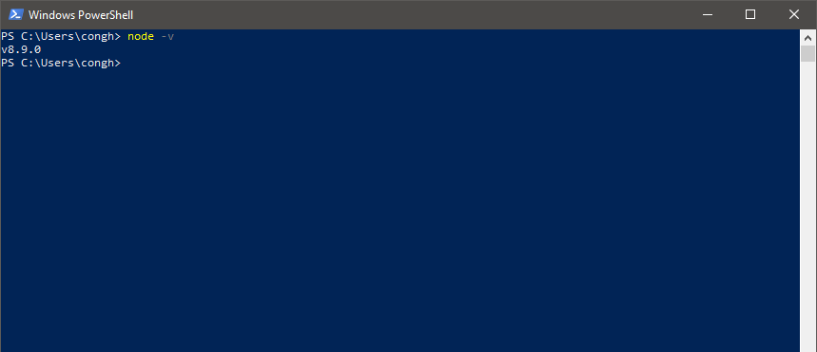

Figure 61 Check Node.js Version

Make sure that npm has been installed on the system. Npm is usually installed together with node.js. Please check if npm has been install by run this command on PowerShell: npm -v

The result should same as below:

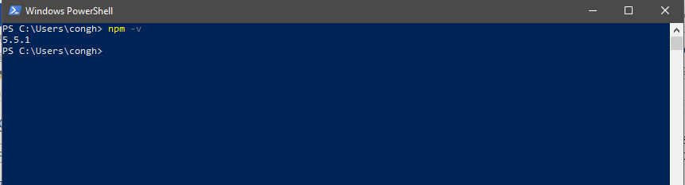

Figure 62 Check NPM has been installed

Make sure that MySQL, MongoDB and Windows Redis has been install and running as Windows services.

Step 1: open run windows, type "services.msc” and click ok.

Step 2: In the Services Winddow, check if MySQL, MongoDB and Windows Redis is a running service.

This example below is for check MySQL. Please do the same with MongoDB & Windows Redis.



#### **1.2.2 Import database**

Using file helpy.sql located under Deployment directory from this document.

#### **1.2.3 Build project**

Create Web Service/Staff Application deployment package by open the PowerShell at the project folder and do following steps:

Step 1: Clean the project

sbt clean

Step 2: Run this comment to create target package:

sbt dist

Step 3: Now get the package at path: [project folder path]/target/universal

For more information, please check at here: https://www.playframework.com/documentation/2.6.x/Deploying#using-the-dist-task

#### **1.2.4 Deploy project**

**Web Service/Staff Application**

Refer Guide for Produciton Configuration: <https://www.playframework.com/documentation/2.6.x/ProductionConfiguration>

Deploy the back-end package:

Assume that the package file name is helpy-webservice.zip. Unzip this file. Open PowerShell, change current folder to the folder that un-zip the package and run this command:

|  |
| --- |
| helpy-webservice/bin/helpy-webervice Dplay.http.secret.key=[optional_secret_key] |

**React.js Front-end Server**

Un-zip the package. Then open PowerShell change the current folder to the folder that un-zip the package and run this command:

|  |
| --- |
| npm start |

**Signaling Server**

Un-zip the package. Then open PowerShell change the current folder to the folder that un-zip the package and run this command:

|  |
| --- |
| node ./signaler-ssl.js |

**Run Worker Service**

Un-zip the package. Then open PowerShell change the current folder to the folder that un-zip the package and run this command:

|  |
| --- |
| ./start_worker.bat |

## 2. User Guide

### **2.1 User**

#### **2.1.1 Request for help**

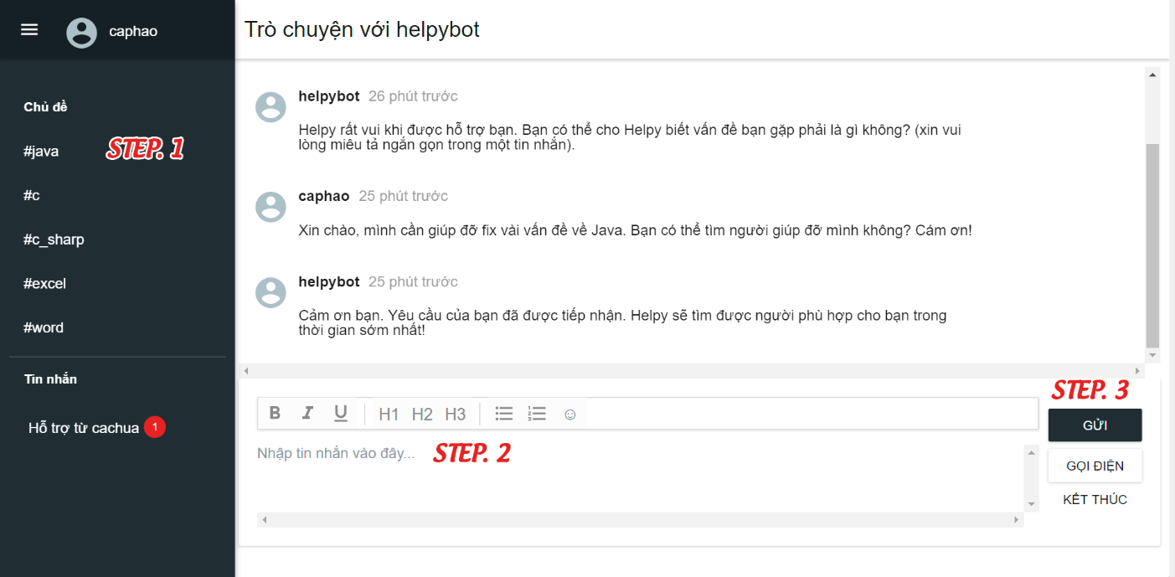

|  |  |
| --- | --- |
| *Step* | *Description* |
| *1* | *Click on “Chủ đề”* |
| *2* | *Fill in request’s description* |
| *3* | *Click “Gửi” button* |

#### **2.1.2 View conversation**

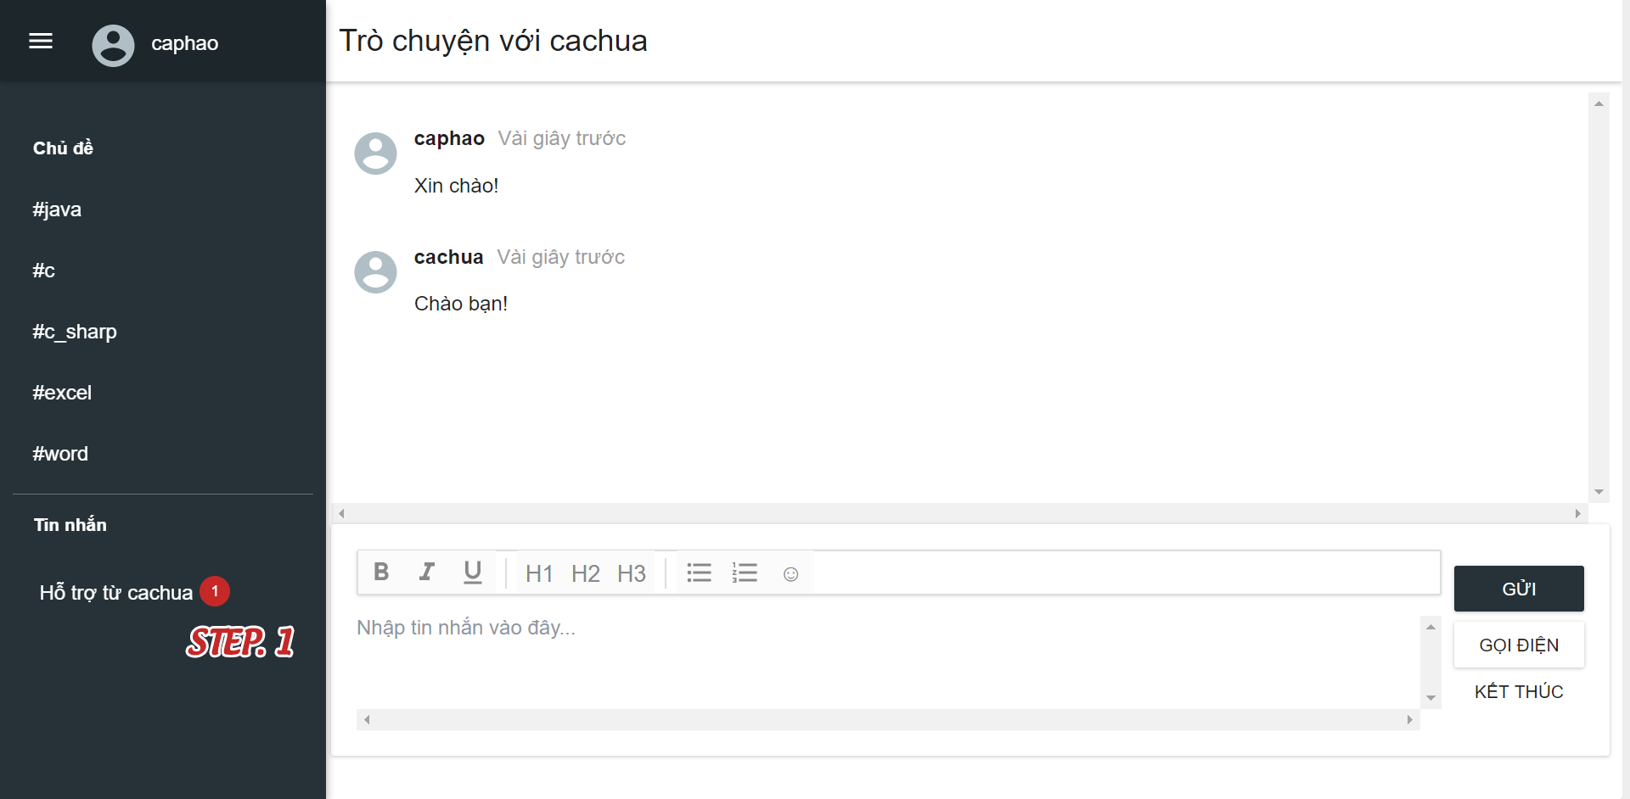

|  |  |
| --- | --- |
| *Step* | *Description* |
| *1* | *Click on “Tin nhắn”* |

##### **2.1.2.1 Chat**

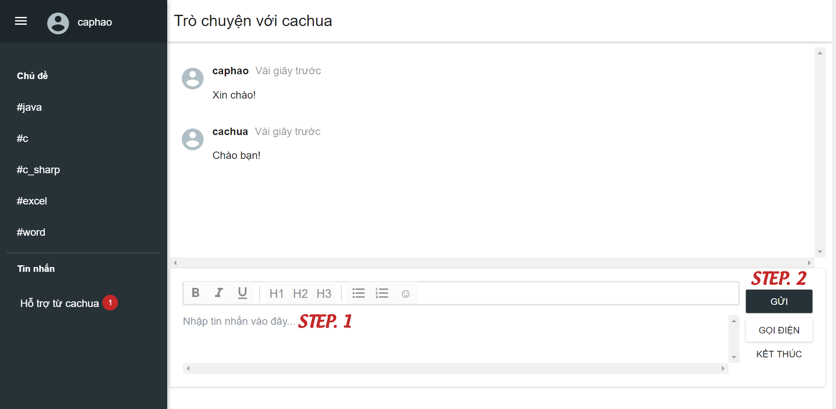

|  |  |
| --- | --- |
| *Step* | *Description* |
| *1* | *Fill in sent message* |
| *2* | *Click “Gửi” button or ENTER to send message* |

##### **2.1.2.2 Call**

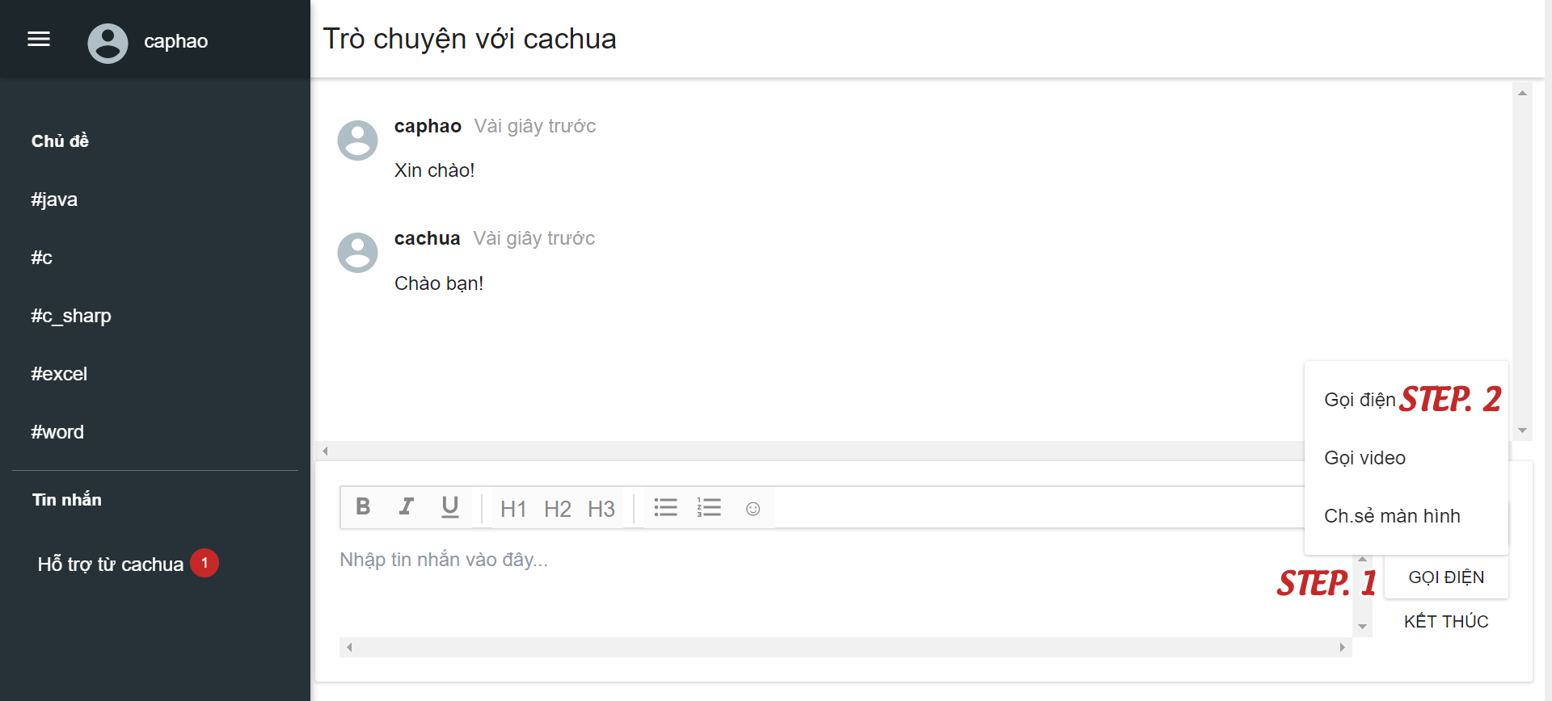

|  |  |
| --- | --- |
| *Step* | *Description* |
| *1* | *Click on “Gọi điện” button* |
| *2* | *Click on “Gọi điện” from call methods list to start call* |

##### **2.1.2.3 Video call**

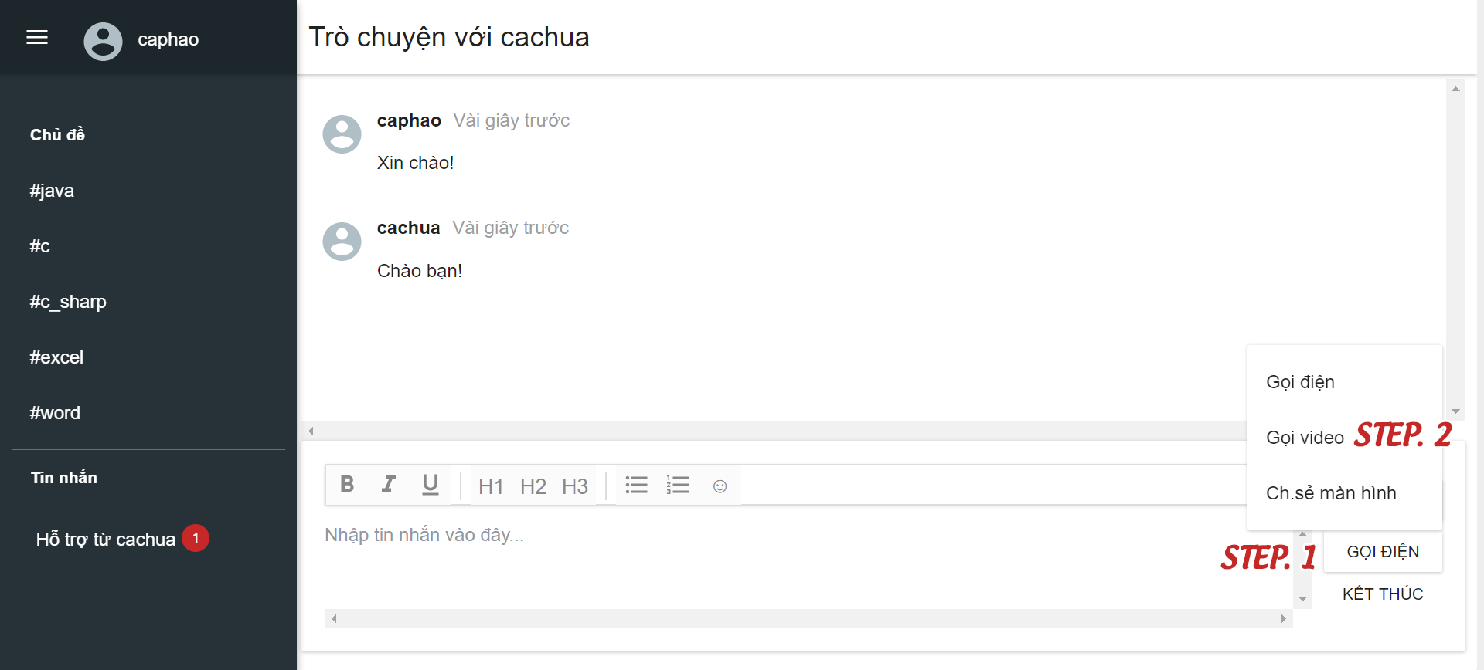

|  |  |
| --- | --- |
| *Step* | *Description* |
| *1* | *Click on “Gọi điện” button* |
| *2* | *Click on “Gọi video”* |

##### **2.1.2.4 Share screen**

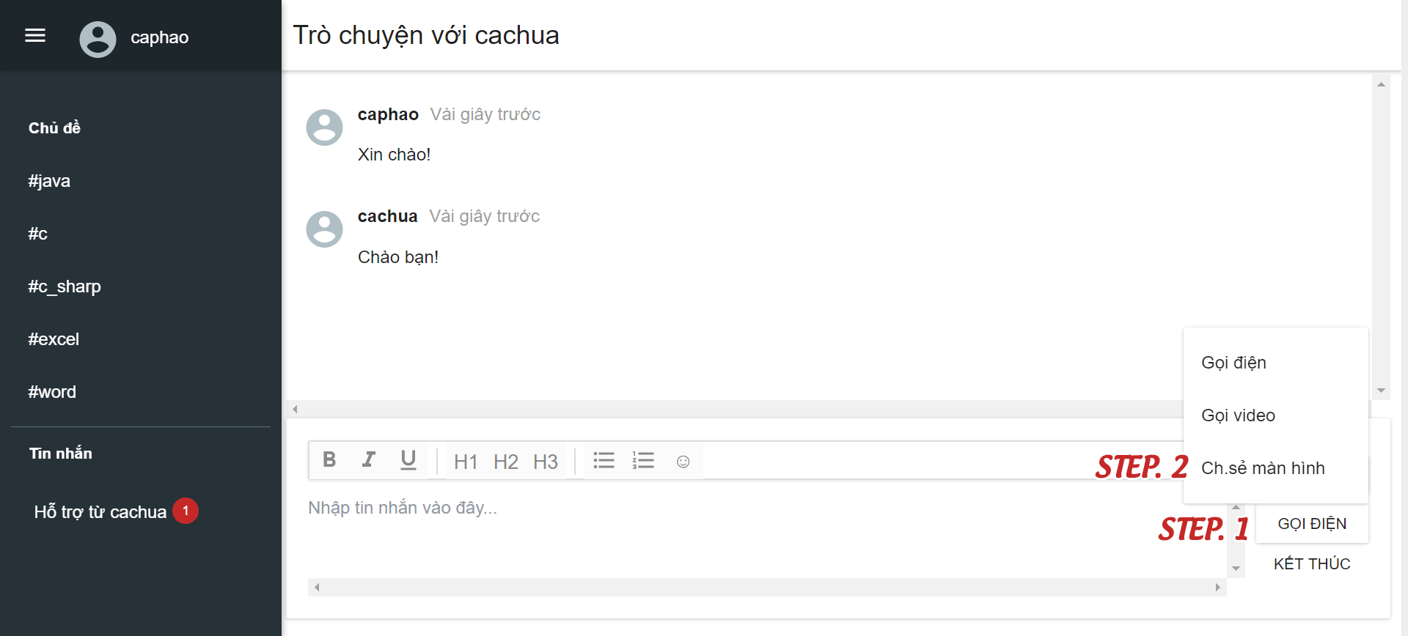

|  |  |
| --- | --- |
| *Step* | *Description* |
| *1* | *Click on “Gọi điện” button* |
| *2* | *Click on “Chia sẻ màn hình”* |

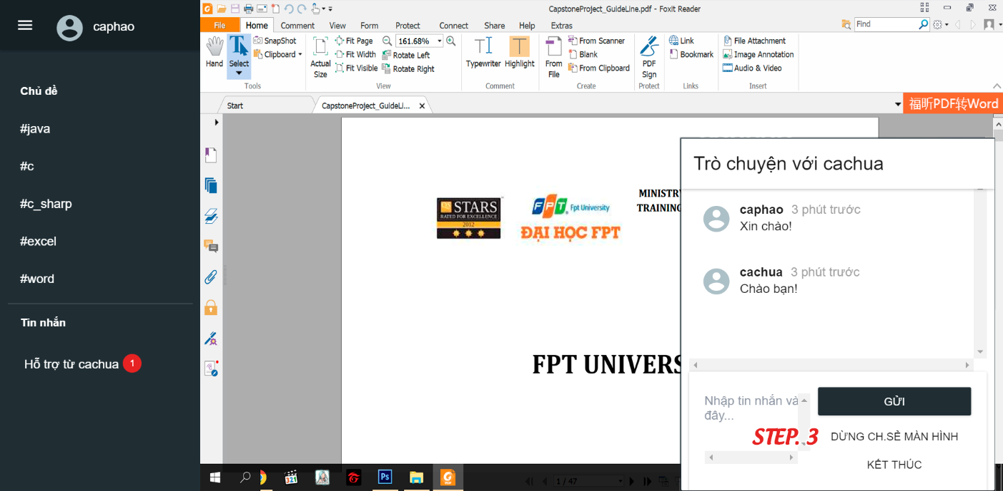

|  |  |
| --- | --- |
| *Step* | *Description* |
| *3* | *Click on “Dừng ch.sẻ màn hình” button to end share screen* |

##### **2.1.2.5 Close conversation**

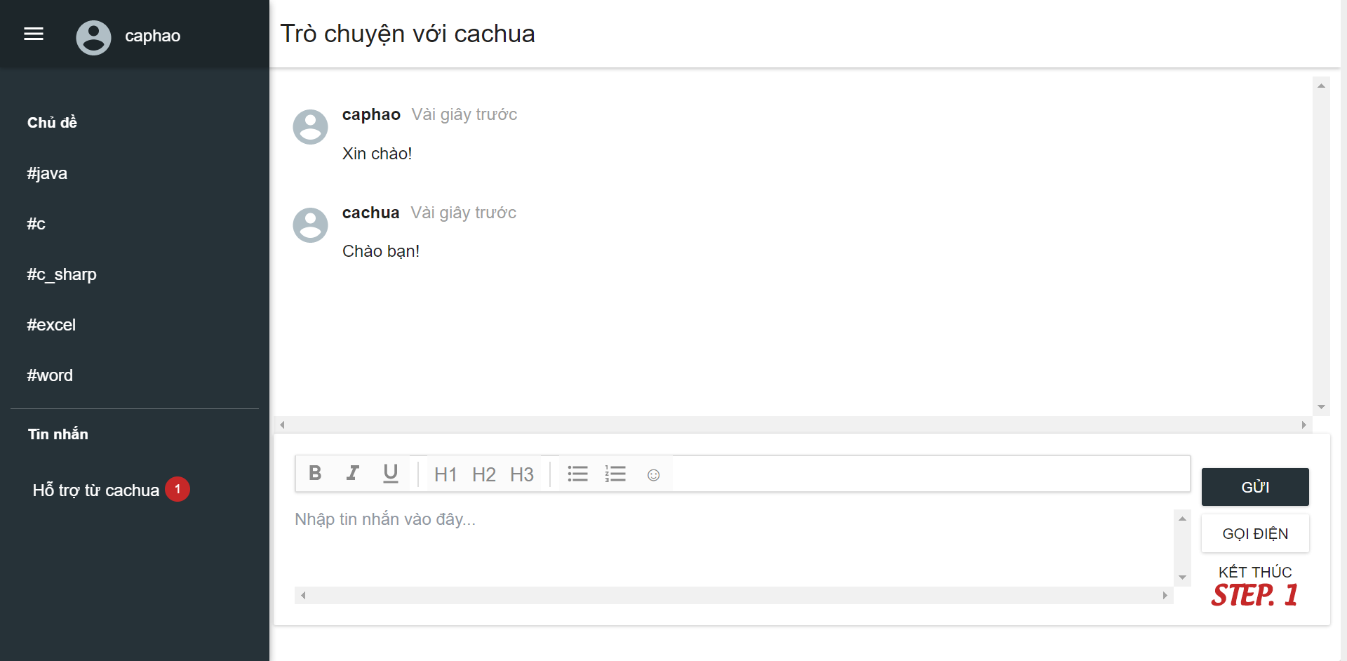

|  |  |
| --- | --- |
| *Step* | *Description* |
| *1* | *Click on “Kết thúc” button* |

### **2.2 Expert**

#### **View request**

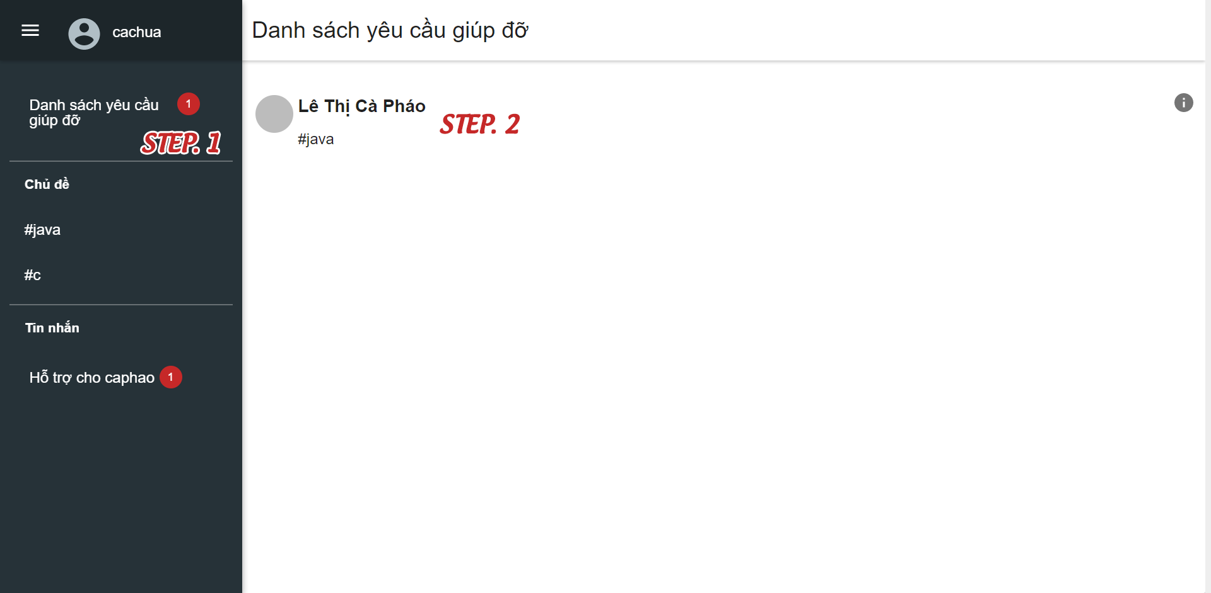

|  |  |
| --- | --- |
| *Step* | *Description* |
| *1* | *Click on “Danh sách yêu cầu giúp đỡ” to view requests list* |
| *2* | *Click on “Yêu cầu” to view request’s detail* |

##### **2.2.1 Accept request**

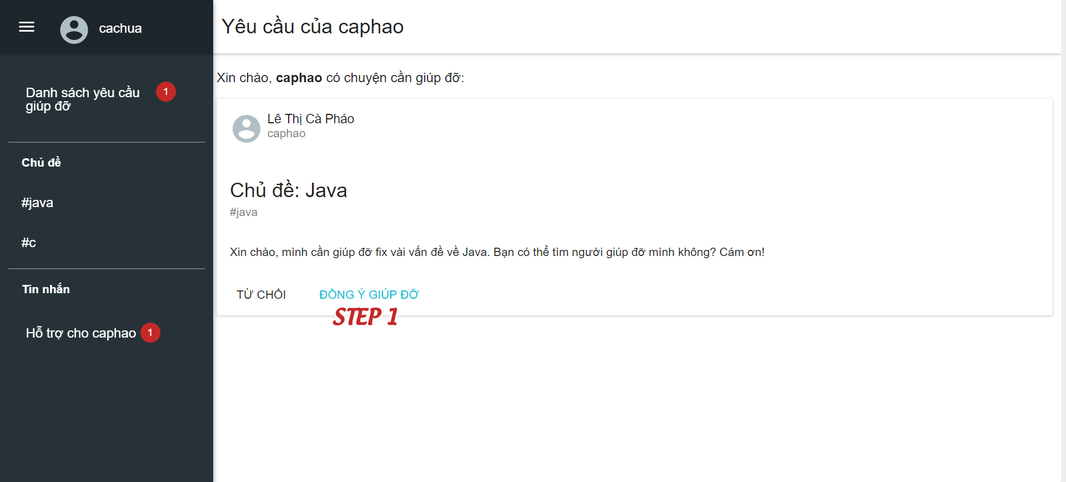

|  |  |
| --- | --- |
| *Step* | *Description* |
| *1* | *Click on “Đồng ý giúp đỡ” button to accept request* |

##### **2.2.2 Decline request**

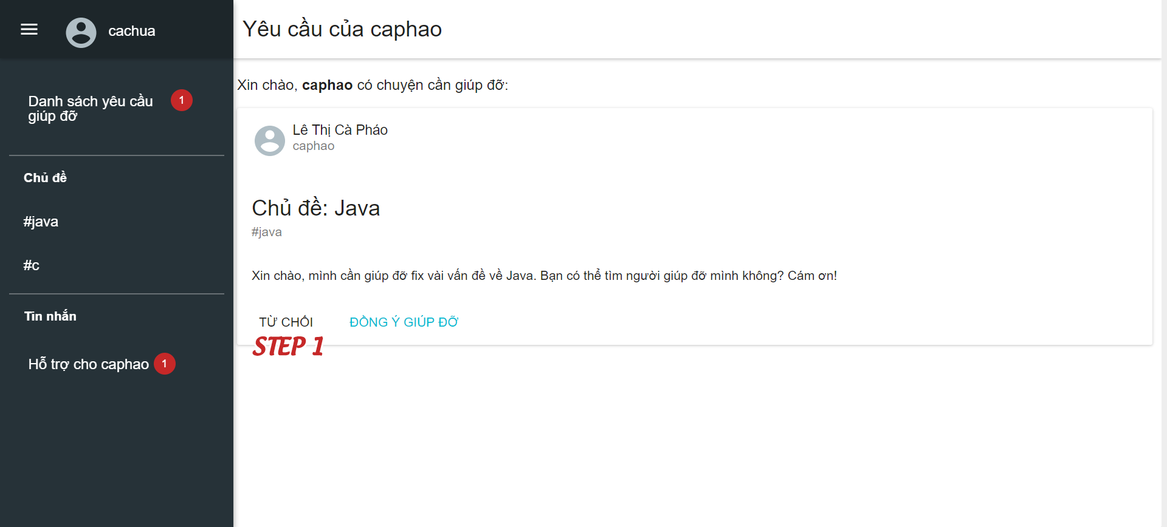

|  |  |
| --- | --- |
| *Step* | *Description* |
| *1* | *Click on “Từ chối” button to decline request* |

### **2.3 Staff**

#### **2.3.1 Expert registration management**

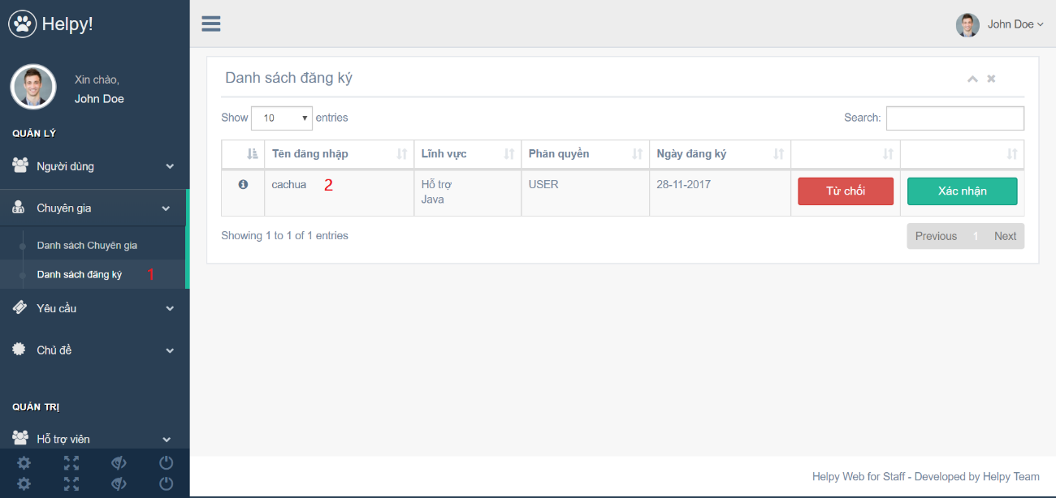

|  |  |
| --- | --- |
| *Step* | *Description* |
| *1* | *Click on “Danh sách đăng ký” on the left menu to view registrations list* |
| *2* | *Click on registration’s username to view registration details* |

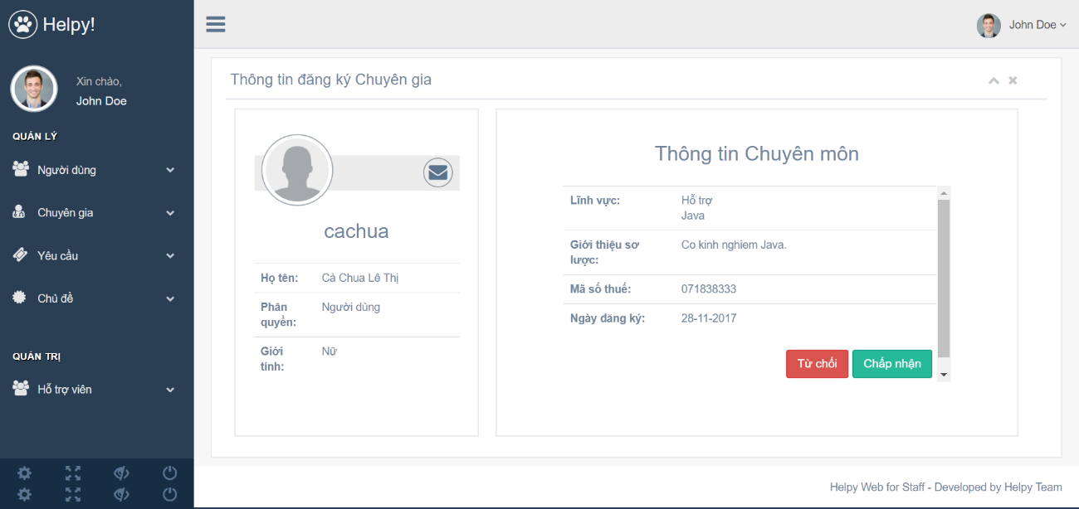

##### **2.3.1.1 Accept registration**

|  |  |
| --- | --- |
| *Step* | *Description* |
| *1* | *Click on “Đồng ý” button* |

##### **2.3.1.2 Decline registration**

|  |  |
| --- | --- |
| *Step* | *Description* |
| *1* | *Click on “Từ chối” button* |

#### **2.3.2 Pending request management**

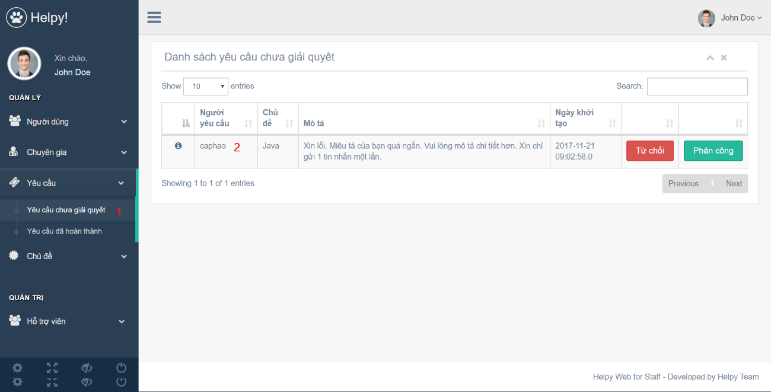

|  |  |
| --- | --- |
| *Step* | *Description* |
| *1* | *Click on “Yêu cầu chưa giải quyết” on the left menu to view pending requests list* |
| *2* | *Click on request’s username to view request details* |

##### **2.3.2.1 Assign request**

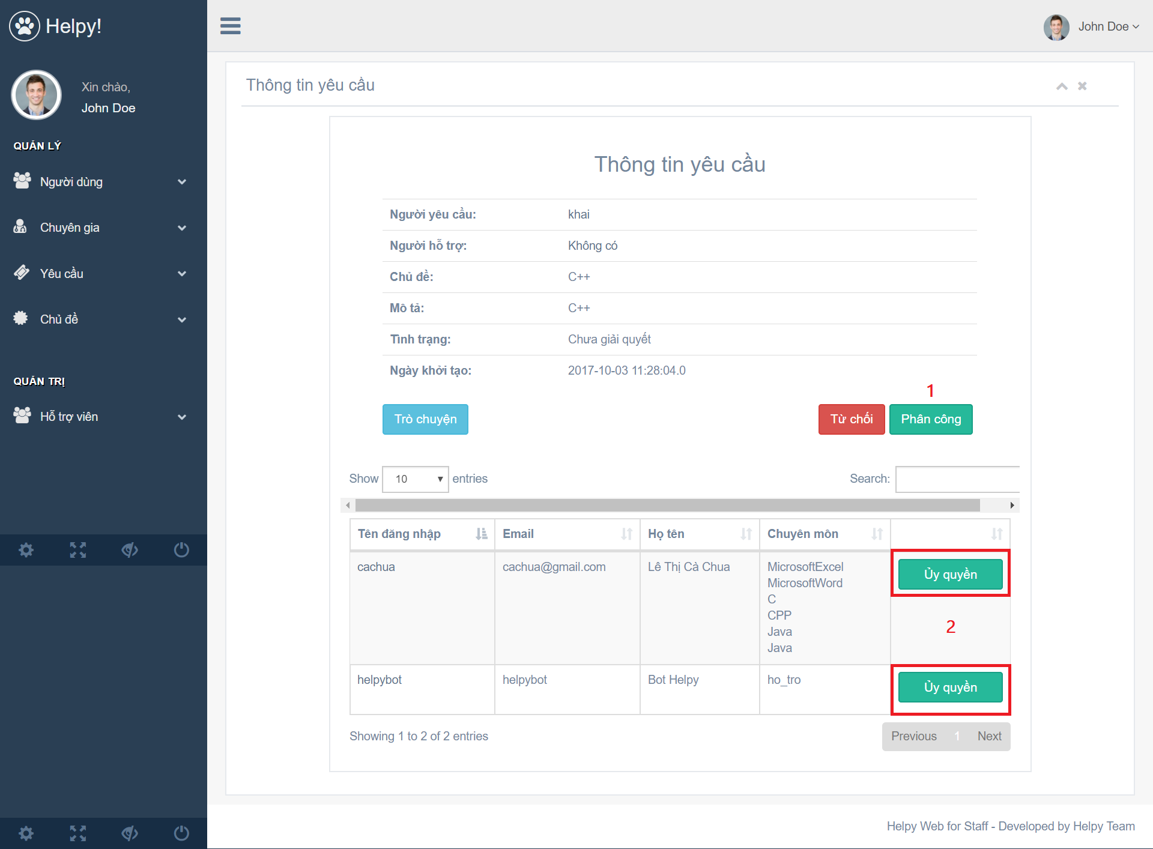

|  |  |
| --- | --- |
| *Step* | *Description* |
| *1* | *Click on “Phân công” button* |
| *2* | *Click on “Ủy quyền” button from experts list* |

##### **2.3.2.2 Decline request**

|  |  |
| --- | --- |
| *Step* | *Description* |
| *1* | *Click on “Từ chối” button* |

# G. APPENDIX & COPYRIGHT INFORMATION

## 1. Appendix

**Opensource Licenses**

Licenses of open-source parties in our project:

- Apache License, Version 2

<https://www.apache.org/licenses/LICENSE-2.0>

- MIT License

<https://opensource.org/licenses/MIT>

- BSD License

<https://opensource.org/licenses/BSD-3-Clause>

- GNU General Public License, version 2

<http://www.gnu.org/licenses/old-licenses/gpl-2.0.html>

- GNU Lesser General Public License, version 2.1

<https://www.gnu.org/licenses/old-licenses/lgpl-2.1.en.html>

**Programming Collective Intelligence**

**By Toby Segaran, published on August 2007 by O’Reilly**.

Copyright © 2007 Toby Segaran. All rights reserved

ISBN-10: 0-596-52932-5

ISBN-13: 978-0-596-52932-1

**Play Framework 2.6**

<https://playframework.com/documentation/2.6.x/Home>

**Flux Application Architecture**

<https://facebook.github.io/flux/docs/in-depth-overview.html#content>

**React.js Document**

<https://reactjs.org/docs>

**MySQL**

<https://dev.mysql.com/doc/>

**MongoDB**

<https://docs.mongodb.com/>

**WebRTC**

<https://webrtc.org/>

**Redis Cache**

<https://redis.io/documentation>

**Firebase Realtime Database**

<https://firebase.google.com/docs/database>

## 2. Copyright Information

NO PART OF HELPY PROJECT SOURCE CODES EXCEPT THE CODES FROM OPEN-SOURCE PARTIES MAY BE REPRODUCED, DISTRIBUTED, OR TRANSMITTED.

For the usage of open-source parties, please follow the license of each party. Refer to the section Acknowledgements.